
COURSE MANUAL
INDIVIDUAL PLACEMENT & SUPPORT

LEADING FOR EXCELLENCE: TRAINING FOR IPS SUPERVISORS
CONTENTS

Personal development plan | 3
Team action plan | 4
IPS principles | 5
Reflective cycle | 6
Factors affecting IPS implementation or service expansion | 7
Stakeholders | 8
IPS client journey flow chart | 9
Manager versus leader | 11
IPS field mentoring observations | 14-16
Fidelity review action planning | 17-18
Handling difficult conversations | 19
Performance management | 24
IPS fidelity scale | 25-51
Johari Window | 53
Workplace Mental Health standards | 54
Psychological Safety | 55
GROW coaching model | 56
Employer engagement | 58-59
FAQs | 60

PERSONAL ACTION PLAN

Action | Who | When

TEAM ACTION PLAN

Action | Who | When

IPS PRINCIPLES

IPS (Individual Placement and Support) supports people with health barriers into employment. It has eight key principles, each of which is needed for the service to work well.

The principles focus on rapidly placing someone into a paid job that relates to their personal preferences and building relationships with local employers to do so. Support continues once the person gets a job and is provided together with treatment care and welfare benefits advice. IPS does not exclude anyone, meaning anyone who wants to work is eligible for employment support.

The service should be individual to a person’s needs and wishes; offer rapid placement in work; and provide ongoing support for as long as it is needed.

- Competitive employment is the primary goal
The fundamental assumption should be that paid employment (part-time or full-time) is a realistic goal for everyone who wants a job, and the central goal of the service must always be paid employment.

- Everyone is eligible
There are no ‘eligibility criteria’ for entry into IPS programmes beyond an expressed motivation to ‘give it a try’. This should be irrespective of issues such as job readiness, symptoms, substance misuse, social skills or a history of violent behaviour.

- Job search is consistent with individual preferences
Working closely with someone’s personal interests and experience significantly increases the chances of them enjoying and retaining a job.

- Job search is rapid
The job search should be started early (normally within one month) to get people into work quickly whilst they are motivated and interested in working.

- Integration of employment specialists and treatment teams
One of the most crucial aspects of the IPS approach is the quality of joint working between employment specialists and the treatment teams. Employment specialists should be integrated and actively take part in assessment meetings.

- Support is time-unlimited and individualised to both the employer and employee
The IPS approach is ‘place-then-train’, rather than ‘train-then-place’, and works to get an individual into work quickly, and then consider training needs once they are in post.

- Welfare benefits counselling supports the person through the transition from benefits to work
Many IPS clients will be on some form of benefits, therefore it is essential to understand how working could affect an individual’s current financial situation.

- Employer engagement
High performing employment specialists build relationships with local employers, face to face, to make an ideal job match.

Adapted from the full paper “Briefing 37: Doing what works” by Centre for Mental Health.

REFLECTIVE CYCLE

Gibbs’ reflective cycle is a popular model for reflection. The model includes 6 stages of reflection and is presented below.

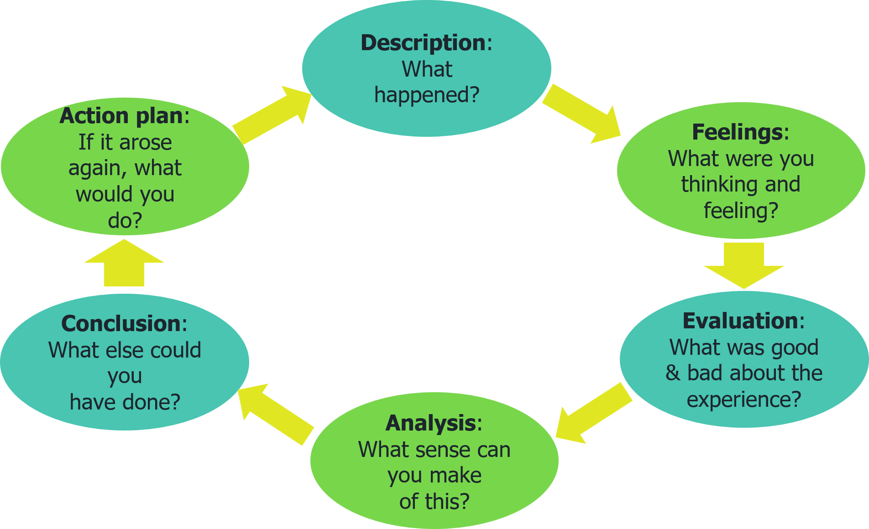

“It is not sufficient simply to have an experience in order to learn. Without reflecting upon this experience it may quickly be forgotten, or its learning potential lost. It is from the feelings and thoughts emerging from this reflection that generalisations or concepts can be generated. And it is generalisations that allow new situations to be tackled effectively.”

Gibbs G (1988). Learning by Doing: A guide to teaching and learning methods

FACTORS AFFECTING IPS IMPLIMENTATION OR SERVICE EXPANSION

Breakout activity

In groups of three/four:

- Discuss the factors you think affect implementing or expanding a successful IPS service
- Identify:

Influencing factors (positive)

Detracting factors (negative)

STAKEHOLDERS

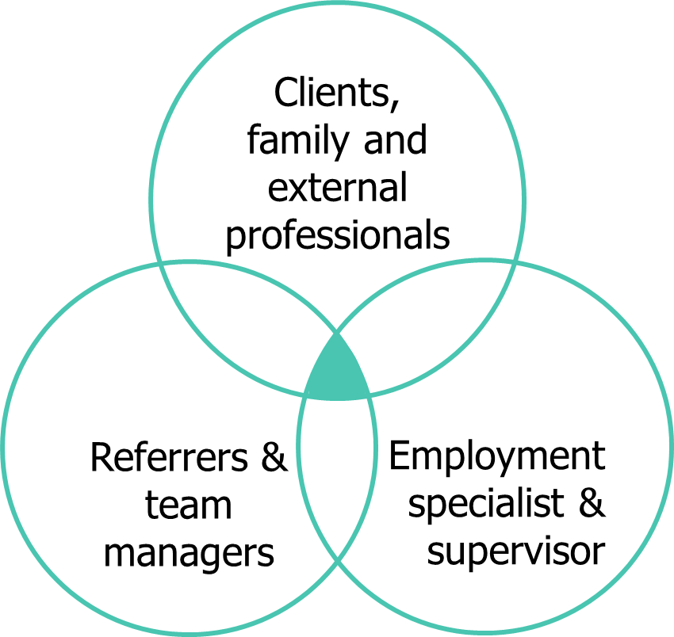
- IPS client
- Families
- External professionals who link with the service
- Treatment/support team members
- Service senior managers/executives
- Employment specialist
- IPS team supervisor/team lead
- Employers & co-workers

What practical challenges to the principles allocated to you might be raised by any of the stakeholders? What are the solutions?

COLLECTING STAKEHOLDER FEEDBACK

When I was struggling during the first few weeks, my Employment Specialist was brilliant. They phoned me and even met me after work. Without them I would not be still be at work.
My
I referred Josie to the service and she has been supported into her dream job. Great work by Sunita.
My employment specialist really gave me confidence that I could get a job. He helped me with my cv and arranged a work trial which led to full-time work. Thank you.

Just brilliant. Everyone should have access to an IPS Service.

I was worried about to explain not working for a few years but with Rob’s help I managed to get a great job and have just increased my hours.
I was so nervous but Tina was so patient. She was a great listener. She found me a job at X store. I really enjoy my job. It is great knowing that I can ring her anytime.
I was
John contacted me to say he was looking to place someone in paid work. He met with me and explain the service and how they match someone with our job and keep in contact afterwards. I can recommend this service to other Employers. And it’s all for free!
IPS CLIENT JOUREY FLOWCHART
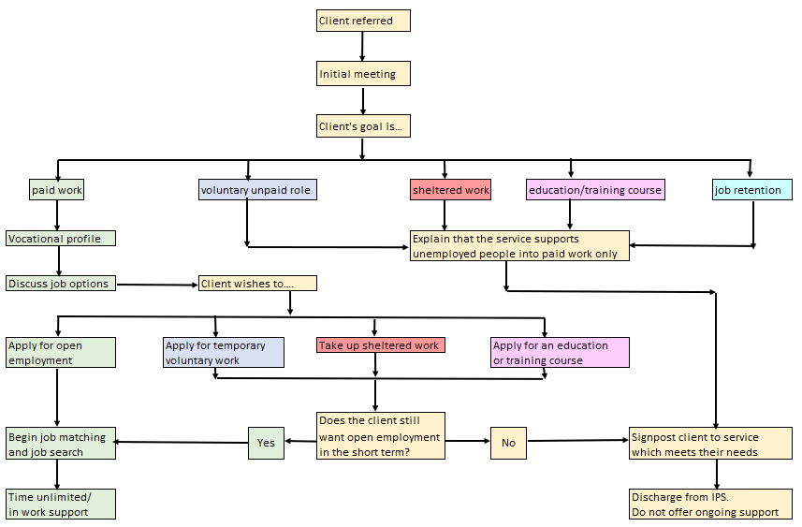
EXERCISE: MANAGER V LEADER QUALITIES

Think about the line manager (or managers) you most enjoyed working for? What was it about them or their style that you liked?

Thinking about the same ‘best line manager(s)’, write below any factors you can think of that made them more of a ‘leader’ than a ‘manager’
Manager | Leader

Breakout activity

- Reflecting on supervisory practise, work in threes/fours:
- Discuss current practice
- Reflecting on strengths-based supervision discuss:
  - what do you do well and
  - any changes you would make?

Current supervisory practice

What are the strengths?

Any practices/areas to change?

EMPLOYER DATABASE & EMPLOYER ENGAGEMENT LOGS

Example Database

Name | Address | Tel no/  Email | Name of contact/role | Hiring authority  Yes/No | Type of business | Jobs | Work  Pattern  Hours | D  A  T  E | Notes/  Next  Steps

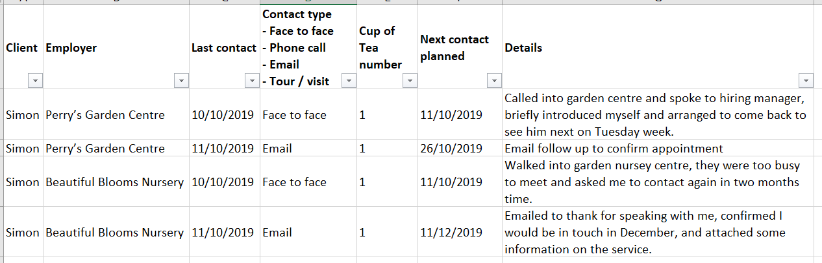
Example Employer Engagement Log

Key factors on EE

- Crucial part of the IPS process – teams should have an EE strategy
- Necessary for a high-fidelity service
- Drives job outcomes that meet preferences
- Supervisor / team leader support is essential
- All Employment Specialists should be supported via field mentoring
- Without EE, what’s left? IPS Administrative job application service
- Log all forms of EE – they are all important
- Zoom and Teams count as face-to- face but logs should ideally differentiate in-person and on-line face to face so that supervisors can monitor this
- In person EE is the gold standard as learning so much more about environment and building better relationships with the employer

IPS FIELD MENTORING OBSERVATIONS

Employer Engagement


Date:

Name of employment specialist:

Name of employer:

Items covered | Observed | notes
Client given IPS info
Was an appointment made in advance of this meeting?
Was an appointment made as a follow-up to find out more about the employer?
Did ES find out about the business? (history, locations, type of product/service provided)
Did ES find out about hiring preferences?
Did ES find out about different types of roles at employer?
Did ES find out about type of candidate employer feels is a good match? (Skills, strengths, qualifications)
Was ES following up on a client’s application?
Did ES describe a client who is a good match to employers hiring preferences?
Did ES explain service to employer?
Where there actions agreed at the end of the meeting?

Clinical Team Meeting/MDT
Date:

Name of employment specialist:

Clinical team:

Items covered | Observed | notes
ES attends whole of meeting
ES/IPS has section on agenda
ES updates team on clients
Team engages in discussion on client update
ES shares information about client’s work or education history
Team generates ideas to suggest to client
Team provide information /solutions relevant to individualised job search
Team provide information/ solutions relevant to job support
Team discuss possible referrals to ES
ES suggests possible referral to IPS for new clinical team client discussed
Are client records or documents shared during the meeting?
Are client records or documents shared during the meeting?

IPS team meeting / group supervision
Date:

IPS team observed:

Items covered | Observed | notes
IPS team has met as a vocational unit
Client successes are shared
Team discusses client challenges/ barriers as a group
Solutions and ideas developed during group discussion on challenges/ barriers are captured
ES’s share job leads
Targets and goals are shared by Service Lead with the team (i.e. total referrals, active clients, job starts, job sustainability, discharge numbers)
Team discusses engagement activity with JCP/DWP programmes
Learning and development is discussed

FIDELITY REVIEW ACTION PLANNING

Exercise: To create a fidelity review action plan for item 13 Disclosure

- Read the fictitious fidelity review report document 'Item 13 disclosure example report' on the next page.
- Based on this report, your task as IPS Supervisor/Team Leader is to write a Fidelity Review Action Plan which will improve your team's delivery of this fidelity item when supporting clients.
- This is not about suggesting actions to have new formats or new places to record the disclosure conversations, as that is already in place.

Using the format below, write down specific actions with responsibilities and deadlines, which will lead to higher fidelity scores at your next review in 6 months' time. Think SMART.

Fidelity review action plan activity: Item 13 Disclosure
Action | Responsibility | Deadline
Notes

EXAMPLE REPORT

FIDELITY ITEM 13

Disclosure

Employment specialists provide clients with accurate information and assist with evaluating their choices to make an informed decision regarding what is revealed to the employer about having a disability.

1 Point | None are present | - Employment specialists do not require all clients to disclose their psychiatric disability at the work site in order to receive services.  - Employment specialists offer to discuss with clients the possible costs and benefits (pros and cons) of disclosure at the work site in advance of clients disclosing at the work site. Employment specialists describe how disclosure relates to requesting accommodations and the employment specialist’s role communicating with the employer.  - Employment specialists discuss specific information to be disclosed (e.g. disclose receiving mental health treatment, or presence of a psychiatric disability, or difficulty with anxiety, or unemployed for a period of time, etc.) and offers examples of what could be said to employers.  - Employment specialists discuss disclosure on more than one occasion (e.g. if clients have not found employment after two months or if clients report difficulties on the job.)
2 Points | One is present
3 Points | Two are present
4 Points | Three are present
5 Points | Four are present
Comments:

It was clear from interviews with clients, employment specialists and the supervisor that there is no requirement for clients to disclose in order to receive IPS support.

Evidence to support giving credit for the other anchors was lacking. In the client records viewed, the vocational profile forms recorded only 'yes' or 'no' answers to 'would the client like to disclose?'. There was no evidence of discussing pros and cons, or the specifics of what could be disclosed, or of disclosure being discussed more than once. We also saw no evidence to support this in the sample client progress notes reviewed.

Clients interviewed recalled being asked 'do you want to disclose?', but not any discussions about what that meant, or the pros and cons of disclosure, or the details of what could or could not be said, or discussing disclosure on more than one occasion. This suggested that disclosure discussions were not taking place as defined by this item.

Service data collated by the supervisor did not provide any evidence to support giving credit for
anchors 2-4.
Recommendations:

A higher score can be achieved by ensuring that client disclosure discussions include consideration of pros and cons (anchor 2), the specific details of what can be disclosed (anchor 3), and of discussions occurring more than once (anchor 4), closely following the requirements as defined by this fidelity item.

Higher scores will be achieved if employment specialists conduct disclosure discussions as defined by this item, and use the relevant sections of the vocational profile form to initially gather and then keep updated this disclosure-related information.

We recommend that the supervisor devises then implements ways to monitor how closely the employment specialists are fulfilling the criteria for this item. The need for additional disclosure training or support for the employment specialists should be considered.
Criterion: Services
Data sourcing: MIS/CMS DOC INT OBS IEP/VP

HANDLING DIFFICULT CONVERSAIONS

Taken from IPS Grow:

Preparation Guide

This document is designed to help you to prepare to handle difficult conversations. Take the time to consider the below questions and prompts to support you in holding these discussions.

1. What do you want to achieve from this meeting (purpose)?

2. What will be covered in this meeting (agenda)?

3a. Who is attending this meeting? What is their role? Consider what will they do during the meeting and how much time will they need.

3b. Do you anticipate that they will want to discuss anything? Yes / No. Consider how this may have an impact on the agenda (maybe now it will need re-ordering?)

4. What decisions need to be made at the meeting? What is the likely impact? Consider intended and unintended consequences.

5. What issues/ barriers may emerge (past or present), and how will you overcome these?

6. Have you identified a method for recording key actions and considered how these are attributed correctly? Consider this below:

7. What emotions might emerge (in you/them) and how will you address/manage these?

8. Additional thoughts/ notes

X, Y, Z TECHNIQUE

When you said/did this ___________ (state what happened)

This is how I or others felt/reacted ___________ (share impact)

In future it would be preferable if you say/do this __________ (provide solution)

You feel ________________________________________________________________

Others have also felt ___________________________________________________________

However, they have found _______________________________________________________

You feel ________________________________________________________________

Others have also felt ___________________________________________________________

However, they have found _______________________________________________________

You feel ________________________________________________________________

Others have also felt ___________________________________________________________

However, they have found _______________________________________________________

Notes

STAFF RETENTION – BREAKOUT ACTIVITY

In groups, plan an induction programme for staff new to role and working in IPS services

- First week
- First month
- First 3 months

Notes

RUNNING ASSESSMENT CENTRES – TOP TIPS



- After telephone pre-screening identify how many candidates are being invited for face-to-face assessment. May need more than one day to assess all candidates across a range of activities.

- Identify what activities will help assess candidates (mix of role play, hybrid competency-based interview, case study, presentation).

- If there are just 3 candidates who have been shortlisted following the telephone interview and you are running short of time, you may find it beneficial to hold a 2-hour assessment which includes the role play and face to face interview only, rather than a full assessment day agenda.

- Secure sufficient numbers of assessors for the assessment as well as a coordinator to support the process to run smoothly. Consider service user involvement e.g. on panel or watching presentations.

- Book some space for the assessment – We would recommend the use of two rooms. One room for the candidate to interview, carry out the role play, presentation etc. The second room is for the waiting candidates.

- Schedule candidates into different assessment windows and manage communications.

- Create candidate and assessor timetables for each day. Consider breaks and refreshments.

- Create assessor packs including job descriptions, person specifications, activity outlines and scoresheets.

- Print assessment centre materials for each day. Collate any other resources required for the day (e.g. name labels).

- Confirm attendance with candidates 3 days before each event and manage any changes, fill gaps as required.

- Manage any reasonable adjustments for candidates with disabilities.

- Set-up assessment centre rooms as required. If possible, have someone act as receptionist.

- Greet and brief candidates and assessors to ensure they understand what the day entails and what their responsibilities are.

- Co-ordinate flow of the day and troubleshoot any issues that arise.

- Collate all scores into a spreadsheet and meet with panel to agree who should and shouldn’t be made a job offer. Consider weightings given to various activities e.g. someone may score highly on presentation but badly in interview.

CHANGE MODELS

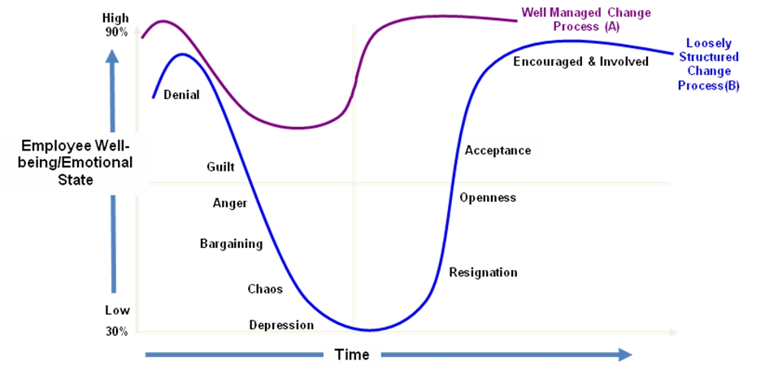

Source: https://knowhow.ncvo.org.uk/your-team/people-management-skills/change/tools/transition

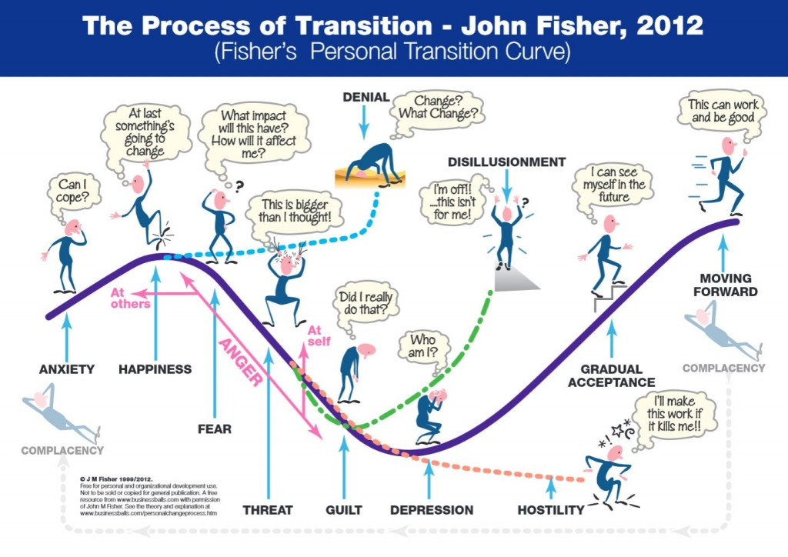

For further explanation please visit:
https://www.businessballs.com/change-management/personal-change-stages-john-fisher/

PERFORMANCE MANAGEMENT

Effective Change Communication

Communication – teams/stakeholders need to understand the why, when and how of any new change.

- Preparation – set the scene
- Sell the idea of IPS and the benefits it will bring
- Collaboration
- Involve people who will be affected
- Develop a common vision
- Listen to the challenges
- Address any fears
- Produce evidence
- Build resilience

Daam Model

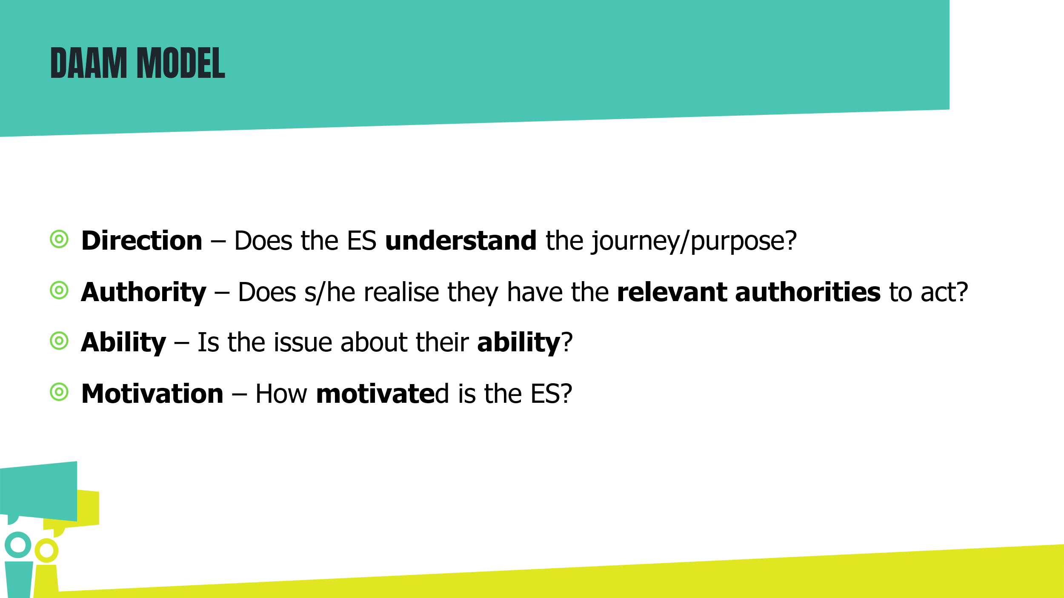

Using the Daam model is useful to understand the barrier/problem/issue that is affecting team or individual performance. Be curious as to why tasks are not being carried out by the employment specialist (ES).
Four stages to consider:

Direction – may need to revisit the “why”. (Team or service mission, IPS key principles, quality, IPS fidelity, client preference)
Authority – do they understand that they can act without waiting for confirmation from you as TL?
Ability – is coaching or additional training needed? What support do they need from you or others in order to carry out the task?
Motivation – exploring is anything else going on for them.

IPS FIDELITY SCALE

Reviewer
Employment service and site
Employment specialist
Fidelity review date | Fidelity review date |  |  | Date of previous review |  | Time elapsed since last review
Total score | Fidelity review score this review | Fidelity level this review |  |  | Fidelity review score last review | Fidelity level last review
Summary
Exemplary score | 115 – 125
Good fidelity | 100 – 114
Fair fidelity | 74 – 99
Not IPS | 73 and below

Data sources:

MIS Management Information System
DOC Document review of employment service and clinical records, NHS Trust policy and procedures
INT Interviews with clients, employment specialists, mental health staff, related programme staff, partner organisation staff, families, or employers
OBS Observations of team meetings and employment specialists
IEP Individual Employment Plan

This UK scale is a slight adaption of The Dartmouth Supported Employment Fidelity Scale. Becker, D. R., Swanson, S. J., Bond, G. R., Carlson, L., Flint, L., Smith, G., et al. (2008). Supported Employment Fidelity Scale. Lebanon, NH: Dartmouth Psychiatric Research Center.

Please note there are language adapted scales for Connect to Work, Drug and Alcohol and Primary Care settings.
FIDELITY ITEM 1

Caseload size

Employment specialists have individual employment caseloads. The maximum active caseload for any full-time employment specialist is 20 or fewer active clients. See the fidelity review manual for a full definition of active clients.

1 Point | Ratio of 41 or more clients per employment specialist
2 Points | Ratio of 31-40 clients per employment specialist
3 Points | Ratio of 26-30 clients per employment specialist
4 Points | Ratio of 21-25 clients per employment specialist
5 Points | Ratio of 20 or fewer clients per employment specialist

Who is counted as active caseload?

- A person who receives monthly outreach attempts
- A person who receives monthly services from the IPS specialist
- A working person who calls the IPS specialist occasionally (less than monthly) to say hello and update the specialist about her job is not considered to be on the caseload
- A person’s IPS case should be closed after three months without services or outreach attempts
- If a person has been referred to an IPS specialist, but has not met the specialist yet, that person is not on the caseload

FIDELITY ITEM 2

Employment services staff

Employment specialists provide only employment services and do not provide treatment case management services. However, employment specialists may also assist clients to solve a range of employment related personal problems that may be barriers to employment.

1 Point | Employment specialists provide employment services less than 60% of the time
2 Points | Employment specialists provide employment services 60 – 74% of the time
3 Points | Employment specialists provide employment services 75 - 89% of the time
4 Points | Employment specialists provide employment services 90 – 95% of the time
5 Points | Employment specialists provide employment services 96% of the time

FIDELITY ITEM 3

Vocational generalists

Each employment specialist carries out all phases of employment service, including intake, engagement, assessment, job placement, job coaching, and follow-along support before stepping down to less intensive employment support from another MH practitioner and/or peer support. Note: It is not expected that each employment specialist will provide benefits counselling to their clients. Referrals to highly trained benefits counsellors are in keeping with high fidelity (see Item 12).

1 Point | Employment specialist only provides vocational referral service to vendors and other programs
2 Points | Employment specialist maintains caseload but refers clients to other programmes for vocational services
3 Points | Employment specialist provides one to four phases of the employment service (e.g. intake, engagement, assessment, job development, job placement, job coaching, and following along supports)
4 Points | Employment specialist provides five phases of employment service but not the entire service
5 Points | Employment specialist carries out all six phases of employment service (e.g. programme intake, engagement, assessment, job development/job placement, job coaching, and follow-along sup- port)

FIDELITY ITEM 4

Integration of supported employment with treatment through team assignment

Employment specialists are part of up to 2 treatment teams from which at least 90% of the employment specialist’s caseload is comprised.

1 Point | Employment specialists are part of a vocational programme that functions separately from the treatment
2 Points | Employment specialists are attached to three of more treatment teams, OR clients are served by individual practitioners who are not organised into teams OR employment specialists are attached to one or two teams from which less than 50% off the employment specialist’s caseload is comprised
3 Points | Employment specialists are attached to one or two treatment teams, from which at least 50–74% of the employment specialist’s caseload is comprised
4 Points | Employment specialists are attached to one or two treatment teams, from which at least 75 – 89% of the employment specialist’s caseload is comprised
5 Points | Employment specialists are attached to one or two treatment teams, from which at least 90 – 100% of the employment specialist’s caseload is comprised

FIDELITY ITEM 5

Integration of supported employment with treatment through frequent team member contact

Employment specialists actively participate in weekly “client focused” meetings with the treatment team, (not replaced by administrative meetings), that discuss individual clients and their employment goals with shared decision-making. Employment specialist’s office is in close proximity to (or shared with) their treatment team members. Documentation of treatment and employment services is integrated in a single client record. Employment specialists help the team think about employment for people who haven’t yet been referred to supported employment services.

1 Point | One or none is present | - Employment specialist attends weekly client focused meetings with the treatment team.  - Employment specialist participates actively in the team meetings with shared decision-making.  - Employment services documentation (vocational assessment/profile, employment plan, progress notes) is integrated into the client’s health record.  - Employment specialist’s office is in close proximity to (or shared with) the team members.  - Employment specialist helps the team think about employment for people who haven’t yet been referred to supported employment services.
2 Points | Two are present
3 Points | Three are present
4 Points | Four are present
5 Points | Five are present

FIDELITY ITEM 6

Collaboration between employment specialists and key staff members in Government DWP programs and their contractors

Liaison is important to promote sufficient referrals and to obtain assistance with Benefits and other return to work assistance. For instance in the UK this will be Job Centre Plus and Work Programme/Work Choice Providers. The employment specialists and Government funded programme staff have frequent contact for the purposes of identifying potential referrals, discussing shared clients, and obtaining additional assistance.

1 Point | Employment specialists and Government funded programme staff have client-related contacts (phone, e-mail, in person) less than quarterly to discuss shared clients and referrals. OR employment specialists and related programme staff do not communicate
2 Points | Employment specialists and Government funded programme staff have client-related contacts (phone, e-mail, in person) at least quarterly to discuss shared clients and referrals
3 Points | Employment specialists and Government funded programme staff have client-related contacts (phone, e-mail, in person) monthly to discuss shared clients and referrals
4 Points | Employment specialists and Government funded programme staff have scheduled, face-to-face meetings at least quarterly, OR have client-related contacts (phone, e-mail, in person) weekly to discuss shared clients and referrals
5 Points | Employment specialists and Government funded programme staff have scheduled, face-to-face meetings at least monthly and have client-related contacts (phone, e-mail, in person) weekly to discuss shared clients and referrals

FIDELITY ITEM 7

Vocational unit

At least 2 full-time employment specialists and a team leader comprise the employment unit. They have weekly client-based group supervision following the supported employment model in which strategies are identified and job leads are shared. They provide coverage for each other’s caseload when needed.

1 Point | Employment specialists are not part of a vocational unit
2 Points | Employment specialists have the same supervisor but do not meet as a group. They do not provide back-up services for each other’s caseload
3 Points | Employment specialists have the same supervisor and discuss clients between each other on a weekly basis. They provide back-up services for each other’s caseloads as needed OR, if a supported employment service is in a rural area where employment specialists are geographically separate with one employment specialist at each site, the employment specialists meet 2-3 times monthly with their supervisor by teleconference
4 Points | At least 2 employment specialists and a team leader form an employment unit with 2-3 regularly scheduled meetings per month for client-based group supervision in which strategies are identified and job leads are shared and clients discussed between each other. They provide coverage for each other’s caseloads when needed OR, if a supported employment service is in a rural area where employment specialists are geographically separate with one employment specialist at each site, the employment specialists meet 2-3 times per month with their supervisor in person or by teleconference and practitioners are available to help the employment specialist with activities such as taking someone to work or picking up job applications
5 Points | At least 2 full-time employment specialists and a team leader form an employment unit with weekly client-based group supervision based on the supported employment model in which strategies are identified and job leads are shared. They provide coverage for each other’s caseloads when needed

FIDELITY ITEM 8

Role of employment supervisor

Supported employment unit is led by a supported employment team leader. Employment specialists’ skills are developed and improved through outcome-based supervision. All five key roles of the employment supervisor are present.

1 Point | One or none is present | - One full-time equivalent (FTE) supervisor is responsible for no more than 10 employment specialists. The supervisor does not have other supervisory responsibilities. (Supported employment leaders supervising fewer than ten employment specialists, may spend a percentage of time on other supervisory activities on a prorated basis. For example, an employment supervisor responsible for 4 employment specialists may be devoted to supported employment supervision half time).  - Supervisor conducts weekly supported employment supervision designed to review client situations and identify new strategies and ideas to help clients in their work lives.  - Supervisor communicates with treatment team leaders to ensure that services are integrated, to problem solve programmatic issues (such as referral process, or transfer of follow- along to treatment workers) and to be a champion for the value of work. Attends a meeting for each treatment team on a quarterly basis.  - Supervisor accompanies employment specialists, who are new or having difficulty with job development, in the field monthly to improve skills by observing, modelling, and giving feedback on skills, e.g., meeting employers for job development.  - Supervisor reviews current client outcomes with employment specialists and sets goals to improve the supported employment service performance at least quarterly
2 Points | Two are present
3 Points | Three are present
4 Points | Four are present
5 Points | Five are present

FIDELITY ITEM 9

Zero exclusion criteria

All clients interested in working have access to supported employment services, regardless of job readiness factors, substance abuse, symptoms, history of violent behaviour, cognitive impairments, treatment non-adherence, and personal presentation. These apply during supported employment services too. Employment specialists offer to help with another job when one has ended, regardless of the reason that the job ended or number of jobs held. Clients are not screened out formally or informally. See the fidelity review manual for how to score this item when the employment specialist caseload is full and no places are currently available.

1 Point | There is a formal policy to exclude clients due to lack of job readiness (e.g. substance abuse, history of violence, low level of functioning, etc.) by employment staff, case managers, or other practitioners.
2 Points | Most clients are unable to access supported employment services due to perceived lack of job readiness (e.g., substance abuse, history of violence, low level of functioning, etc.)
3 Points | Some clients are unable to access supported employment services due to perceived lack of job readiness (e.g., substance abuse, history of violence, low level of functioning, etc.).
4 Points | No evidence of exclusion, formal or informal. Referrals are not solicited by a wide variety of sources. Employment specialists offer to help with another job when one has ended, regardless of the reason that the job ended or number of jobs held.
5 Points | All clients interested in working have access to supported employment services. Practitioners encourage clients to consider employment, and referrals for supported employment are solicited by many sources. Employment specialists offer to help with another job when one has ended, regardless of the reason that the job ended or number of jobs held.

FIDELITY ITEM 10

The treatment service provider demonstrates a focus on competitive employment

The provider promotes competitive work through multiple strategies. The provider’s initial assessment includes questions about interest in employment. The provider displays written postings (e.g., brochures, bulletin boards, posters) about employment and supported employment services. The focus should be with the provider’s services for adults with severe mental illness or drug and alcohol treatment. The provider supports ways for clients to share work stories with other clients and staff. The provider measures rate of competitive employment and shares this information with Trust leadership and staff.

1 Point | One or none is present | - Provider intake includes questions about interest in employment.  - Provider includes questions about interest in employment on all annual (or semi-annual assessment or treatment plan reviews.  - Provider displays written postings (e.g., brochures, bulletin boards, posters) about working and supported employment services, in lobby and other waiting areas.  - Provider supports ways for clients to share work stories with other clients and staff (e.g. provider-wide employment recognition events, in-service training, peer support groups, newsletter articles, invited speakers at client treatment groups, etc.) at least twice a year.  - Provider measures rate of competitive employment on at least a quarterly basis and shares outcomes with Trust leadership and staff.
2 Points | Two are present
3 Points | Three are present
4 Points | Four are present
5 Points | Five are present

FIDELITY ITEM 11

Executive team support for supported employment

Provider executive team members (e.g. CEO/ executive director, chief operating officer, QA director, chief financial officer, clinical director, medical director, human resource director) assist with supported employment implementation and sustainability. All five key components of executive team support must be present for a score of 5.

1 Point | One or none is present | - Executive director and clinical director demonstrate knowledge regarding the principles of evidence-based supported employment. Provider quality assurance process includes an explicit review of the supported employment programme, or components of the programme, at least every 6 months through the use of the supported employment fidelity scale or until achieving high fidelity, and at least yearly thereafter. Provider quality assurance process uses the results of the fidelity assessment to improve supported employment implementation and sustainability.  - At least one member of the executive team actively participates at supported employment leadership team meetings (steering committee meetings) that occur at least every six months for high fidelity programmes and at least quarterly for programmes that have not yet achieved high fidelity. Steering committee is defined as a diverse group of stakeholders charged with reviewing fidelity, programme implementation and the service delivery system. Committee develops written action plans aimed at developing or sustaining high fidelity services.  - The provider CEO/executive director communicates how supported employment services support the mission of the provider and articulates clear and specific goals for supported employment and/or competitive employment to all provider staff during the first six months and at least annually (i.e., supported employment kick-off, all-provider meetings, newsletters, etc). This item is not delegated to another administrator.  - The IPS service leader shares information about IPS evidence based barriers (difficulties) and facilitators (successes) with the provider executive team (including the CEO) at least twice each year. The executive team helps the service leader identify and implement solutions to barriers.
2 Points | Two are present
3 Points | Three are present
4 Points | Four are present
5 Points | Five are present

FIDELITY ITEM 12

Work incentives planning

All clients are offered assistance in obtaining comprehensive individualised work incentives planning before starting a new job and assistance accessing work incentives planning thereafter when making decisions about changes in work hours and pay. Work incentives planning includes the impact on all sources of income and fringe benefits (Personal independence payments, travel concession, DLA, Working Tax Credits, Universal Credit etc.) and all costs associated with commencing or changing employment. Clients are provided information and assistance about reporting earnings to any other programme that needs to know the new income details (e.g. Housing, Council Tax, HMRC etc).

1 Point | Work incentives planning is not readily available or easily accessible to most clients served by the IPS service.
2 Points | Employment specialist gives client contact information about where to access information about work incentives planning.
3 Points | Employment specialist discusses with each client changes in benefits based on work status.
4 Points | Employment specialist or other practitioner offers clients assistance in obtaining comprehensive, individualised work incentives planning by a person trained in work incentives planning prior to client starting a job.
5 Points | Employment specialist or other practitioner offer clients assistance in obtaining comprehensive, individualised work incentives planning by a specially trained work incentives planner prior to starting a job. They also facilitate access to work incentives planning when clients need to make decisions about changes in work hours and pay. Clients are provided information and assistance about reporting earnings to DWP, housing programmes, etc. depending on the person’s benefits.

FIDELITY ITEM 13

Disclosure

Employment specialists provide clients with accurate information and assist with evaluating their choices to make an informed decision regarding what is revealed to the employer about having a disability.

1 Point | None are present | - Employment specialists do not require all clients to disclose their psychiatric disability at the work site in order to receive services.  - Employment specialists offer to discuss with clients the possible costs and benefits (pros and cons) of disclosure at the work site in advance of clients disclosing at the work site. Employment specialists describe how disclosure relates to requesting accommodations and the employment specialist’s role communicating with the employer.  - Employment specialists discuss specific information to be disclosed (e.g. disclose receiving treatment, or presence of a psychiatric disability, or difficulty with anxiety, or unemployed for a period of time, etc.) and offers examples of what could be said to employers.  - Employment specialists discuss disclosure on more than one occasion (e.g. if clients have not found employment after two months or if clients report difficulties on the job.)
2 Points | One is present
3 Points | Two are present
4 Points | Three are present
5 Points | Four are present

FIDELITY ITEM 14

Ongoing, work-based vocational assessment

Initial vocational assessment occurs over 2-3 sessions and is updated with information from work experiences in competitive jobs. A vocational profile form that includes information about preferences, experiences, skills, current adjustment, strengths, personal contacts, etc., is upgraded with each new job experience. Aims at problem solving using environmental assessments and consideration of reasonable accommodations. Sources of information include the client, treatment team, clinical records and with the client’s permission, information from family members and previous employers.

1 Point | Vocational evaluation is conducted prior to job placement with emphasis on office-based  assessments, standardised tests, intelligence tests, work samples.
2 Points | Vocational assessment may occur through a stepwise approach that includes: revocational work experiences (e.g., work units in a day programme), volunteer jobs, or set aside jobs (e.g. provider-run businesses, sheltered workshop jobs, affirmative businesses, enclaves).
3 Points | Employment specialists assist clients in finding competitive jobs directly without systematically reviewing interests, experiences, strengths etc. and do not routinely analyse job loss (or job problems) for lessons learned.
4 Points | Initial vocational assessment occurs over 2-3 sessions in which interests and strengths are explored. Employment specialists help clients learn from each job experience and also work with the treatment team to analyse job loss, job problems and job successes. They do not document these lessons learned in the vocational profile, OR the vocational profile is not updated on a regular basis.
5 Points | Initial vocational assessment occurs over 2-3 sessions and information is documented on a vocational profile form that includes preferences, experiences, skills, current adjustment, strengths, personal contacts, etc. The vocational profile form is used to identify job types and work environments. It is updated with each new job experience. Aims at problem solving using environmental assessments and consideration of reasonable accommodations. Sources of information include the client, treatment team, clinical records, and with the client’s permission, from family members and previous employers. Employment specialists help clients learn from each job experience and also work with the treatment team to analyse job loss, job problems and job successes.

FIDELITY ITEM 15

Rapid job search for competitive job

Initial employment assessment and first face-to- face employer contact by the client or the employment specialist about a competitive job occurs within 30 days (one month) after programme entry.

1 Point | First face-to-face contact with an employer by the client of the employment specialist about a competitive job is on average 271 days or more (>9months) after programme entry.
2 Points | First face-to-face contact with an employer by the client or the employment specialist about a competitive job is on average 151 and 270 days (5-9 months) after programme entry.
3 Points | First face-to-face contact with an employer by the client or the employment specialist about a competitive job is on average between 61 and 150 days (2-5 months) after a programme entry.
4 Points | First face to face contact with an employer by the client or the employment specialist about a competitive job is on average between 31 and 60 days (1-2 months) after programme entry.
5 Points | The programme tracks employer contacts and the first face-to-face contact with an employer by the client or the employment specialist about a competitive job is on average within 30 days (one month) after programme entry.

FIDELITY ITEM 16

Individualised job search

Employment specialists make employer contacts aimed at making a good job match based on client’s preferences (relating to what each person enjoys and their personal goals) and needs (including experience, ability, symptoms, health, etc) rather than the job market (i.e., those jobs that are readily available). An individualised job search plan is developed and updated with information from the vocational assessment/ profile form and new job/educational experiences.

1 Point | Less than 25% of employer contacts by the employment specialist are based on job choices which reflect client’s preferences, strengths, symptoms, etc. rather than the job market.
2 Points | 25-49% of employer contacts by the employment specialist are based on job choices which reflect client’s preferences, strengths, symptoms, etc. rather than the job marked.
3 Points | 50-74% of employer contacts by the employment specialist are based on job choices which reflect client’s preferences, strengths, symptoms, etc., rather than the job market.
4 Points | 75-89% of employer contacts by the employment specialist are based on job choices which reflect client’s preferences, strengths, symptoms, etc., rather than the job market and are consistent with the current employment plan.
5 Points | Employment specialists makes employer contacts based on job choices which reflect client’s preferences, strengths, symptoms, lessons learned from previous jobs etc., 90-100% of the time rather than the job market and are consistent with the current employment/job search plan. When clients have limited work experience, employment specialists provide information about a range of job options in the community.

FIDELITY ITEM 17

Job development - frequent employer contact

Each employment specialist makes at least 6 face-to-face employer contacts per week on behalf of clients looking for work (rate for each week then calculate average and use the closest scale point). An employer contact is counted even when an employment specialist meets the same employer more than one time in a week, and when the client is present or not present. Client-specific and generic contacts are included. Employment specialists use a weekly tracking form to document employer contacts.

1 Point | Employment specialist makes less than 2 face-to-face employer contacts that are client-specific per week.
2 Points | Employment specialist makes 2 face-to-face employer contacts per week that are client- specific; OR does not have a process for tracking.
3 Points | Employment specialist makes 4 face-to-face employer contacts per week that are client-specific, and uses a tracking form that is reviewed by the supported employment supervisor on a monthly basis.
4 Points | Employment specialist makes 5 face-to-face employer contacts per week that are client-specific, and uses a tracking form that is reviewed by the supported employment supervisor on a weekly basis.
5 Points | Employment specialist makes 6 or more face-to-face employer contacts per week that are client specific, or 2 employer contacts times the number of people looking for work when there are less than 3 people looking for work on their caseload (e.g., new programme). In addition, employment specialist keeps records that can be reviewed by a supervisor on a weekly basis.

FIDELITY ITEM 18

Job development - quality of employer contact

Employment specialists build relationships with employers through multiple visits in person that are planned to learn the needs of the employer, convey what the supported employment programme offers to the employer, describe client strengths that are a good match for the employer (rate for each employment specialist, then calculate average and use the closest scale point).

1 Point | Employment specialist meets employer when helping client to turn in job applications, OR employment specialist rarely makes employer contacts.
2 Points | Employment specialists contacts employer to ask about job openings and then shares these “leads” with clients.
3 Points | Employment specialist follows up on advertised job openings by introducing self, describing programme, and asking employer to interview client.
4 Points | Employment specialist meets with employers in person whether or not there is a job opening, advocates for clients by describing strengths and asks employers to interview clients.
5 Points | Employment specialist builds relationships with employers through multiple visits in person that are planned to learn the needs of the employer, convey what the supported employment programme offers to the employer, describe client strengths that are a good match for the employer.

FIDELITY ITEM 19

Diversity of job types

Employment specialists assist clients in obtaining different types of jobs.

1 Point | Employment specialists assist clients to obtain different types of jobs less than 50% of the time.
2 Points | Employment specialists assist clients to obtain different types of jobs 50-59% of the time.
3 Points | Employment specialists assist clients to obtain different types of jobs 60-69% of the time.
4 Points | Employment specialists assist clients to obtain different types of jobs 70-84% of the time.
5 Points | Employment specialists assist clients to obtain different types of jobs 85-100% of the time.

FIDELITY ITEM 20

Diversity of employers

Employment specialists assist clients in obtaining jobs with different employers.

1 Point | Employment specialists assist clients to obtain jobs with different employers less than 50% of the time.
2 Points | Employment specialists assist clients to obtain jobs with the same employers 50-59% of the time.
3 Points | Employment specialists assist clients to obtain jobs with different employers 60-69% of the time.
4 Points | Employment specialists assist clients to obtain jobs with different employers 70-84% of the time.
5 Points | Employment specialists assist clients to obtain jobs with different employers 85-100% of the time.

FIDELITY ITEM 21

Competitive jobs

Employment specialists provide competitive job options that have permanent status rather than temporary or time-limited status, e.g. transitional employment positions. Competitive jobs pay at least the minimum wage, are jobs that anyone can apply for and are not set aside for people with disabilities. (Seasonal jobs and jobs from temporary agencies that other community members use are counted as competitive jobs)

1 Point | Employment specialists provide options for permanent, competitive jobs less than 64% of the time, OR there are fewer than 10 current jobs.
2 Points | Employment specialists provide options for permanent, competitive jobs about 65-74% of the time.
3 Points | Employment specialists provide options for permanent competitive jobs about 75-84% of the time.
4 Points | Employment specialists provide options for permanent competitive jobs about 85-94% of the time.
5 Points | 95% or more competitive jobs held by clients are permanent.

FIDELITY ITEM 22

Individualised follow-along support

Clients receive different types of in-work support that are based on the job, client preferences, work history, needs, etc. Supports are provided by a variety of people, including treatment team members (e.g. medication changes, social skills training, encouragement), family, friends, co-workers (i.e. natural supports), and employment specialist. Employment specialist also provides employer support (e.g. educational information, job accommodations) at client’s request. Employment specialist offers help with career development, i.e. assistance with education, a more desirable job, or more preferred job duties.

1 Point | Employment specialist does not meet face-to-face with the client after the first month of starting a job.
2 Points | Employment specialist has face-to-face contact with less than half of the working clients for at least 4 months after starting a job.
3 Points | Employment specialist has face-to-face contact with at least half of the working clients for at least 4 months after starting a job.
4 Points | Employment specialist has face-to-face contact with working clients weekly for the first month after starting a job, and at least monthly for a year or more, on average, after working steadily, and as desired by clients.
5 Points | Employment specialist has face-to-face contact within 1 week before starting a job, within 3 days after starting a job, weekly for the first month, and at least monthly for a year or more, on average, after working steadily and as desired by clients. Clients may be transitioned to intermittent support, or regular monitoring, following steady employment. Employment specialist contacts clients within 3 days of hearing about the job loss.

FIDELITY ITEM 23

Time-unlimited follow-along supports

Employment specialists have face-to-face contact within 1 week before starting a job, within 3 days after starting a job, weekly for the first month, and at least monthly for a year or more, on average, after working steadily and as desired by clients. Clients are transitioned to step down job supports from a provider worker following steady employment. Employment specialists contact clients within 3 days of learning about the job loss

1 Point | Employment specialist does not meet face-to-face with the client after the first month of starting a job.
2 Points | Employment specialist has face-to-face contact with less than half of the working clients for at least 4 months after starting a job.
3 Points | Employment specialist has face-to-face contact with at least half of the working clients for at least 4 months after starting a job.
4 Points | Employment specialist has face-to-face contact with working clients weekly for the first month after starting a job, and at least monthly for a year or more, on average, after working steadily, and as desired by clients.
5 Points | Employment specialist has face-to-face contact within 1 week before starting a job, within 3 days after starting a job, weekly for the first month, and at least monthly for a year or more, on average, after working steadily and as desired by clients. Clients may be transitioned to intermittent support, or regular monitoring, following steady employment. Employment specialist contacts clients within 3 days of hearing about the job loss.

FIDELITY ITEM 24

Community-based services

Employment services such as client engagement, job finding and follow-along supports are provided in natural community settings by all employment specialists. (Rate each employment specialist based upon their total weekly scheduled work hours, then calculate the average and use the closest scale point).

1 Point | Employment specialist spends 30% time or less in the scheduled work hours in the community.
2 Points | Employment specialist spends 30-39% time of total scheduled work hours in the community.
3 Points | Employment specialist spends 40-49% of total scheduled work hours in the community.
4 Points | Employment specialist spends 50-64 % of total scheduled work hours in the community.
5 Points | Employment specialist spends 65% or more of total scheduled work hours in the community.

65% of 37.5 hours per week = 24.5 hours in the community, and 13 hours in the office. That’s about 2.7 hours per day.

What counts as community time?
- Meeting with clients in community settings, client homes, libraries, parks, coffee shops, restaurants, career profile activities out of the office, etc.
- Accompanying clients to job centre appointments, meetings at job centre offices.
- Travel time from one work destination to another.
- Face to face job development, sitting in on interviews, business tours.
- Observing/visiting someone at the job site.
- Accompanying someone to an appointment regarding benefits. e.g. Citizens Advice or job centre
- Attending a benefits analysis meeting with a client
- Meeting with the housing authority on how employment could affect their rent.
- Meeting at schools, colleges and local career centres.

What does not count as community time?
- Vocational unit meetings in the community
- Writing notes in the community
- Virtual job development
- Client meetings in the office
- Treatment team meetings
- Meeting with clients in group homes, day programs and other agency offices.

FIDELITY ITEM 25

Assertive engagement and outreach by integrated treatment team

Service termination is not based on missed appointments or fixed time limits. There is systematic documentation of outreach attempts. Engagement and outreach attempts are made by integrated team members. Multiple home/community visits. Coordinated visits by employment specialist with integrated team member. Connect with family, when applicable. Once it is clear that the client no longer wants to work or continue supported employment services, the team stops outreach.

1 Point | Evidence that 2 or less strategies for engagement and outreach are used. | - Service termination is not based on missed appointments or fixed time limits.  - Systematic documentation of outreach attempts.  - Engagement and outreach attempts made by integrated team members.  - Multiple home/community visits.  - Coordinated visits by employment specialist with integrated team member.  - Connect with family, when applicable.
2 Points | Evidence that 3 strategies for engagement and outreach are used.
3 Points | Evidence that 4 strategies for engagement and outreach is used.
4 Points | Evidence that all 5 strategies for engagement and outreach is used.
5 Points | Evidence that all 6 strategies for engagement and outreach are used.

SCORE SUMMARY

Element |  | Last fidelity review | This fidelity review | Change in score
Staffing
1 | Number on caseload
2 | Employment services staff
3 | Vocational generalists
Organisation
4 | Integration with CMHT through team assignment
5 | Integration with CMHT through frequent contact
6 | Collaboration between employment specialists and JC+/WP
7 | Vocational unit
8 | Role of employment supervisor
9 | Zero exclusion criteria
10 | Provider focus on competitive employment
11 | Executive team support
Services
12 | Work incentives planning
13 | Disclosure
14 | Ongoing, work-based vocational assessment
15 | Rapid search for competitive job
16 | Individualised job search
17 | Job development – frequent employer contact
18 | Job development – quality of employer contacts
19 | Diversity of job types
20 | Diversity of employers
21 | Competitive jobs
22 | Individualised follow-along supports
23 | Time-unlimited follow-along supports
24 | Community-based services
25 | Assertive engagement and outreach by integrated team
Total score
Maximum IPS score

USING DATA TO IMPROVE PERFORMANCE

Breakout activity:

You are the IPS service manager, responsible for overall performance. In your groups, look at the graph below.

1. What is the graph telling you?

2. What are you going to do about it?

In particular, consider:
What factors might lie behind team A’s performance?
To test your theories:
- What further data would you look at?
- What other actions would you take?

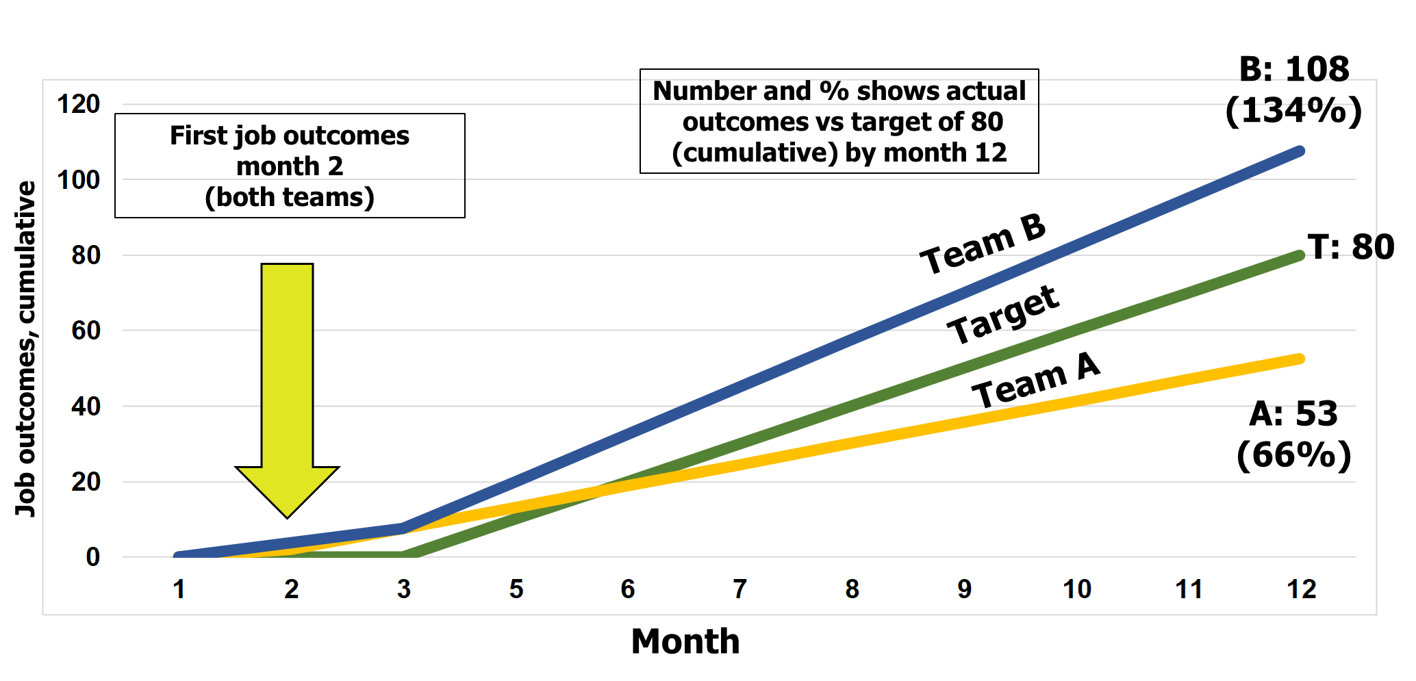

Johari Window
is a psychological tool created by Joesph Luft and Harry Ingham in 1955

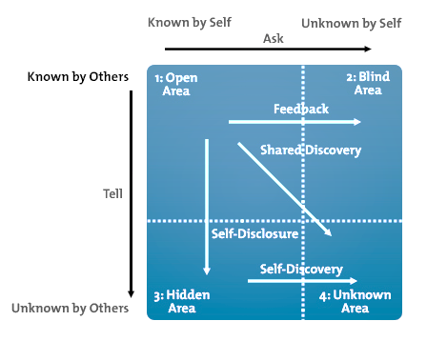

Notes

Health and safety executive management standards

Source: https://www.hse.gov.uk/stress/standards

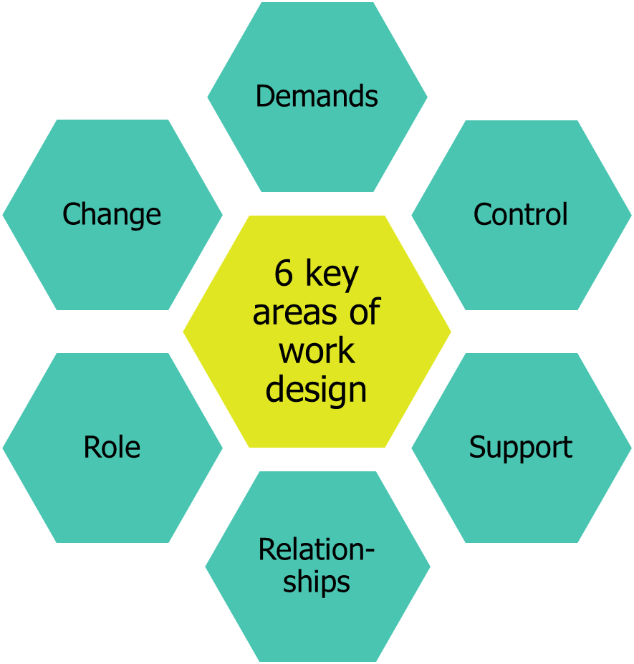

NICE guideline: workplace health: management practices

Source: NICE guideline [NG13]: Workplace health: Management practices. https://www.nice.org.uk/guidance/ng13

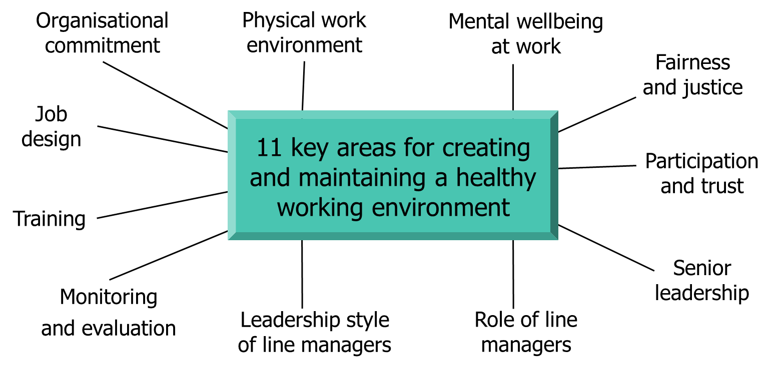

WHAT IS PSYCHOLOGICAL SAFETY

“Psychological safety is a belief that one will not be punished or
humiliated for speaking up with ideas, questions, concerns or
mistakes and that the team is safe for inter-personal risk taking.”
Amy Edmonson
Amy C. Edmondson is an American scholar of leadership, teaming, and organizational learning.^{[1]} She is currently Professor of Leadership at Harvard Business School.^{[2][3]} Edmondson is the author of seven books and more than 75 articles and case studies.^{[4]} She is best known for her pioneering work on psychological safety, which has helped spawn a large body of academic research in management, healthcare and education over the past 15 years. Her books include "Right Kind of Wrong, the Science of Failing Well" (September 5, 2023),^{[5]} “The Fearless Organization,Creating Psychological Safety in the Workplace for Learning, Innovation, and Growth” (2018)^{[6]}) and “Teaming: How Organizations Learn, Innovate and Compete in the Knowledge Economy” (2012).

PS AUDIT - SELF-REFLECTION
Self-reflection:
- If someone makes a mistake in the team - will it be used against them?
- Do people feel comfortable raising problems and challenging issues?
- Do people reject others for being different?
- Does it feel safe for employment specialists to take risks?
Secondary questions:
- “if not, why not?” or “If so, why is this?”.

CORE COMPONENTS/VALUES IN IPS TEAMS
- Trust & Inclusivity – Creating an environment where diverse perspectives are valued.
- Open Communication – Encouraging staff to voice concerns without fear of retribution.
- Supportive Leadership – Managers modeling vulnerability and fostering a culture of learning.
- Reflexivity & Learning – Teams regularly reviewing challenges and successes to improve.

GROUP ACTIVITY
Group 1 - Trust & Inclusivity
Group 2 - Open Communication
Group 3 - Supportive Leadership
Group 4 - Reflexivity & Learning
- Discuss how you build and support this component in your service?
- Think about the opportunities?
- Have you any examples of good practice to share?
- Appoint a spokesperson to feedback.
Notes

COACHING – GROW MODEL

Goal – what do want to achieve?
Reality – where are you now?
Options – What could you do?
Will – What will you do?

4 STEPS

DEFINING CLEAR GOALS | Think of and write down one professional goal for yourself
Goal:
UNDERSTANDING REALITY | List three factors impacting progress toward your goal
1.
2.
3.
IDENTIFYING POSSIBLE PATHS FORWARD | List three possible solutions to one obstacle you face
1.
2.
3.
WILL (COMMITMENT AND ACTION) | Choose one action/solution to implement within the next week
Think SMART:

BREAKOUT ACTIVITY – PAIRS OR THREES

Task: Each person shares a current challenge they want coaching on one at a time.
Guide them through the GROW model by asking structured questions:
Goal: "What do you want to achieve?"
Reality: "Where are you now? What obstacles exist?"
Options: "What solutions could work?"
Will: "What will you commit to doing next?"

EMPLOYER ENGAGEMENT

GROUP ACTIVITY

Discuss how could you deal with the following response from your employment specialist in supervision: -
- Group 1 - my client isn’t ready yet.
- Group 2 - my client doesn’t want to disclose so I can’t do employer engagement.
- Group 3 - my client turned down the last two roles I found them and don’t want to be in that position again with an employer.
- Group 4 – I was planning to but I don’t have time with all the other parts of the job

BUILDING AND AN EE STRATEGY - KEY ELEMENTS

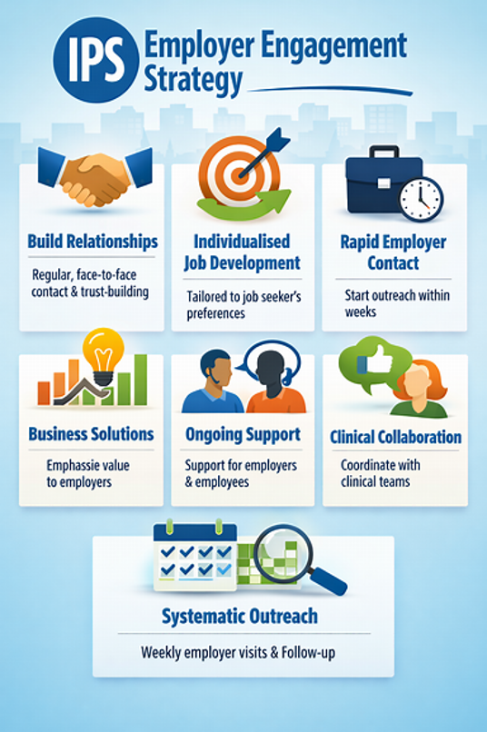
Why we do employer engagement
How it can benefit the person
How it can benefit the employer
How it can benefit the employment specialist

How we do it
3 Cups of Tea/Stepped Approach
Good vocational profile – know the client’s work preferences and any adjustments
Agreements on sharing personal information
Planned outreach – research local market
Frequency – 6 face-to-face/zoom contacts per week
Building relationships with employers
Ongoing support to both employer and client incl. in work support plans
Collaborating with clinical teams, families or other agencies involved with the client
Recording and documentation

Role of Team Leader
Support and training using field mentoring
Reflection – what went well

Remember creating an EE strategy with the team is good co-production and helps with buy-in. Having a defined strategy sets clear expectations and enables good quality EE.
FAQ’S

WHO IS COUNTED AS ACTIVE CASELOAD?
- A person who receives monthly outreach attempts
- A person who receives monthly services from the IPS specialist
- A working person who calls the IPS specialist occasionally (less than monthly) to say hello and update the specialist about her job is not considered to be on the caseload
- A person’s IPS case should be closed after three months without services or outreach attempts
- If a person has been referred to an IPS specialist, but has not met the specialist yet, that person is not on the caseload

NOTES


LEADING FOR EXCELLENCE: TRAINING FOR IPS SUPERVISORS
COURSE MANUAL

Visit our website for more IPS information and resources.

www.centreformentalhealth.org.uk

© Centre for Mental Health, 2023
Some items adapted from Dartmouth Psychiatric Research Center, New Hampshire, USA.

