INDIVIDUAL PLACEMENT & SUPPORT

TEAM LEADER TRAINING


COURSE MANUAL
Welcome
We are delighted that you have been able to join this new 4-day IPS Leadership course, commissioned by NHS England and designed for IPS Team Leaders or IPS Supervisors working in secondary mental health services.
Developed in collaboration with Centre for Mental Health, Social Finance and IPS Grow, this course focuses on the core knowledge and key skills required to establish and lead high performing IPS services.
This training is being delivered virtually across 4 days using a mixture of presentation, group work, digital breakout rooms, polls, coursework, action learning sets, self-directed learning, and individual learning logs.
The course will cover:
- The leadership role of employment supervisor/team leader
- Specialist skills development for employment specialists and the wider team
- Measuring and improving outcomes for clients
- Managing culture, reducing stigma, and addressing bias
- Coaching, supervision, and support
- Building personal relationships
- Multi-disciplinary team working
- Dealing with challenges and problem solving in IPS
- Working across teams, services, and organisations
- Understanding the IPS client base and assessing/managing risks
- Evaluating impact of the IPS service, governance, planning and development
- Research, evaluation, and development of the IPS service
This workbook mirrors the course content over the four training days. It contains some information to supplement presentations, details of exercises and links to further resources. This version is supplied as an online document.
In order to maximise your learning please ensure that you set aside time to complete additional tasks including considering how you are embedding the learning by use of reflective logs.
We hope that you enjoy the course.
Contents
Day 1 Introduction, The IPS Team Leader, Communication 3
Day 2 Recruitment, Supervision & Staff Wellbeing 34
Day 3 Quality, Performance & Change 45
Day 4 Technical Competencies & Data Management 68
Reflective log template 80
Assignments options 81
Appendix 1 – Employer Engagement Checklist 83
Appendix 2 – Client Meeting Checklist 85
Appendix 3 – IPS Providers SWOT Template 87
Appendix 4 – Race Equity Plan & Anchors 88

DAY 1

Introduction to Reflective Practice

Journal writing and reflective practice has been recognised by educators for many years as an effective strategy to promote reflective thinking and learning. It is by making connections between our experiences that we create meaning and internalise our learning.
Your Learning Journal will enable you to create a record of the connections and meanings you are making as you engage in learning experiences and your daily work. They are very personal, and no two people will have exactly the same response to any one experience.
If done conscientiously, your reflections in your Learning Journal will record most of the important things you learn during our time together and throughout your development in the months ahead.

Helpful hints for using your Learning Journal over the next few months:
- Do something different, use colour, use diagrams, draw pictures, cut out articles or pictures from magazines
- Be creative, imaginative, and descriptive. Write artistically if you want.
- Begin asking yourself these questions: "What?", "So what?" and "Now what?"
- Listen as your mind makes connections.
- Paste in sayings and quotes.
- Go paper or digital based on your preference.

Helpful hints for using your learning journal post training:
- Make a few notes during an event by capturing a few thoughts that go fleeting across your mind as you witness or observe the event.
- Note the name of the event, the date and time of each entry to provide a sense of continuity and reference point.
- The best time to make an entry in your Learning Journal is as soon as possible after the event takes place.
- Try "flow writing" rapidly following your intuition. Do not stop to judge what you have written.
- Periodically re-read your Learning Journal entries. They will provide more to write in your ongoing reflections.

We offer the Gibbs Reflective Learning Cycle as a way to formerly review your experience:
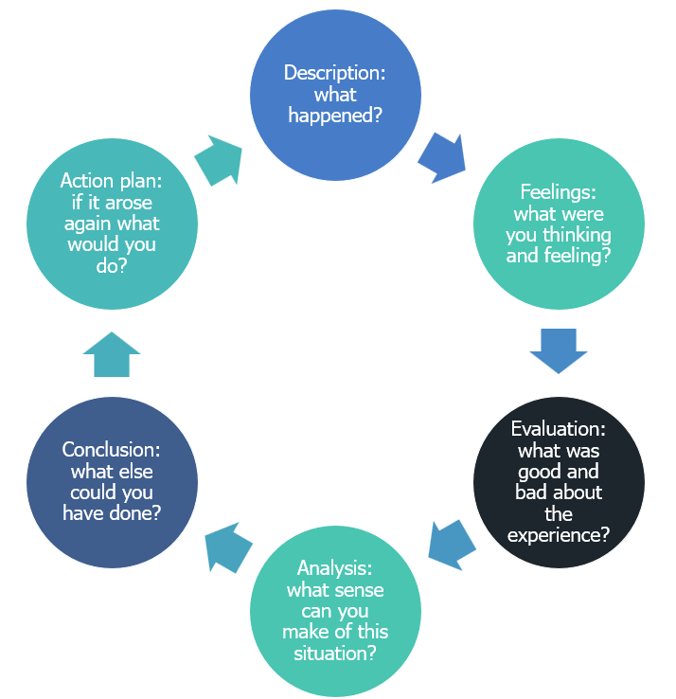

Individual Tasks:

- Reflection:

- Explore how to make reflection and keeping a journal a standard practice.
- When to complete?
- What to write?
- Who to review with?

- Complete a reflection on your own leadership style:

Complete the leadership style quiz and write a reflection on what you have learnt about yourself.

https://www.mindtools.com/pages/article/leadership-style-quiz.htm

Reflective Journal Template
A reflective journal is a place to document your reflection entries. It can be something good or bad that has happened to you that you can self-reflect on and learn from past experiences. A reflective journal can help you to identify important learning events that had happened in your life:
What happened? | Describe what happened:
What were your feelings? | Consider how this made you feel/react?
Evaluate what was good or bad about the experience? | Link this to task, relationship, or process.
Analysis | What can you make of this situation?
Conclusion | General thoughts/feeling and what else could you have done?
ACTION PLAN | If this situation arose again – what would you do differently?
Role of the supervisor
Session aims and objectives:
- Improve the level of specific IPS supervision provided to employment specialists and both the confidence and competence of those providing this support
- Increased knowledge of IPS supervisor duties and the rationale for this
- Provide examples of exemplary practice.
- Distinguish between the role of the supervisor and team manager duties.

Can you think of the designated duties for the different parts of the role?
Managerial responsibilities | Supervisory responsibilities

Skills and competencies of the IPS Supervisor


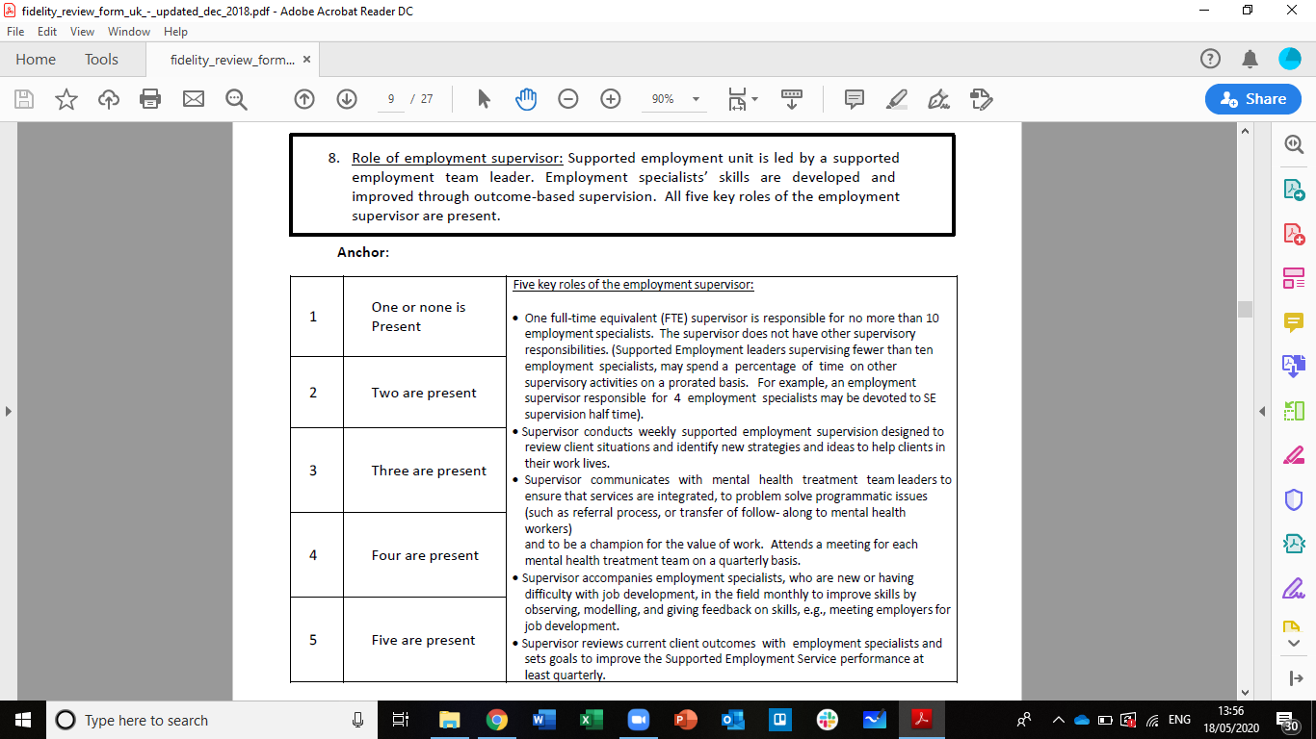
In your groups discuss your current practice and the evidence you have to support fidelity.
For each group member, document evidence and provide fidelity rating for this item and 1 recommendation
1.
2
3

Thinking about your current needs?
What support do you need? | What can you get this from? | What do you currently do?

Communication in multiple settings

Aims:
For participants to be able to identify key stakeholders and key partners to support their service and have a range of tools to engage, influence and manage these stakeholders and where necessary undertake effective complex meetings and communication.

Objectives:
- Gain a stakeholder mapping framework to identify key stakeholders and how to influence and keep them engaged.
- Gain understanding of how to work with conflict
- Gain a difficult conversation framework
- Gain ideas for application into different IPS settings

Managing and influencing stakeholders
The international standard providing guidance on social responsibility, called ISO 26000, defines a stakeholder as an:
"individual or group that has an interest in any decision or activity of an organisation."

Why is stakeholder management important?
Can you think of other reasons why stakeholder management is important?

Team focus | Supervisory responsibilities
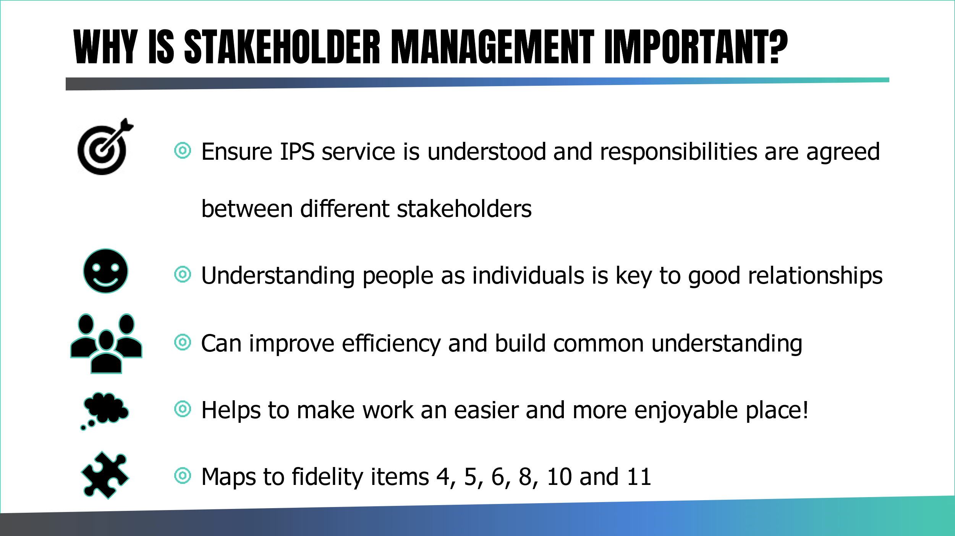

Stakeholder Mapping Matrix as a Stakeholder Management Tool
Do you know what a stakeholder mapping matrix is? A stakeholder mapping matrix is one of the most important stakeholder management tools that provide many benefits such as identifying key stakeholders, understanding their requirements, and planning the type of communications they need.
A successful service should deal with your stakeholders by classifying, evaluating, and managing them to maximise your impact and reach given a service cannot exist without stakeholder participation.
Stakeholder definition is as follows: Stakeholders are individuals, organisations, or anybody who affect the service and will be affected by it. For example, people who are involved in your service such as the service user/client, managers, and team members are some of your stakeholders.
Key stakeholders may be inside or outside the Service. Stakeholders are interested in the success of the project, and they can influence the IPS Service success. As a Team Leader, if you do not manage your stakeholders carefully, your life will be more difficult because they may slow down processes due to lack of engagement or they may come to you with never-ending demands.
Once you have created the list of key stakeholders and classified them according to their roles, the next step is to map the stakeholders accordingly.
In order to deal with your stakeholders, you need to identify and classify them according to their influence/power and interest. Ideally early on in your service mobilisation, you need to follow the stakeholder mapping process as seen in the table below to map your stakeholders and in turn develop ways of engaging with them based on their influence/power to help shape the success of the service.
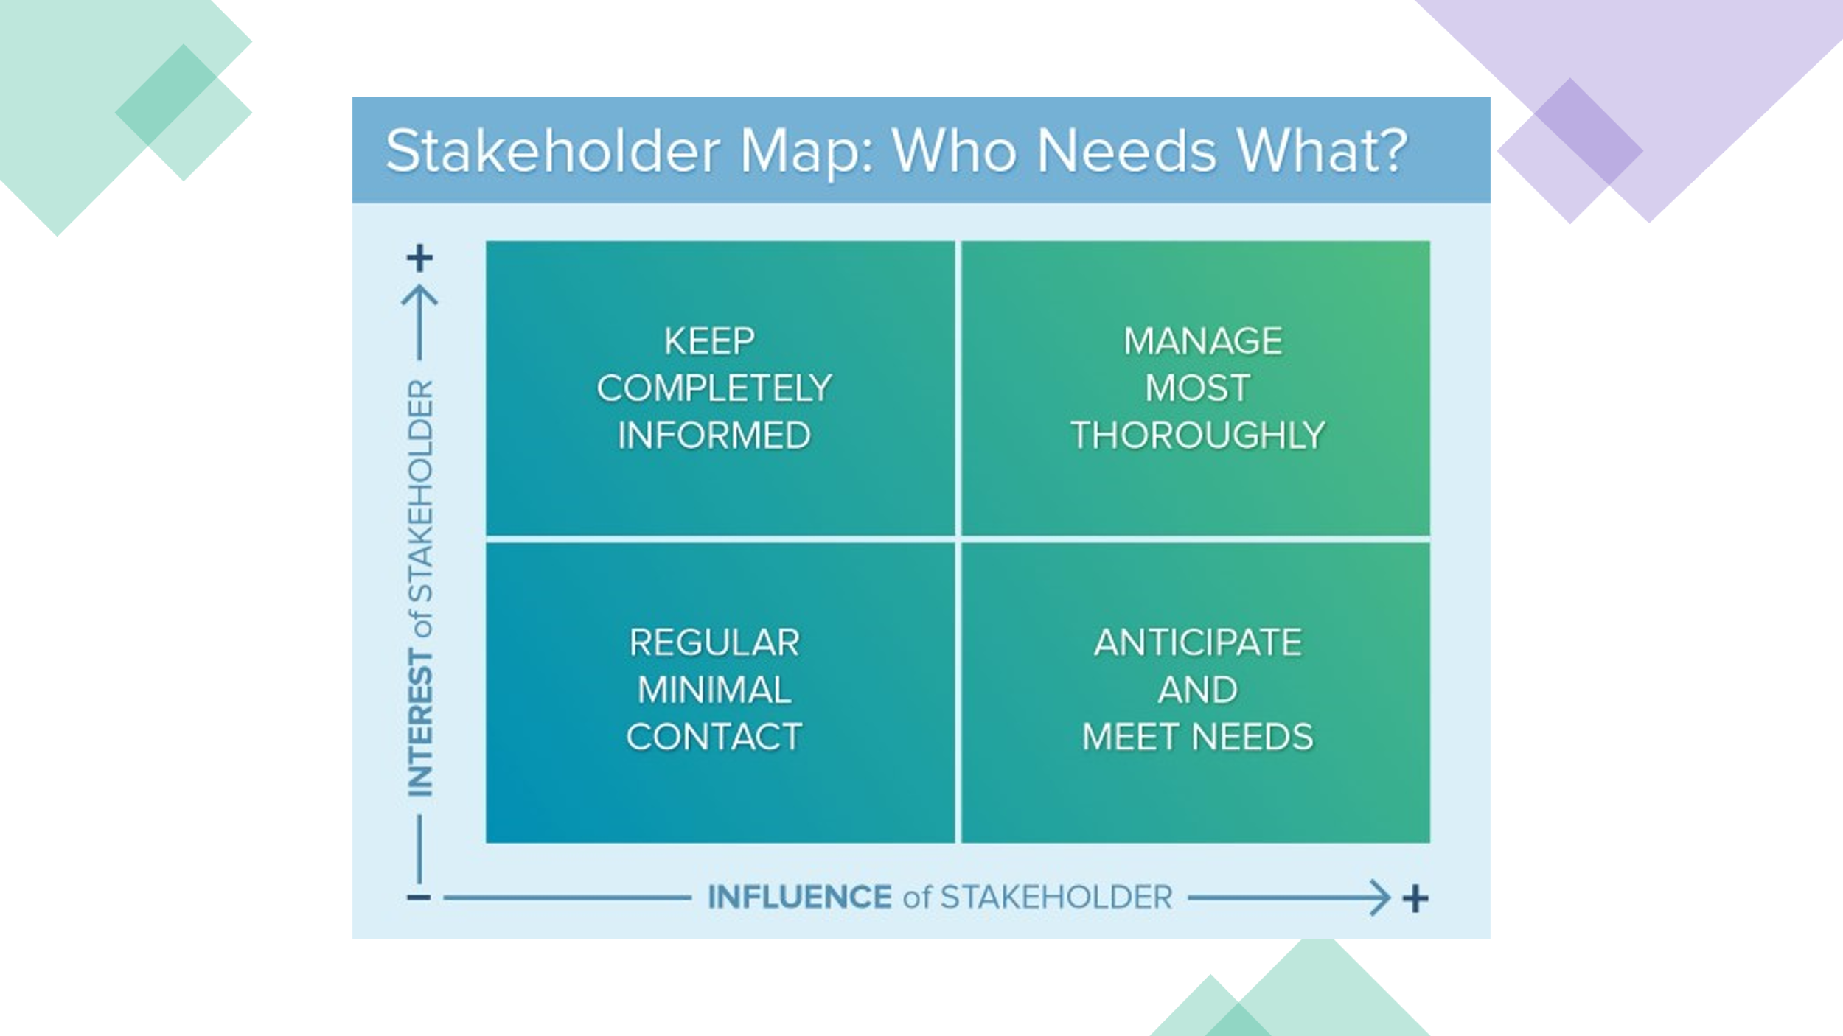

Exercise: 10 minutes
Work in groups of 3.
Please discuss the many and varied stakeholders linked to a typical IPS Service and list them in a quadrant. This then allows you to understand how to categorise them for an engagement/communication/stakeholder management plan.

After placing key stakeholders in one of each quadrant, please identify how you would maintain links, communication, and relationships with those stakeholders.

Do we see the same stakeholders appearing in different places?​
Do you think these roles can change over time?​
Can we influence these roles? Are these positions dynamic?

Add up how many stakeholders you have identified to manage most thoroughly – and what creative ways you would keep them closely involved and engaged.
Let’s see which group can identify the highest numbers and most creative ways!

NOTE: it is important to review your stakeholder mapping perhaps quarterly or at least 6 monthly to see if any stakeholders have shifted in their roles, influence/power, and interest.
You can adjust your relationship and engagement and communication with them accordingly.
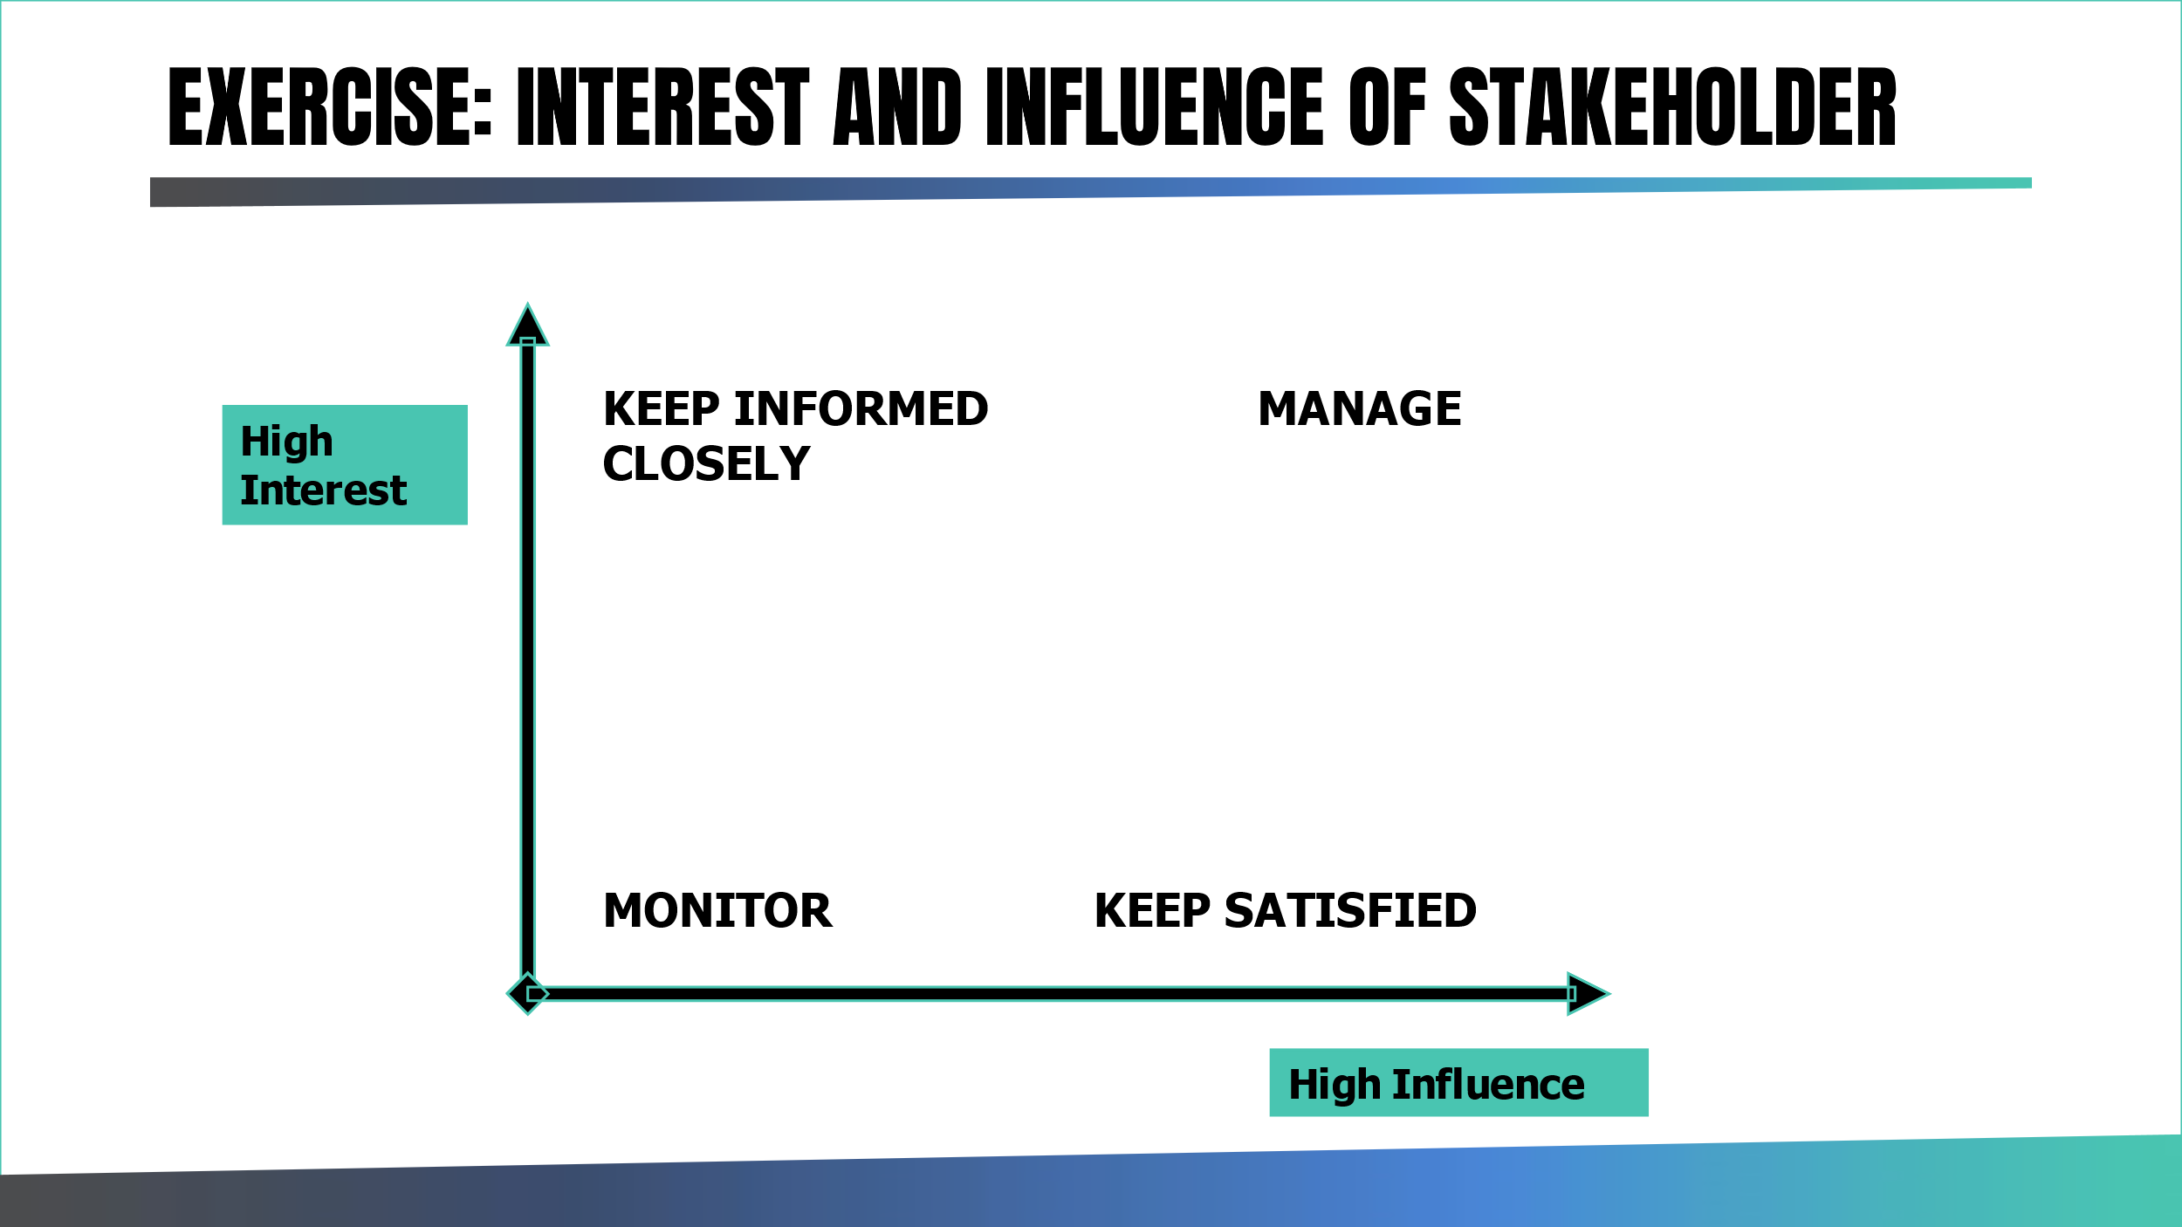

Understanding stakeholder objectives:
It is critical to work closely with these stakeholders, to know who you need to manage most thoroughly and to find ways to understand their needs and ways to engage and interest them in the service needs.

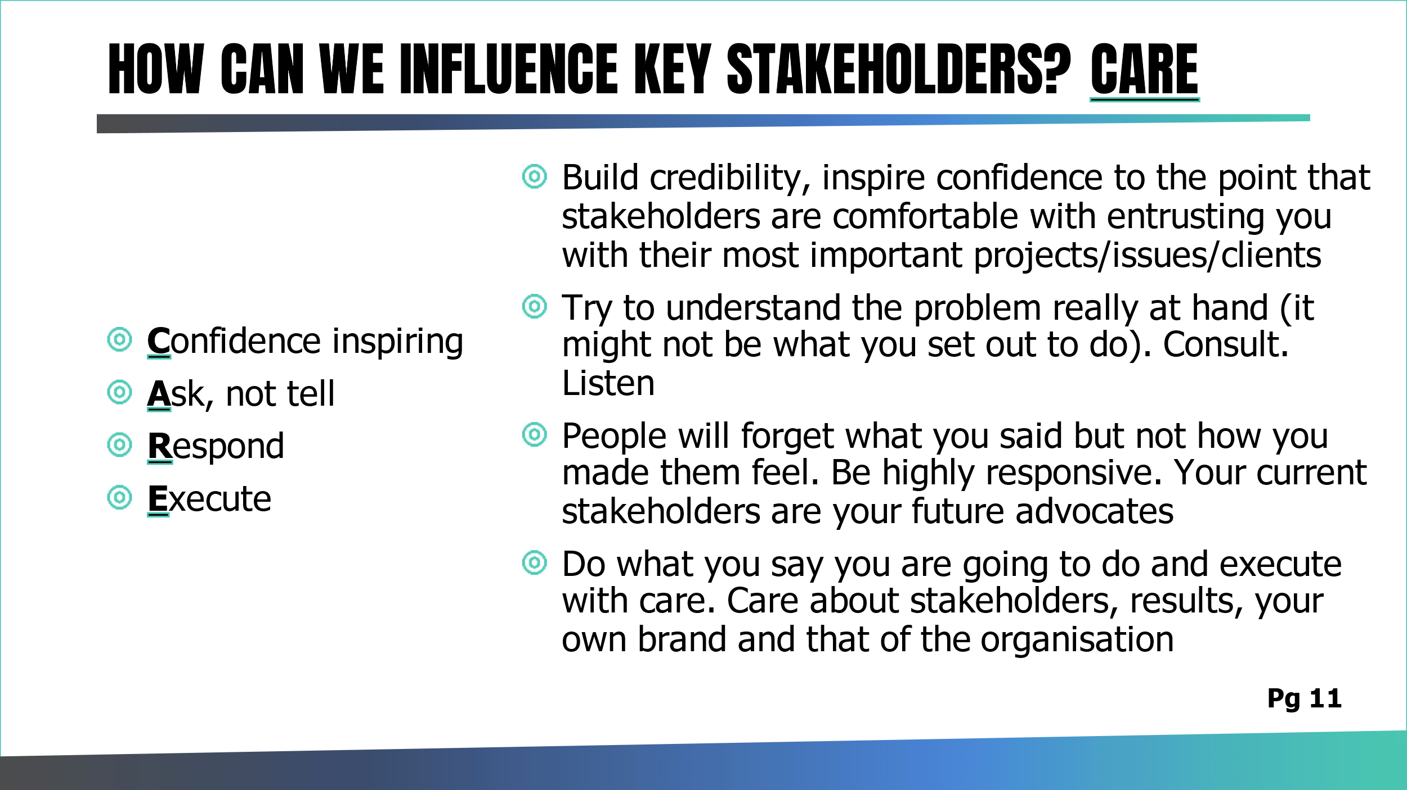

Influencing stakeholders
Work of Influence and persuasion – refer to Robert Cialdini.
Robert Cialdini published his book “Influence: The Psychology of Persuasion” in 1984. The author takes the position that persuasion is a science, not an art, hence with the right approach anybody can become the master in the skill of persuasion.

See: https://www.influenceatwork.com/principles-of-persuasion-are-not-just-for-business/

His work suggests ways to build stronger relationships with your networks and influence and shape your system/service/network for success.

His work is an influential precursor to Nudge Theory (see: https://www.hrmonline.com.au/section/strategic-hr/nudge-theory-ethical/).
Robert Cialdini’s and colleagues developed a further book – 50 Scientifically Proven Ways to Be Persuasive – which outlines a gathering of psychology research into 1 book and gives 50 scientifically proven ways to influence.

The 50 ways constitute 50 chapters of the book, the longest of which is 7 pages.
Have a look at the list and consider what ways you are currently using and what 3 ways you could consider using.

See: https://fs.blog/2009/08/yes-50-scientifically-proven-ways-to-be-persuasive/

IDEA:
Review a few ideas from the list weekly at your Team Meeting and explore as a team what new ideas you could perhaps try.

Work of influence and persuasion – refer to Robert Cialdini
5 underlying principles for influence and persuasion: | Essential skills of an  effective influencer | Essential traits of an  effective influencer
Reciprocity = Obligation to give when you receive. Try and find ways to help your clinical teams using IPS practice. And share what you have done.  Scarcity = people want more of those things they think they can have less of.  Authority = people follow the lead of credible, knowledgeable experts. It is our role to be the experts on IPS, know the facts, have the recovery stories to share and be the credible “go to” to build interest and engagement.  Commitment and consistency =  Looking for and asking for small and consistent commitments that can be made – an IPS example is that we would look for voluntary, public, and active IPS champions including clinical team members to start to boost the profile of the service versus expecting every clinical staff member to engage at once.  Liking = people prefer to say yes to someone they like. It seems that there are 3 important factors to liking someone: we like those that are similar to us, those that give us compliments and those people that cooperate with us. | Asking the right questions in an open and interesting manner  Listening actively to find common ground  Sharing your work from the perspective of how it provides solutions | Be friendly, personable, courteous, flexible and open  Have good self- esteem, you are as good as everyone else you meet  Be brave, you need to be when you walk into a room full of strangers or meet key important people  Be generous, influencing and networking is about giving first and receiving second  Be persistent and resilient. Why bother trying if you do not follow up?

Assignment 2: Stakeholder mapping
Undertake a stakeholder mapping exercise for your service.
Categorise stakeholders and identify how to best communicate and engage with them and build a plan to make that happen.

Managing complex communication
Managing complex situations, managing conflict, and having difficult conversations are all essential in ensuring a successful service. Naturally, many of us would want to avoid these sorts of experiences in our home life. However, as we embed new or extended IPS delivery into existing and changing health systems, as we strive to continuously improve and possibly with ever decreasing resources, we need to be prepared with tools to manage potentially difficult situations, conversations, and conflict.
We know many of you have attended conflict resolution training as part of your mandatory Trust training. Managing complex situations, conflict and having difficult conversations are all essential parts of ensuring a successful service.
You may need to manage internal team conflict, handling or giving bad news to team members, or handle challenging situations within the many teams we operate in. Your role is to support your staff, support the service and ultimately ensure all focus and energy is on supporting our service users into paid employment versus being lost in issues that have not been handled early and effectively resolved.

What is conflict?

When you think of the word CONFLICT what is the first thing that you:

- THINK

- FEEL

- SAY



Conflict can be constructive or destructive. It can be a time to create space and a way forward if managed with thought, preparation, and attention.
Conflict is defined by Rahim (2010) in Managing Conflict in Organizations as:
“some form of friction, disagreement, or discord arising within a group when the beliefs or actions of one or more of the members of the group are either resisted by or unacceptable to one or more members of the same or other group”
Types of conflict: There are three different types of conflict in any interaction:
- Task conflict
  - What should be done?
- Relationship conflict
  - Who should do what? How should they interact?
- Process conflict
  - How should we go about doing the task?

Conflict is something to embrace and not avoid. However, there is a science to the way you approach resolving conflict, so you get the right outcome for the service.
There are five styles for managing conflict, no one style is “correct”. It is important to recognise your own style and recognise the style of the other person, then choose and implement your style to handle the conflict accordingly. This approach will likely help to manage conflict constructively as a result. The different conflict styles are outlined in the table below:

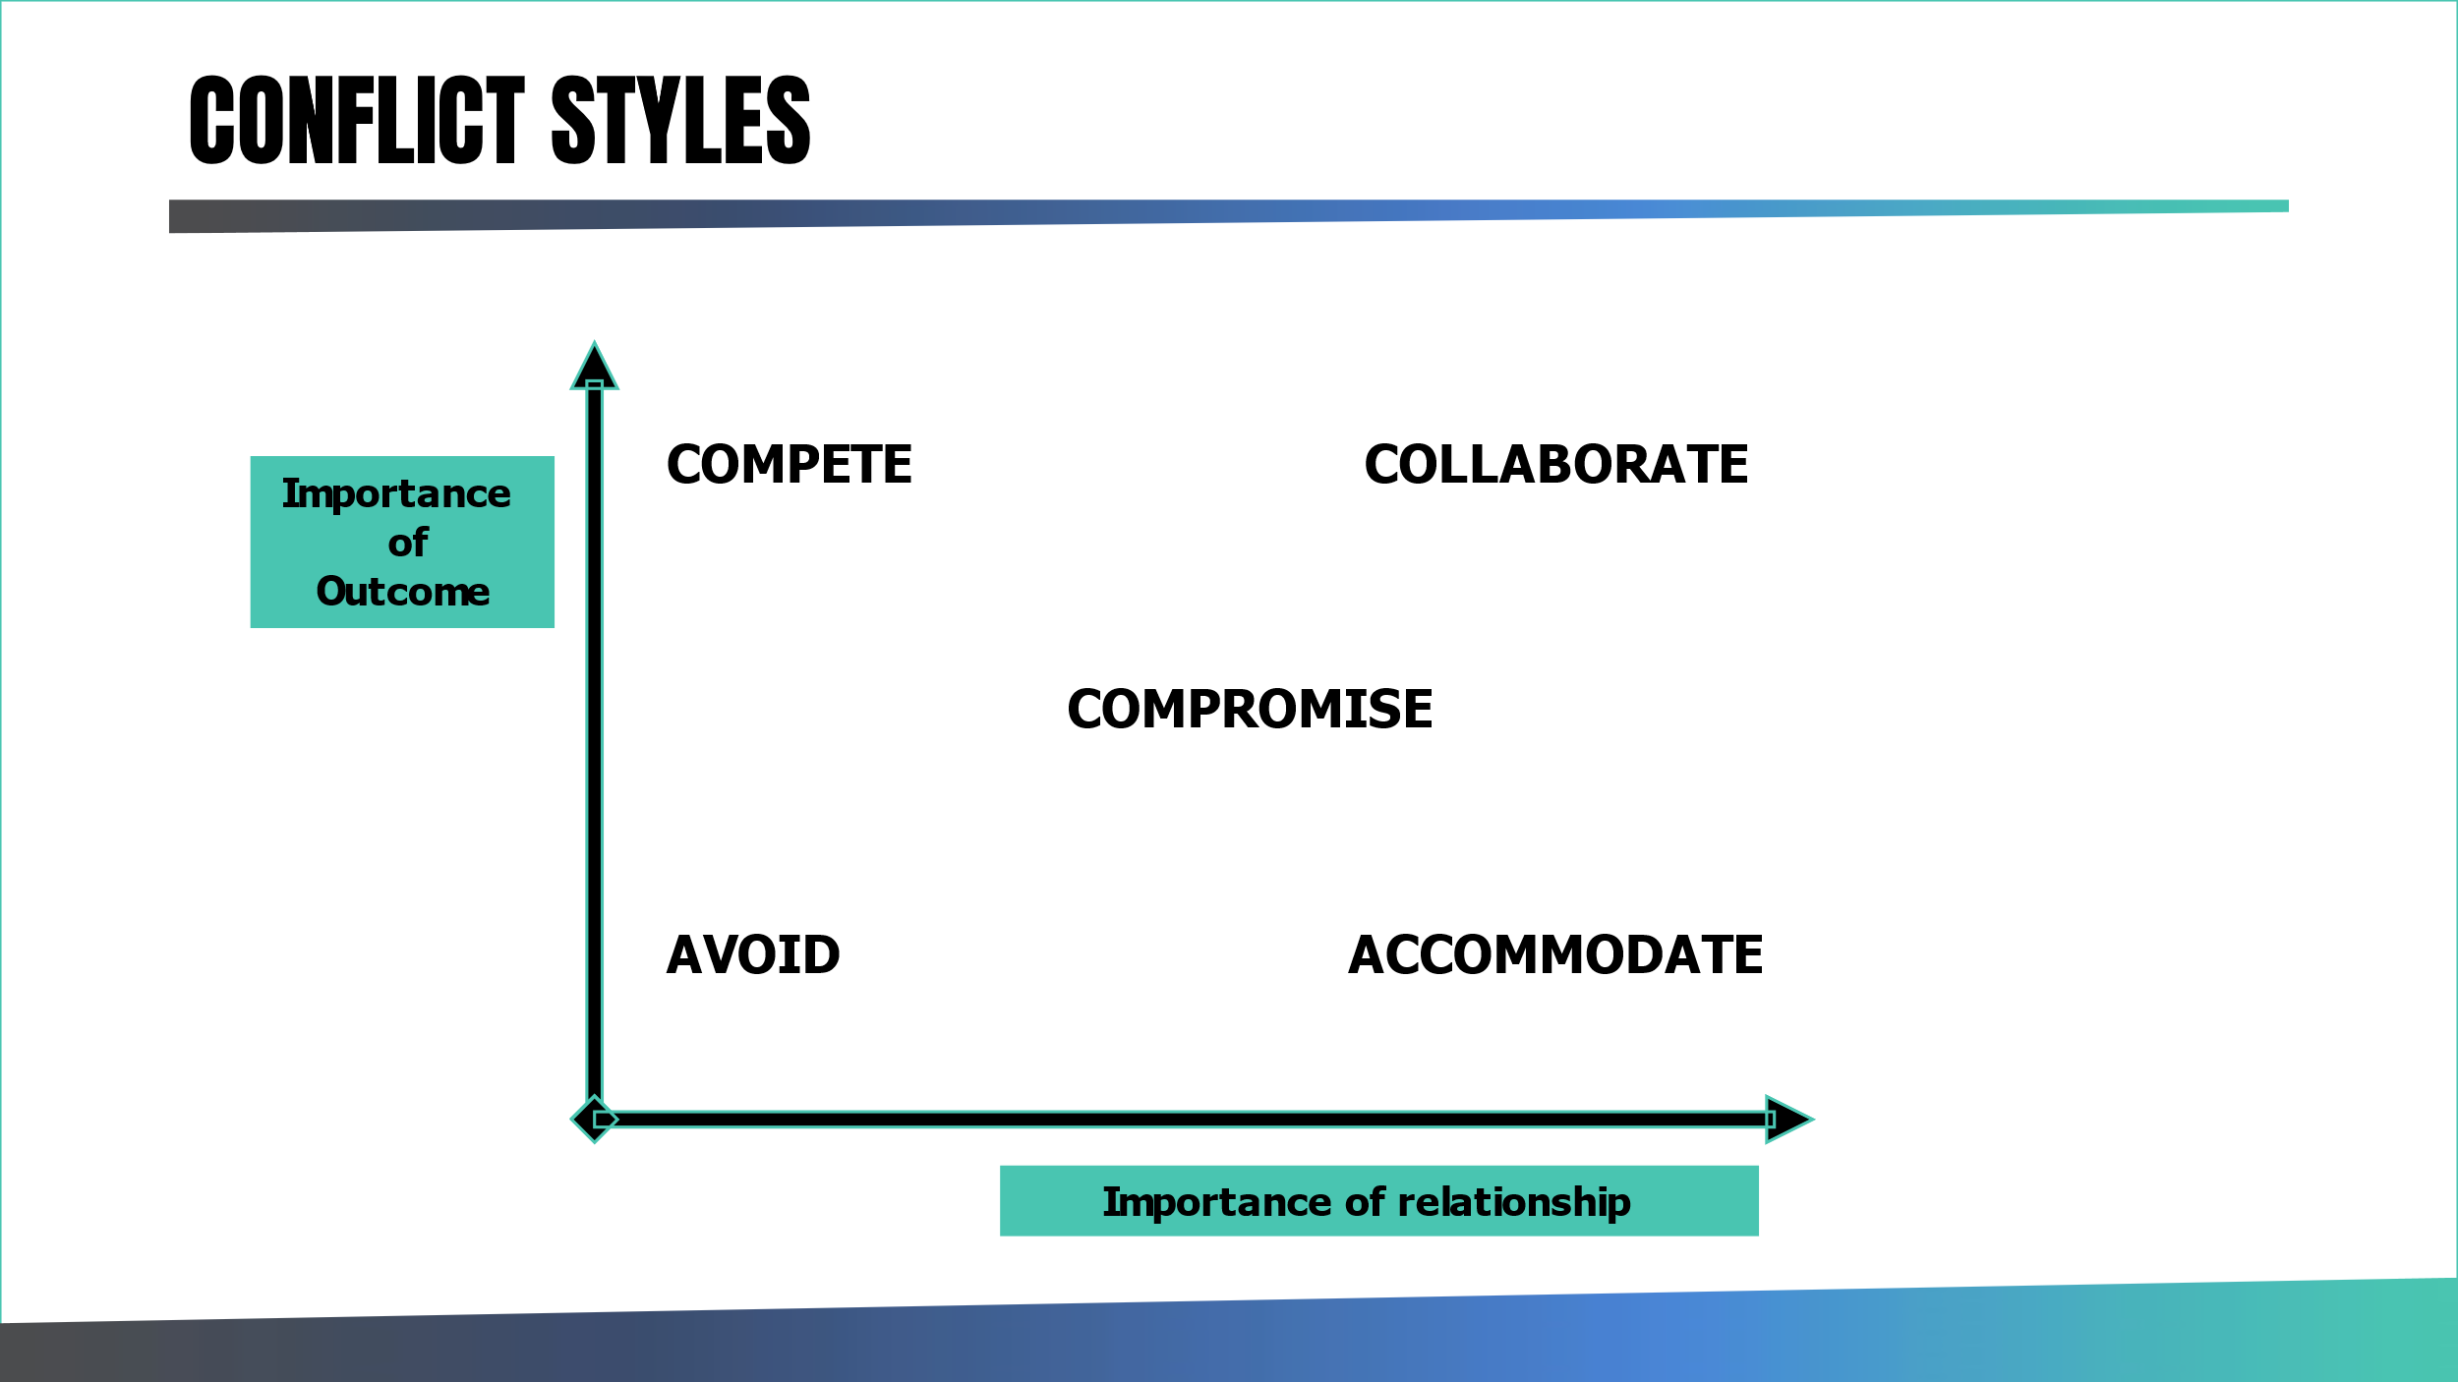

Exercise:
What is your “go to style”? What would be the style you are most uncomfortable dealing with?

What is a difficult conversation?
A difficult conversation is anything you find it hard to talk about with another person, e.g.:
- “what happened”
- “feelings”
- “identity”
How can you (and the other person) move from:
- Certainty to curiosity
- Impact to intention
- Blame to contribution
Source: Difficult Conversations: How to Discuss What Matters Most by Douglas Stone, Bruce Patton & Sheila Heen
NOTE: A difficult conversation can be avoided or dealt with poorly or managed appropriately

Things to consider when exploring difficult conversations:

How we communicate
Verbal ​  Verbal 7% through the words used in an interaction​  Paralanguage​  38% through the pitch, tone, and pace of the voice ​  Body language​  55% through the gesture and appearance ​ | 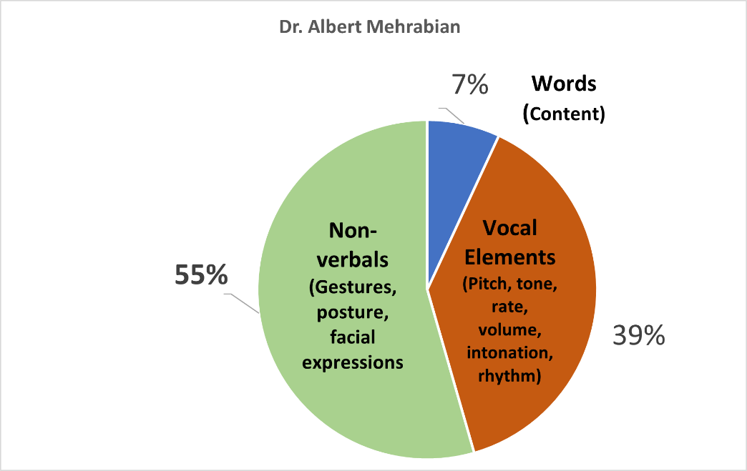

Active listening:
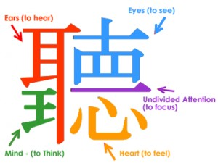

Chinese character for listening.
At the centre of the character is a single stroke holding all the elements together.

Skills needed for effective active listening:
Non-verbal communication
Use of silence
Minimal verbal prompts
Reflecting
Paraphrasing
Reframing
Summarising
Use of questions

Process of active listening requires a number of skills that can be best described as a continuum.

Levels of Listening:
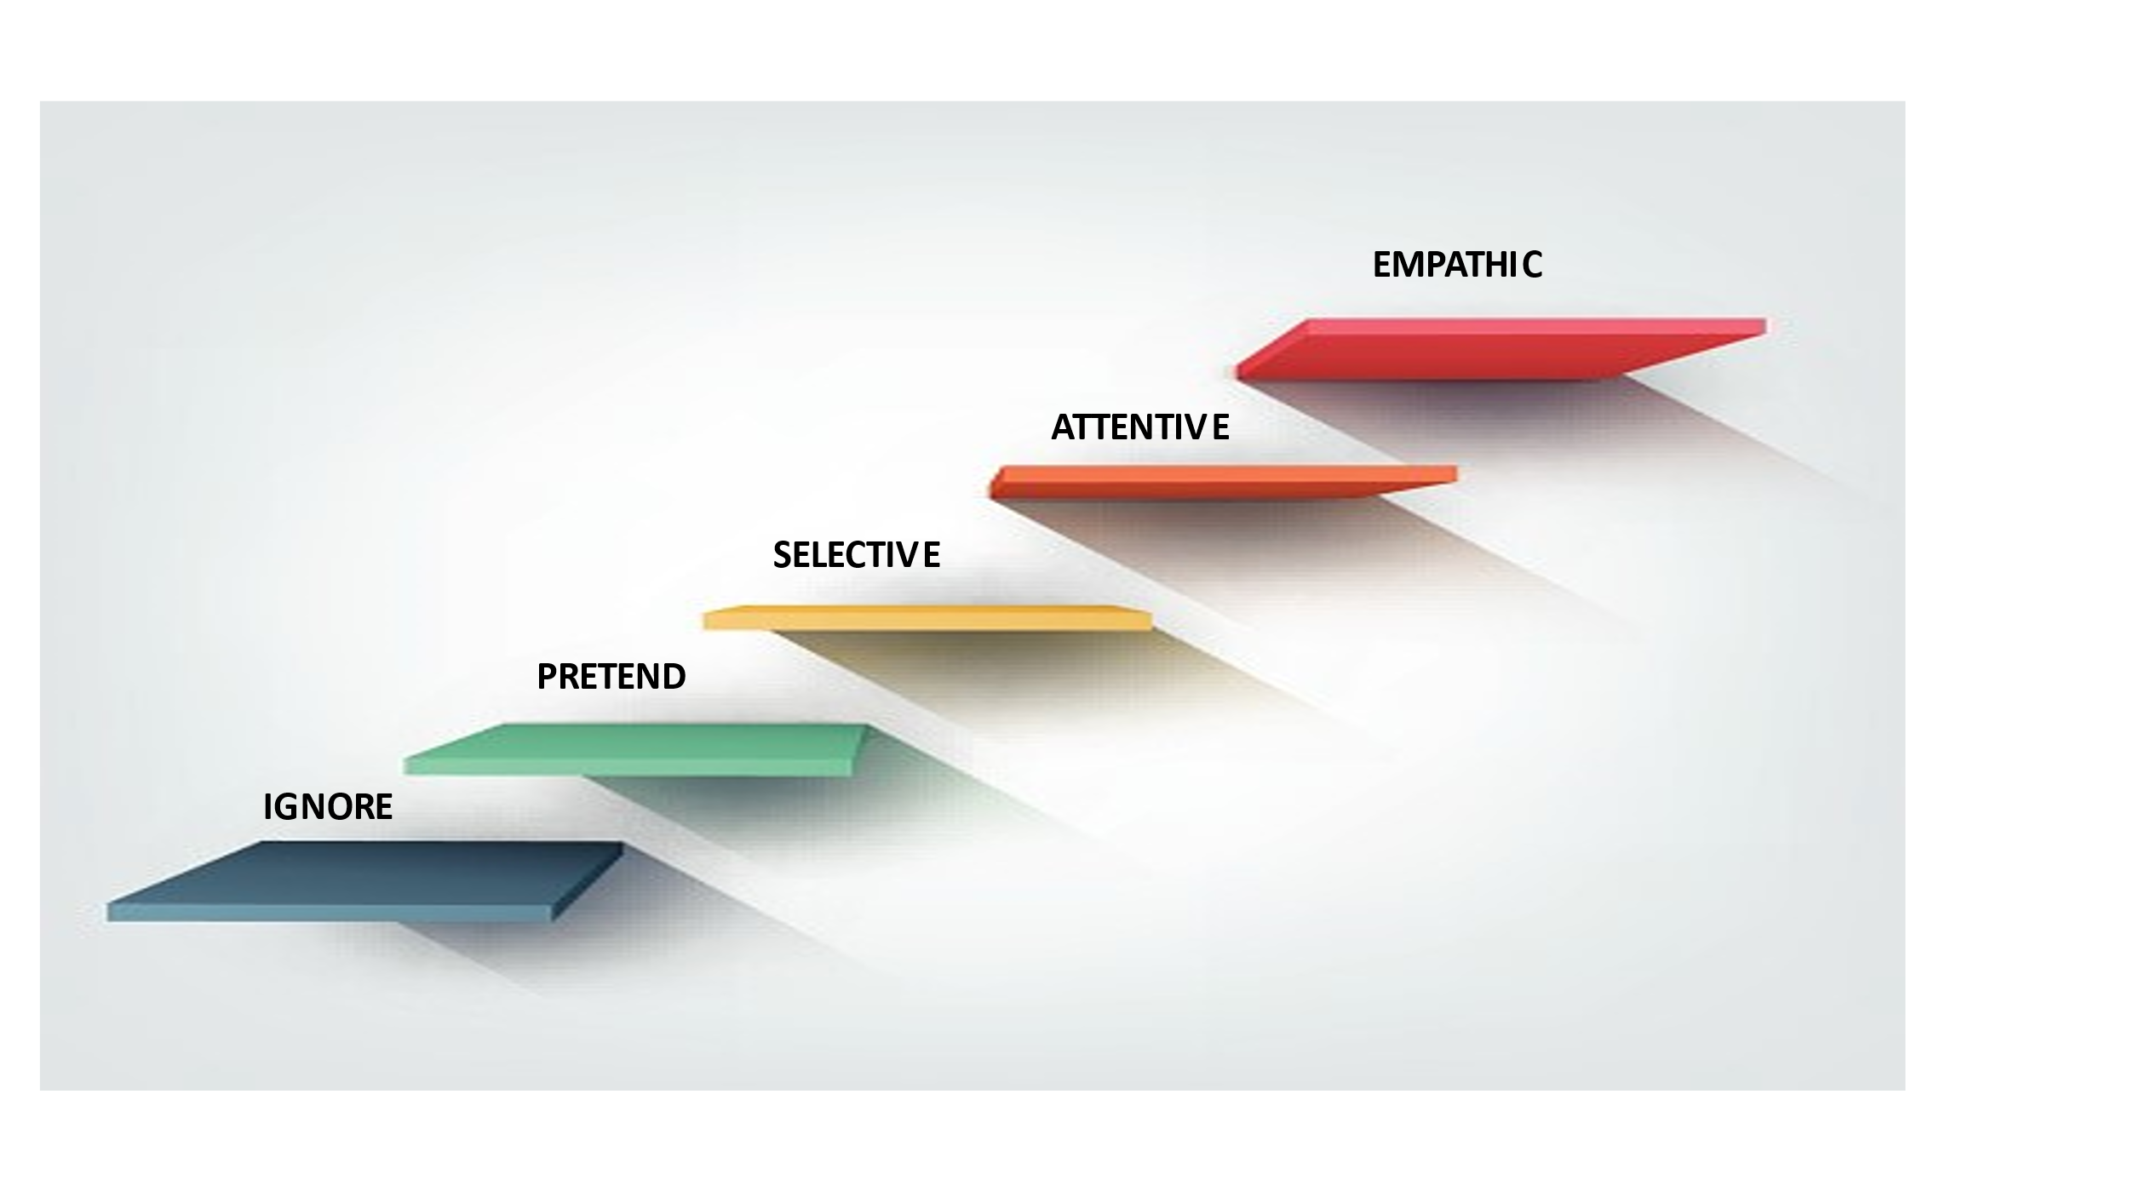

Attentive and empathic
Practice ACTIVE listening
Attempt to understand from their point of view. This is not the same as agreeing.
Rephrase and play back to establish rapport and mutual understanding. Adopt/adapt some of their language.
Summarise.

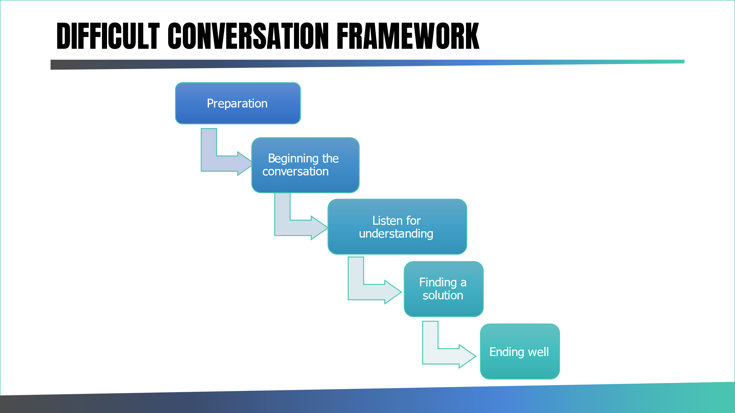
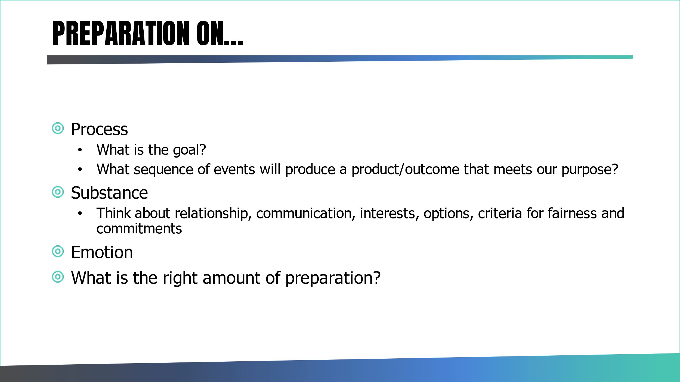

Exercise:
In pairs review the difficult conversation frameworks below

- Does it make sense?
- Anything missing?
- How could you learn to use this?

- Start the conversation | Purpose – share your purpose in having the conversation  Invitation to partner (collaborate) – invite the other person to partner with you to sort out the situation  Manage emotion  Be present
- Manage emotion | Recognise - Their emotions/your emotions  Respect – it is their emotion and their response  Respond – from a place of curiosity and not certainty
- Listen for understanding | Be curious  Ask questions  Acknowledge feeling
- Attentive and empathetic | Practice ACTIVE Listening  Attempt to understand from their point of view (not the same as agreeing)  Rephrase and play back to establish rapport and mutual understanding  Adopt / adapt some of their language  Summarise
- Finding a solution | Soft on people / hard on the problem  Open questions / exploring  Listening – allowing venting  Silence  Patience  Using emotional vocabulary- name it  Summarising  Managing expectations
- Deadlock and difficulty | Avoid attacking the person and manage excessive emotions  Uncover and create value  Build a 'Golden Bridge of Retreat’  Leave some space to think / reflect
- Ending well | Summarise actions  Identify process going forward  Agree follow-up

Preparation Guide

- What do you want to achieve from this meeting (purpose)?
- What will be covered in this meeting (agenda)?

- Who is attending, what is their role, what will they do and how much time do they need?
Do you anticipate that they will want to discuss anything? Will this have an impact on the agenda (will it need re-ordering)?

- What decisions need to be made at the meeting, and what is the likely impact?
- with this individual (and/or key stakeholders)
- on future relationships

- What issues / barriers might emerge (past or present) and how will you overcome them?

- Have you identified a method of recording key actions and how will you ensure that this is attributed correctly?

- What emotions might emerge (in you / them) and how will you address / manage these?

Wrap up – managing conflict and difficult conversations:

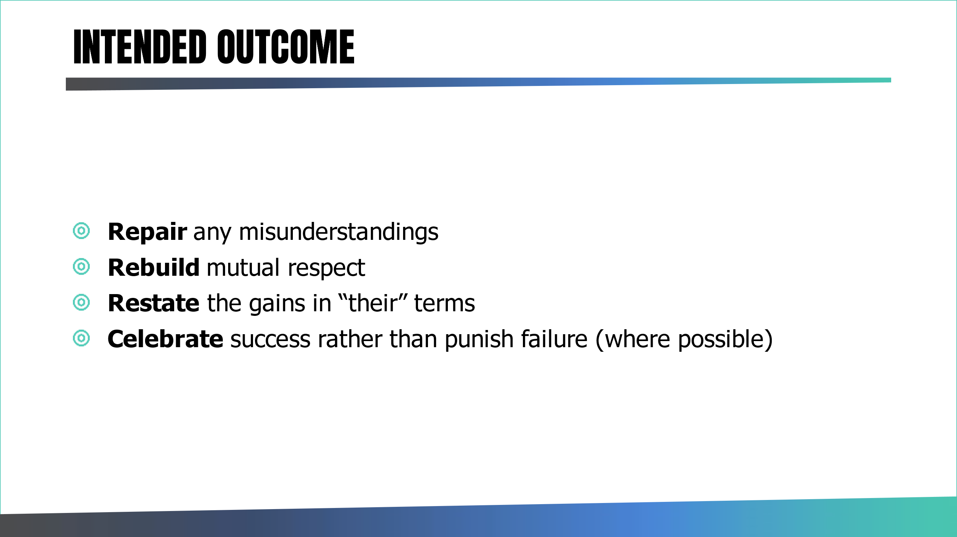

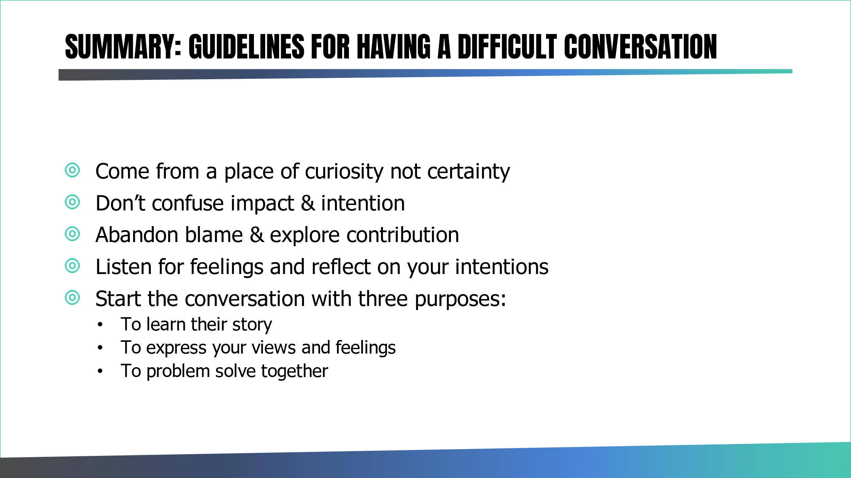

Assignment 3: Difficult conversations
Using the preparation guide, plan and undertake a difficult conversation with a key stakeholder that perhaps you have avoided or could revisit.
Please reflect on the experience in your reflective journal

Teaching skills for an IPS Supervisor
IPS supervisors report that it is often difficult to find new recruits who already have the skills and experience needed to be good employment specialists. In response, supervisors search for applicants who have the right personality traits and attributes for the job and focus on teaching the IPS specific skills needed to achieve good outcomes. Regular feedback in forums suggest that Employment Specialists appreciate a supervisor who teaches because that helps them to develop, continuously review, improve, and learn and in turn stay interested in their jobs. Supervisors who teach on a regular basis with staff can also ensure that all team members use best practices in their delivery.
If as a new Supervisor you have never been an employment specialist yourself, you can excel in teaching skills for IPS. A review of the adult education literature would suggest that you are best placed to understand and embed those skills by doing the work yourself.

Many Supervisors report that great experience is gained by maintaining a small caseload (perhaps 2-3 people) and importantly working side by side with the team. If your job is too big to manage your own caseload, you could work with the ES to support them with elements of their caseload. Your team will appreciate that you are learning skills by doing the job and you in turn will build credibility, respect, and an understanding of the ES role by clearly being willing to undertake the work of the team.

If you have been an employment specialist, it is suggested where possible that you continue to update and improve your skills by working alongside your staff and carrying a small caseload. Jobs and employer hiring practices change continually. Stay current by spending a portion of your time doing employment specialist work – which makes you a more impactful teacher and Supervisor.

Exercise:
In small groups have 5 minutes to explore these 2 questions then return to the main group to discuss:
Why IPS Supervisors teach? | How people learn?

How People Learn - 3 related and evolved models:

3 models for learning are proposed that are examples of an evolution of an initial approach.
- Robinson (1974) Conscious Competence Model of Skill Acquisition
- Dreyfus & Dreyfus 5 stage skill acquisition model – recognise people can go forward in skill and competence to a mastery level, however, may regress back to previous stages for want of consistent practice on newly learned skills.
- Reflective Competence Model = continuous review of learning and particularly at mastery level to minimise complacency and ensure relevance of skill understanding
Robinson (1974) Conscious Competence Model of Skill Acquisition – now called “Conscious competence theory’.
The early known work in explaining the mechanism of developing proficiency is known as ‘conscious competence’. In 1974, Robinson explained that an individual progresses through four definite stages of learning a new skill (or behaviour, ability, technique, etc.). This model explains the skill acquisition in common sense terms and 4 stages.

An extended variance of Robinson’s theory is provided by Dreyfus & Dreyfus (1986) five-stage skill acquisition model. See figure below:

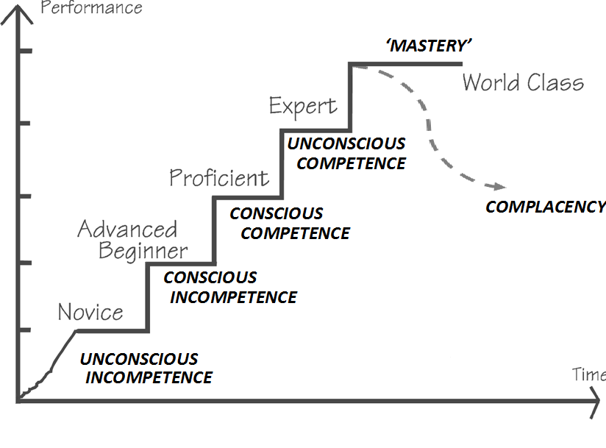

Unconscious incompetence:
A naïve is assumed to be at ‘unconscious incompetence’ stage. At this stage, a person is not aware that he lacks a particular skill, or in some cases the individual may not even know the relevance or usefulness of the skill.
Conscious incompetence:
Then the person moves to a stage of ‘conscious incompetence’ where they start becoming aware of the existence and relevance of the skill, and they may start recognising how much they do not know. This usually happens with a discovery process. Now the person starts working toward attaining that skill and does necessary practice.
Conscious competence:
Eventually, the person reaches a stage of ‘conscious competence’ in which they can reliably perform the learned skill without assistance. This still requires attention, concentration and has not yet become automatic at it.
Unconscious competence:
However, with consistent practice and repeated use, the individual moves to the next stage of ‘unconscious competence’ when the skill becomes automatic (i.e., the skill enters the subconscious mind and becomes second nature).
The model emphasises progression is from quadrant 1 through 2 and 3 to 4. It is not possible to jump stages. For some advanced skills, the individual may regress back to previous stages for want of consistent practice on newly learned skills. The model considers the idea of mastery.

Will Taylor (2007) Reflective Competence Model of Skill Acquisition
A new body of arguments is emerging which indicates that at ‘Unconscious competence’ level, the individual may cease to learn any further and may lack knowledge or skills in new methods and thus as an expert the individual will find themselves once again unconsciously incompetent. To close this loop, William Taylor suggested a Reflective Competence Model with a fifth level called ‘reflective competence’ to represent the continuous self-observation to keep ideas and skills fresh and allow for skill development further (shown in figure below). The model suggests we do not stay unconscionably competent all the time unless we continue practicing, reflecting, gaining coaching, and making adjustments and improvements in our competence. If we do not do so, we lose competence in some cases.
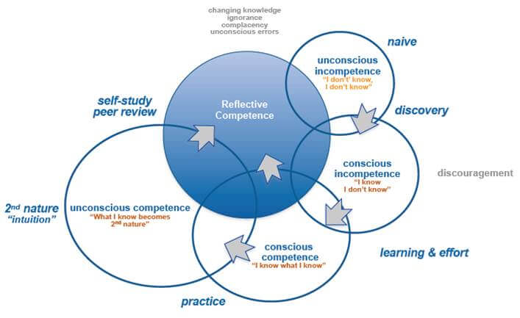

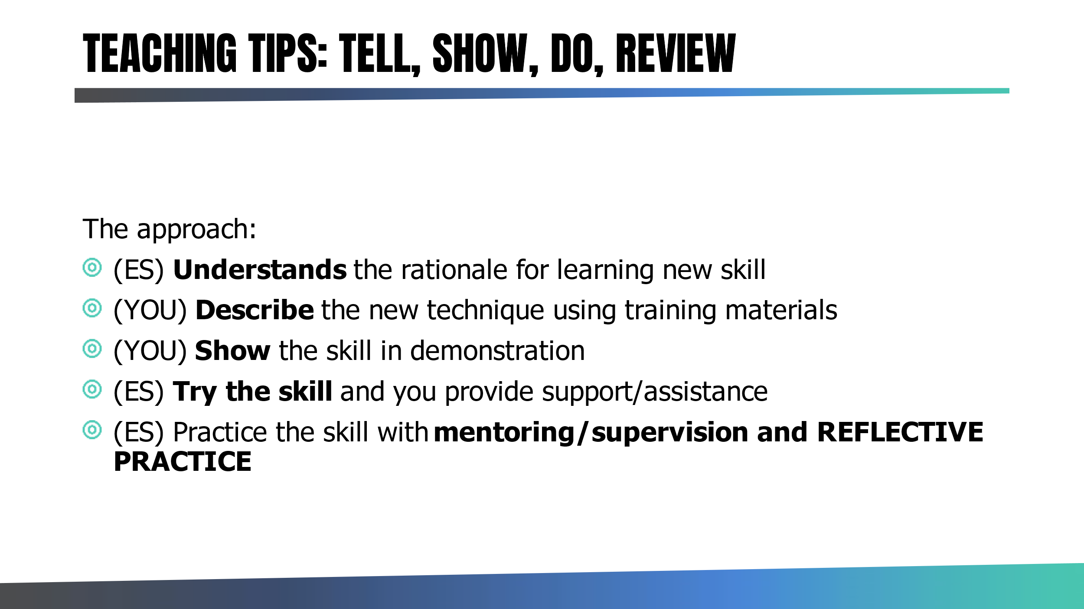

To teach a new skill, we suggest you follow the steps below:

  - Describe the new IPS skill. Talk about the rationale for using that particular skill. Explain the strategies that the employment specialist will use and why. Provide learning materials such as videos or reading material (worth exploring the ES preference for learning – visual, auditory, and Kinaesthetic).

  - Demonstrate the skill. In the field either you or an experienced ES show in real time the execution of the skill. Review the observation by the employment specialist afterwards to deep dive into the skill and explain the techniques that you used. If you ran into a problem, explain what you could do differently next time and ask your ES if they have any ideas for how to deal with that situation.

  - Ask the employment specialist to try the new skill while you observe. Confirm with them before they try the skill that it is okay if you step in and help if needed. Undertake a mini review after the ES has finished and explore with them what they thought went well, what was a worry or could have been done better, what further help they may need to master the skill. Then you share as the observer what you felt went well and suggest what they could do differently next time. Remember, we are always working to a strengths-based model, so trying to find what went well and build trust and commitment to strive to do better.

Repeat steps 2 and 3.

  - Ask the employment specialist to undertake the new skill by themselves and reflect on their practice later with you.

  - Field mentoring: Eventually as part of your field mentoring cycle, you will observe them again undertaking the skill and be able to share feedback on what went well, what could perhaps be improved.

NOTE: Again, not everyone learns in the same way. Ask each employment specialist about how they learn best and make adaptions to your approach. However never give up the idea of working alongside the employment specialist as part of your teaching plan. This is a fundamental IPS supervisor skill and key responsibility. You need to build trust in the team so that staff enjoy, welcome, and learn from in the field observation and mentoring. Ideally help people become comfortable with this from their first weeks in the job.

Exercise: Create a teaching plan using the Tell Show Do Approach:
Ideas: Building employer relations, providing individualised job support, managing assertive engagement
Skill/Goal: | Plan
Tell: To become interested in trying something new, people need to understand the rationale for the practice. | What evidence will you use? How will you do this?
Show: Next, the supervisor describes the new technique through discussion or teaching material. | How will you do this? What resources will you use?
Demo: What most people also require is to see a skill demonstrated | Where will you do this?
Do: Ask the ES to try doing the new skill with you on hand to support | What needs to be agreed and thought about to ensure this goes well? How do you provide feedback?
Do: Ask the ES to try doing the new skill independently | How will you ensure quality?

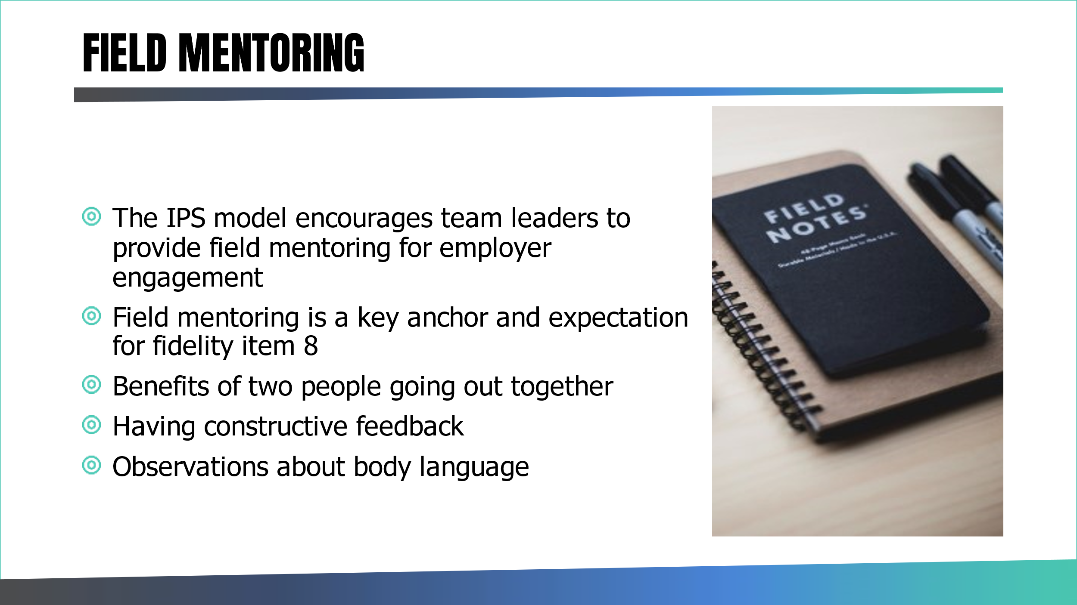

How People Incorporate New Information into Their Work
As we have seen from our reflective competence model, people need support, coaching, opportunity for self-reflection and peer reviews to ensure a new skill becomes learnt and embedded in their practice. Furthermore, even when they become proficient in a skill, they need occasional coaching and review by someone else to explore if they could improve or to ensure they have not become complacent.

In IPS we suggest that to help the ES embed a new way of working, they are best supported by coaching from their supervisor which allows them to discuss practice issues, observe practice by the supervisor and practice their delivery with support and guidance. Coaching by the supervisor can provide support and encouragement to those employment specialists who are intimidated by trying new techniques.

Types of coaching:
- Office based
- Review of case files
- Field mentoring

Office-based supervision is one way to coach. Ideally set a formal meeting once a month. Supervisors can ask employment specialists to carry out a task and then discuss what happened during their next supervision meeting. Office-based supervision also helps the employment specialist to understand the expectations of the job, for example, if part of every meeting is spent talking about visits with employers, the specialist will know that he must schedule employer visits weekly. Remember to always write up your monthly supervision notes and have clear action log that can be reviewed at the next meeting.

Reviewing documentation is another way to provide coaching. An example of this is when an IPS supervisor reads employer contact logs, asks the specialist questions about the quality of the contact, and points out when an employment specialist forgets to follow up with an employer. While reviewing logs with the specialist, the supervisor can also help the person think about his relationship with a particular employer and brainstorm methods to deepen that relationship.

Working side-by-side with employment specialists is the most effective strategy for coaching. Imagine that you were teaching someone to do a reverse park in a car. Part of that teaching process is certainly office based and discussing the technique. However mostly you would go for a drive in a car. The supervisor would demonstrate the reverse parking manoeuvre and then coach the person as they attempt the reverse park.

In IPS, it is not possible to know which barriers people will run into when they try a new technique on their own. A person may feel confident about trying a new strategy for job development until an employer asks a question that the employment specialist did not anticipate. Working together is also a way to demonstrate tone and style. For example, if a supervisor demonstrated how to engage a new person in IPS services, an employment specialist would observe that the supervisor used a friendly, relaxed style of interaction. If a supervisor demonstrated meeting a new employer, the employment specialist would observe that the supervisor was polite and attentive, but not overly formal.

Working side-by-side can cause some specialists to feel nervous in the beginning, though over time it begins to feel like “business as usual.” To help specialists adjust, explain that you also learn from people on the team by observing their work. Use a strengths-based approach by pointing out what the person does well and acknowledging the person’s improvements over time. Finally, ask for feedback about your techniques as well as providing suggestions to the employment specialist. That is a useful strategy for developing a learning culture on the team because it shows that you want to continually develop your own skills.

In IPS we use the term “field mentoring” to mean working alongside an employment specialist. We recommend that supervisors provide field mentoring on a frequent basis: at least monthly for experienced employment specialists and more often for new employment specialists.

Plan the type of field mentoring you will provide for each specialist before the supervision appointment. To choose which type of field mentoring you will provide, consider the person’s outcomes. Are people on her caseload getting jobs? Are they adept at engaging people in services? Do they involve family members on a regular basis? Do most people on their caseload keep their jobs, and if not, why?

Always write up the field mentoring observation using the template. See Appendices.

Download a copy:

https://future.nhs.uk/IPSWorkspace/view?objectId=61440933

Employer Engagement
Date:
Name of Employment Specialist:
Name of Employer:
Items covered | Observed |  |  | Notes
IPS info given

Was an appointment made in advance of this meeting?

Was an appointment made as a follow up to find out more about the employer?

Did ES find out about the business? (history, locations, type of products/service provided)

Did ES find out about hiring preferences?

Did ES find out about different type of roles at employer?

Did ES find out about type of candidate employer feels is a good match? (Skills, strengths, qualifications)

Was ES following up on a client’s application?

Did ES describe a client who is a good match to employers hiring preferences?

Did ES explain service to the employer?

Were there actions agreed at end of meeting?

Assignment Idea: Teaching skills
Using the Tell Show Do Approach, create a teaching plan with one of your staff and try that out from start to finish.
Please reflect on the experience in your reflective journal

Or

Use the field mentoring template to support a staff member back into field work after the covid-19 lockdown.

DAY 2

Recruitment and Supervision

Aims & Objectives
Increase Team Leader competence in recruiting IPS staff
Improve staff wellbeing and retention
Improve the supervisor/supervisee working relationship

Objective
Share best practice
Understand qualities and behaviours of high performing Employment Specialists
How to attract a more diverse workforce
Practice skills in running individual and group supervision
Reflect on current practice

Distinguishing Behaviours of High Performers:

- Establishes a working alliance with everyone on caseload
- Secures jobs that align with individual preferences
- Develops service users’ job search skills
- Provides assistance in the workplace and supports employers
- Develops a network of employers
- Builds effective working relationships with stakeholders
- Puts in extra efforts to address service users’ needs
- Effectively manages a caseload of participants

Video:
Lockett, 2019. YouTube: https://www.youtube.com/watch?v=rLJ45m95Sjg

Exercise/Break-out activity:

10-minute discussion in groups.
Consider how would you assess those qualities in a candidate? Think about which behaviours candidates would need to possess and which ones you could train/develop?

Are there any other “must-have” qualities/behaviours from your perspective?

Notes:

Recruitment Practicalities:

- Review job descriptions/person specifications
- Recruiting as internal Trust team or third-party provider
- Internal vs external applicants
- Open to secondments
- Contract length – fixed term contract vs permanent
- Could this be a peer employment specialist role?
- Have you considered diversity?

Notes:

Diverse Workforce

Race at Work Charter
- Appoint an Executive Sponsor for race
- Capture ethnicity data and publicise progress
- Commit at Board level to zero tolerance of harassment and bullying
- Make it clear that supporting equality in the workplace is the responsibility of all leaders and managers
- Take action that supports ethnic minority career progression

For more info: https://www.bitc.org.uk/race/

Equality Act 2010 – Protected Characteristics

- age
- disability
- gender reassignment
- race
- religion or belief
- sex
- sexual orientation
- marriage and civil partnership
- pregnancy and maternity

Assignment Option:

Compare the ethnic diversity of your IPS staff team with a) your IPS client group and b) the local population. Does your staff team reflect the ethnic mix of your client group? Does your client group reflect the ethnic mix of the local population?

Review the results and use the IPS Grow template to review your practice using the race equity anchors (appendix 4) and develop a plan to ensure IPS services are meeting local needs.

For template please see: Fidelity, GSA & Race Equity Action Plan Template available on FutureNHS platform
https://future.nhs.uk/gf2.ti/f/1000098/202042341.2/XLSX/-/Fidelity_%20GSA%20_%20Race%20Equity%20Action%20Plan%20Template.xlsx
Please add an entry to your reflective log.

Shortlisting best practice:

- Two or more managers
- Use job description and person specification
- List all job requirements or use rating system
- Separate shortlisting to avoid bias
- Record decisions and retain records for at least 6 months
- Avoid making assumptions.

Bias in Recruitment:

- HALO EFFECT
- STEREOTYPE BIAS
- AFFINITY BIAS
- CONFIRMATION BIAS
- GROUPTHINK

Notes:

Activity: Assessment centre
Work in groups of 5 for 10 minutes

Map out what an assessment centre could look like. Think about what you would need to consider.

Notes:

IPS Grow assessment centre checklist:
https://future.nhs.uk/IPSWorkspace/search?searchTermAND=assessment+centre+checklist&scope=1000098

Top tips/checklist:
- Identify how many candidates are being invited for face to face assessment and therefore how many days are required to assess all candidates across a range of activities
- Identify what activities will help assess candidates (mix of role play, hybrid competency-based interview, case study, presentation).
- If there are just 3 candidates who have been shortlisted following the telephone interview and you are running short of time, you may find it beneficial to hold a 2-hour assessment which includes the role play and face to face interview only, rather than the full assessment day agenda.
- Secure sufficient numbers of assessors for the assessment as well as a coordinator to support the process to run smoothly
- Book some space for the assessment – We would recommend the use of two rooms. One room for the candidate to interview, carry out the role play, presentation etc. The second room is for the waiting candidates.
- Schedule candidates into different assessment windows and manage communications·
- Create candidate and assessor timetables for each day
- Create assessor packs including activity outlines and scoresheets
- Print assessment centre materials for each day
- Collate any other resources required for the day (e.g. name labels)
- Confirm attendance with candidates 3 days before each event and manage any changes, fill gaps as required
- Manage any reasonable adjustments for candidates with disabilities
- Setup assessment centre rooms as required
- Greet and brief candidates and assessors to ensure they understand what the day entails and what their responsibilities are
- Co-ordinate flow of the day and troubleshoot any issues that arise
- Collate all scores into a master spreadsheet and meet with panel to agree who should and shouldn’t be made a job offer
- Phone or email candidates to follow up and confirm whether they’ve been successful.
- Organise pre-employment checks and other employment paperwork
- Provide constructive feedback to candidates who request this.

Activity: Induction
Work in groups of 5

Discuss/list the key elements you would include in an induction programme for an Employment Specialist new to IPS:
- First week
- First month
- 3 months

Notes:

Manual of Me:
Free tool to use with your teams: https://www.manualof.me/

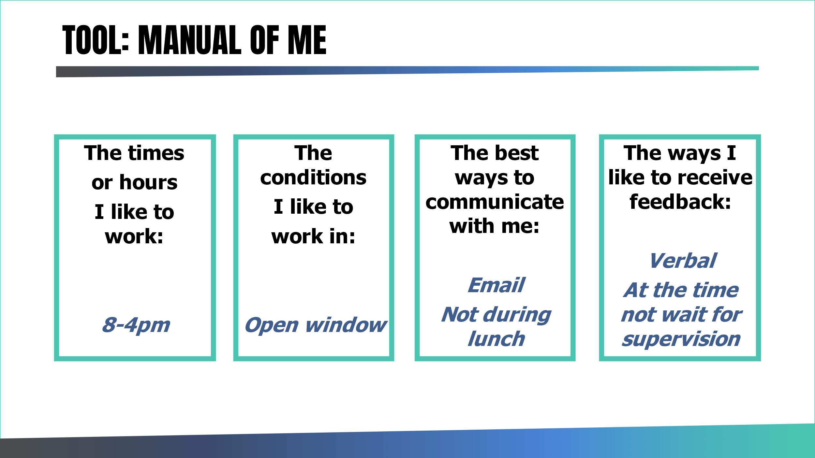

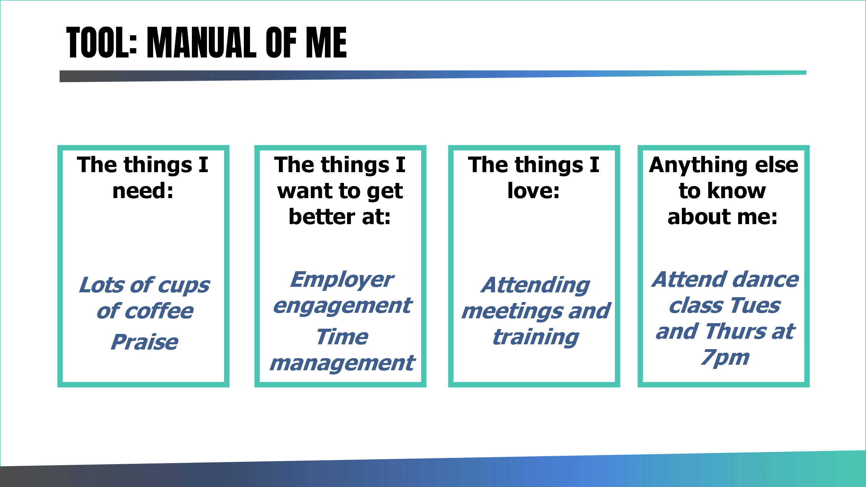

Managing Stress in the Workplace

- Developing a supportive culture
- Clear policy & procedures
- Knowing the signs of potential “burn out”
- Developing staff resilience
- Support from external agencies
- Acting when stress is mentioned
- Role model behaviour
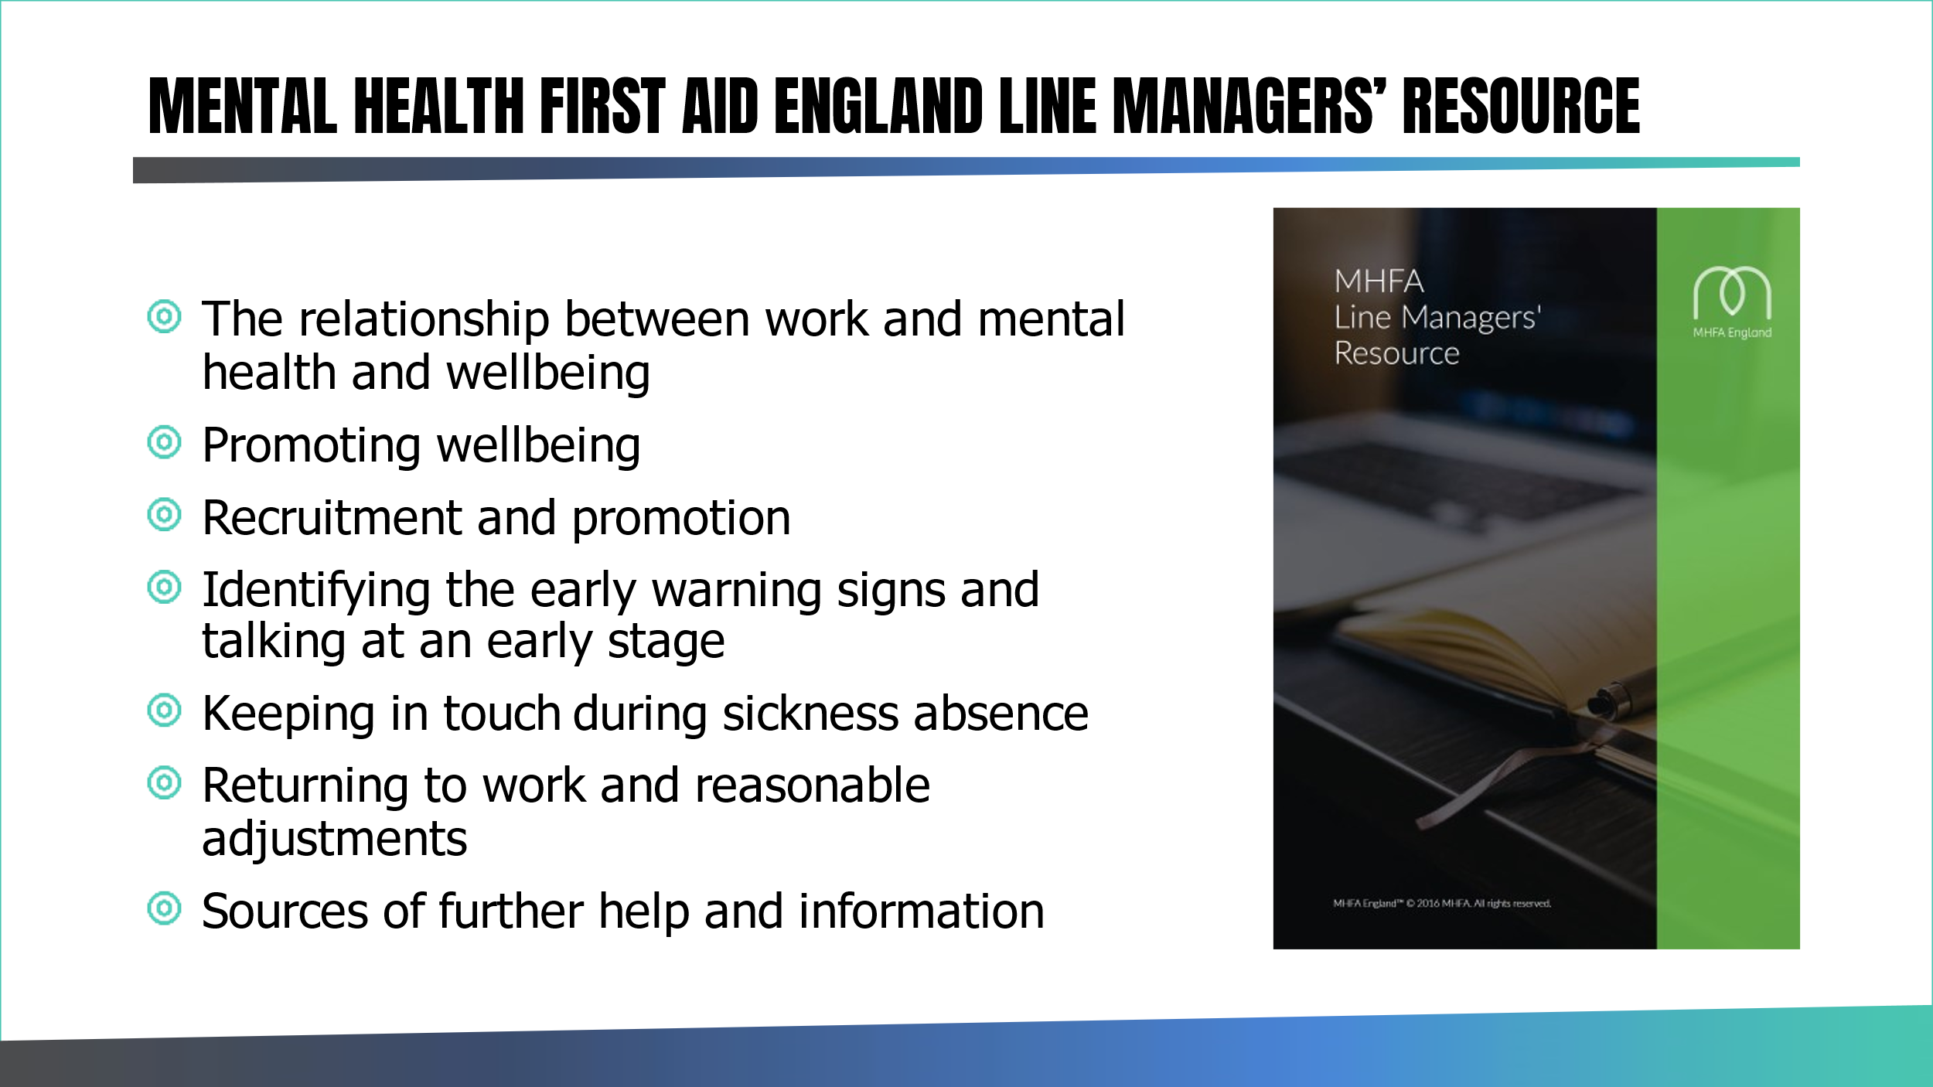

See: https://mhfaengland.org/mhfa-centre/resources/for-workplaces/

Group Activity – Supervision:
10 minutes

Work in three groups:
Group 1 – consider benefits to supervisee
Group 2 – consider benefits to supervisor
Group 3 – discuss types of formal and informal supervision in IPS.

Notes:

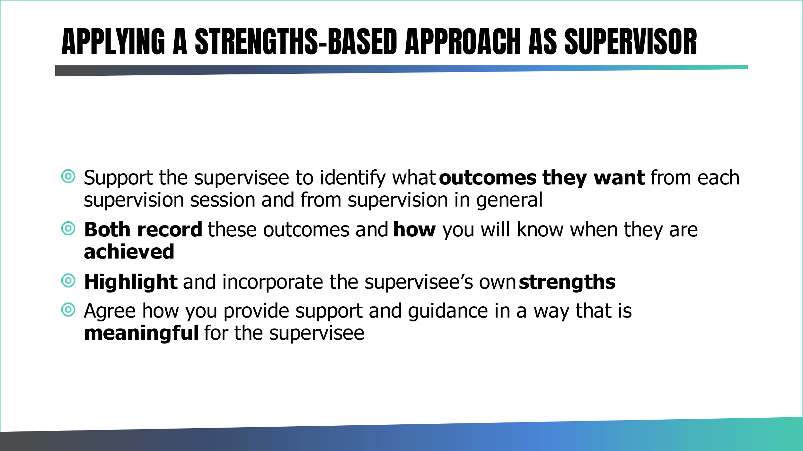

CNWL example of an IPS Contract Supervision Form (Appendix A):
https://ipsgrow.org.uk/ips-provider-community/free-ips-resources/

Notes:

XYZ Technique:
X – When you said or did X
Y – I felt or thought or another team member felt Y
Z – Perhaps you could have done or said Z

Weekly Group Supervision:

Activity:

What should be included in weekly group supervision?

Notes:

Johari Window:

The Johari Window model is a simple and useful tool for illustrating and improving self-awareness, and mutual understanding between individuals within a group.

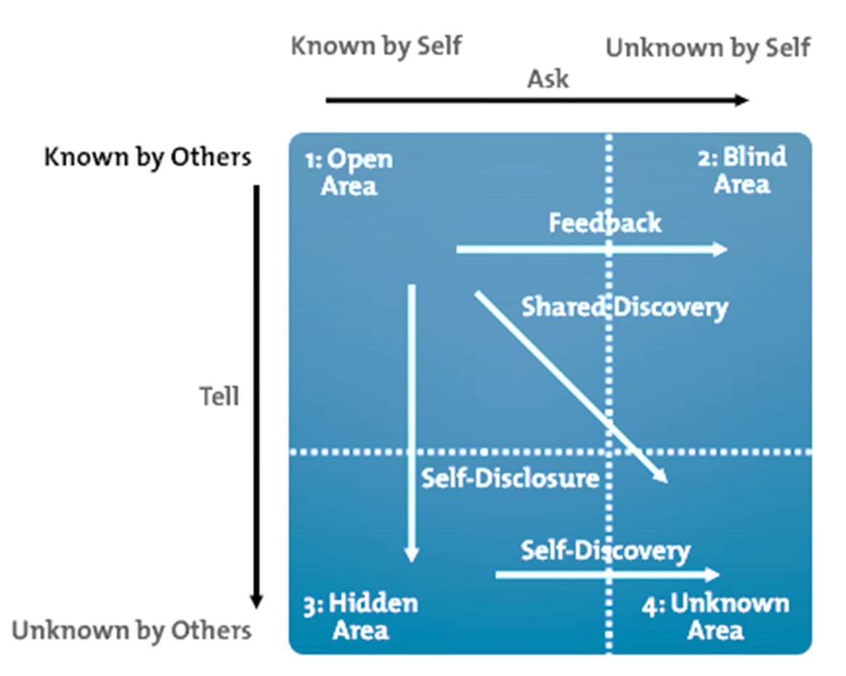

Joseph Luft and Harry Ingham in 1955

- Open (or free) area: Things that the person and others know about them.
- Blind area (blind self, blind spot): Known by others (e.g. you as supervisor, or other team members), but not by self. Asking for feedback reduces the blind area.
- Hidden area (hidden self, avoided self, façade): Known to self, but not to others. Includes ‘secrets’, i.e. things that the person does not want others to know. Disclosure to others reduces hidden area.
4. Unknown area (unknown self, area of unknown activity):
Unknown to self, unknown to others.

Infield Mentoring Checklist:
https://future.nhs.uk/IPSWorkspace/view?objectId=61440933

Activity:

10 mins – observation of ES talking to an employer. Team Leader observes.
5 mins – Team leader gives feedback to the ES. Employer now observes.
5 mins – Employer then gives feedback to the Team Leader. ES observes.

During the skills practice Team Leader to consider the following:

Did ES find out about the business? (history, locations, type of products/service provided)

Did ES find out about different type of roles at employer?

Did ES find out about hiring preferences?

Did ES find out about type of candidate employer feels is a good match? (Skills, strengths, qualifications)

Did ES describe a client who is a good match to employers hiring preferences?

Dis ES explain the service to the employer?
Were there actions agreed at the end of the meeting?
Additional comments:
active listening skills, language etc.

Observation of feedback:

Used examples/facts
Gave praise
Body language/tone
Two-way conversation

Used “I“ statements

Any other comments

Tips for giving feedback:

- Timely – immediate if possible.
- Privately
- Use “I” statements
- Focus on no more than 2 items at one time
- Strike a professional tone.
- Emphasize facts not feelings.
- Watch your words.
- Be direct when giving feedback.
- Make it a two-way conversation.
- Focus on the fix.
- Balance negative feedback with praise.

Notes:

DAY 3

Managing Remote Workers and dispersed teams

Aims of Day 3
Increase Team Leader competence in supporting remote staff and dispersed teams
Improve the support offered to remote workers and increase staff wellbeing, retention and productivity

Definitions:
Remote worker – someone works outside of a traditional office environment.
Dispersed teams – a dispersed team has members who are not located in the same place. For example virtual teams or cross-functional teams.
Homeworker – based and working from home (no organisational base).

What are the challenges for remote workers?
What are the challenges for managing remote staff?
How do you support your dispersed team?

Gap Analysis:

A process companies use to examine their current performance with their desired/expected performance and whether resources are used effectively.

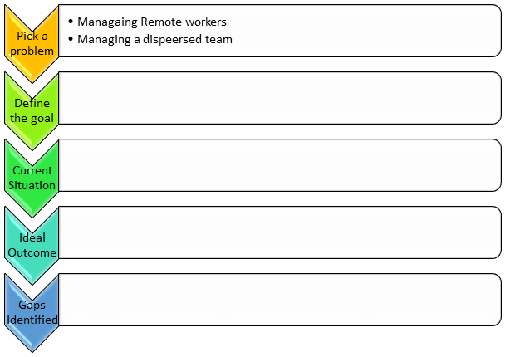
Code of conduct

What do you expect of your team | What do they expect of each other

Remote workers charter
“should there be a national charter for IPS services”
What would you include?

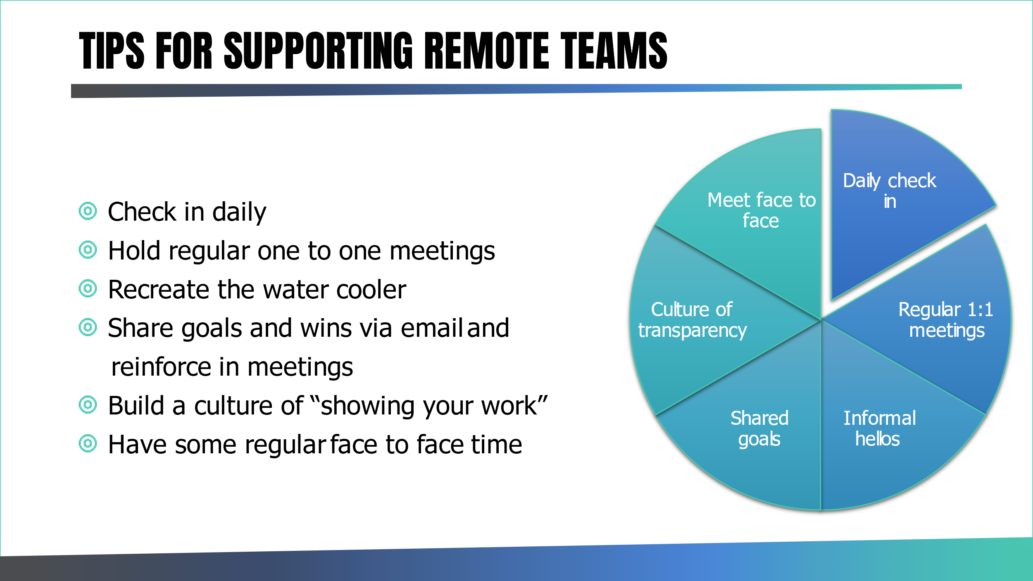

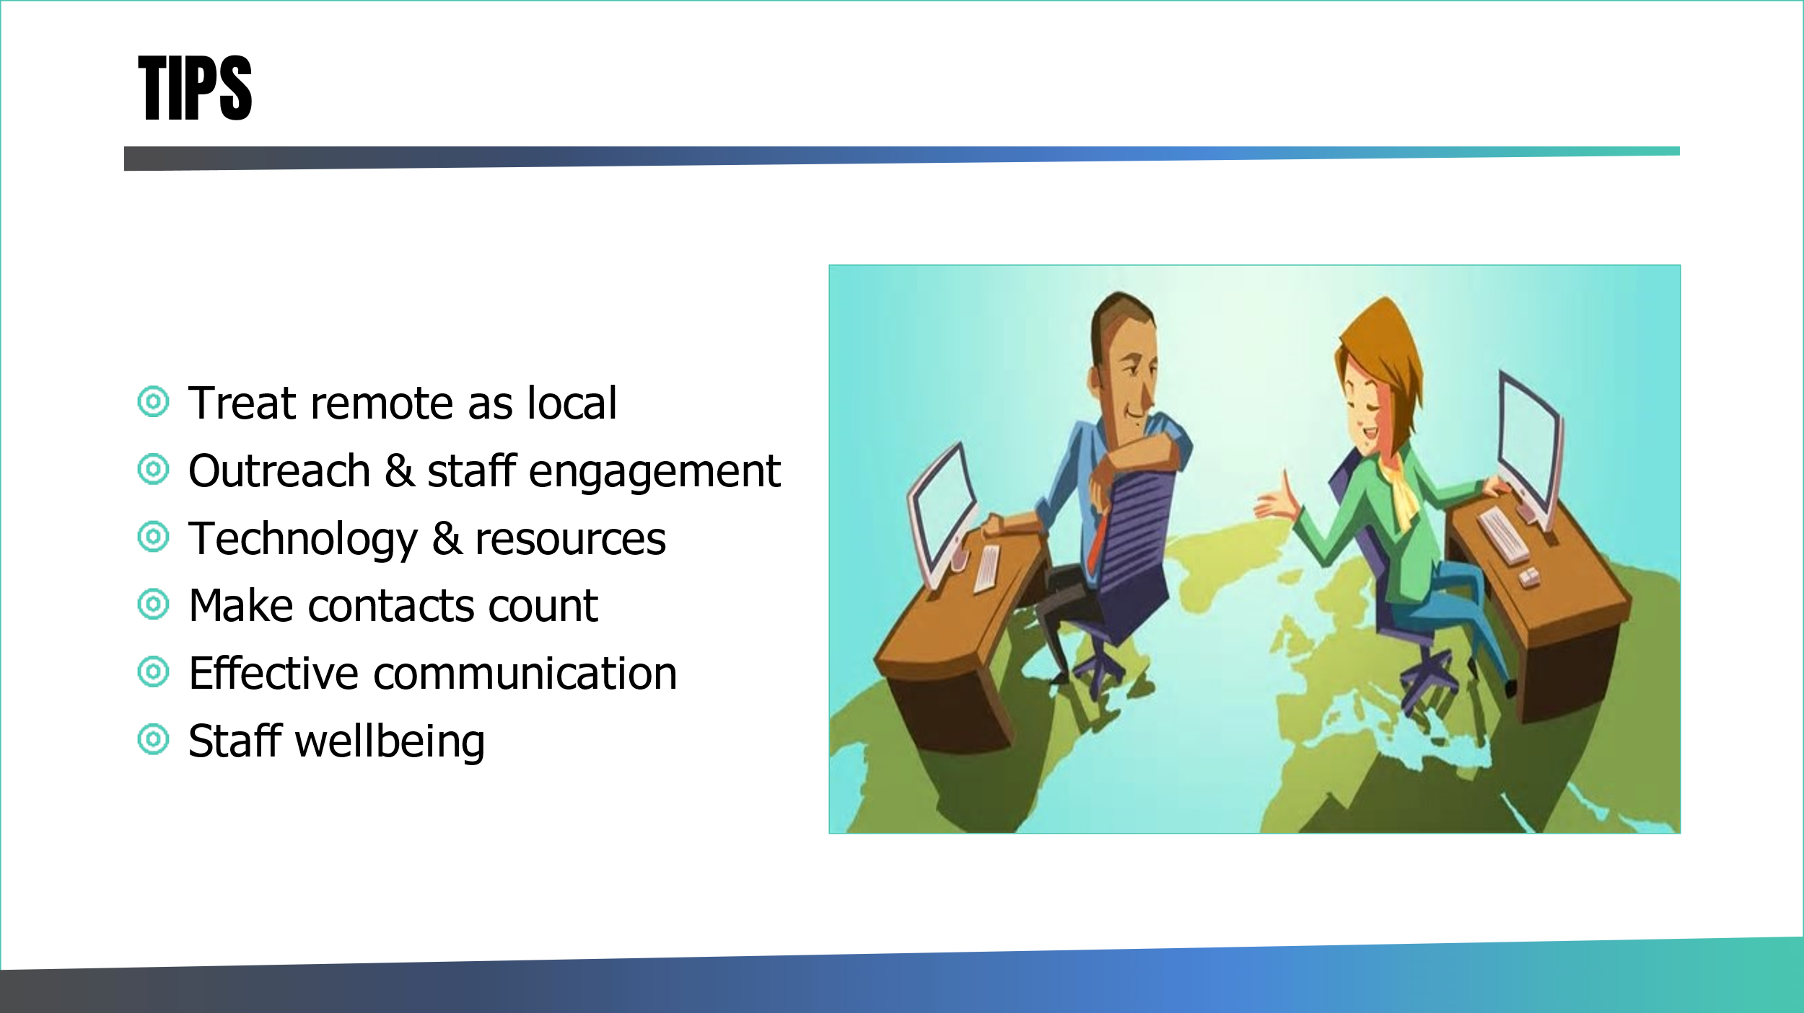

Quality Assurance and fidelity

Quality assurance helps an organisation meet its clients' demands and expectations... It saves costs and fixes issues before problems become larger, and it helps to set and maintain quality standards by preventing problems to begin with.

Investing in quality assurance is indispensable in many systems today.

British Standards Institution on Quality:

“For all organisations it’s essential to be asking how to improve the quality of their products and services to consistently meet their customers’ expectations…”

“Checking that the system works is a vital part of delivery…”

“It is recommended that an organization performs internal audits to check how its quality management system is working. An organization may decide to invite an independent certification body to verify that it is in conformity to the standard…”

IPS Service user expectations:

Time and time again, the service users of IPS state their expectaions from delivery are:
- Want help to find a job
- Want quick access to specialist vocational advice
- Want to be able to see a person when needs be

The IPS Service VALUE PROPOSITION: to help service users find and keep employment

We therefore need to ensure that all our resources, activity and focus is on HELPING A SERVICE USER GAIN EMPLOYMENT.

Quality assurance processes such as weekly and monthly moniotoring of IPS data and self assessment and independent fidelity reviews, all help to ensure the service delivers on its value proposition.

PLAN – DO – CHECK – ACT and ensure we consistently strive to meet service user expectaions and help them gain paid employment – and over time WE GET BETTER AND BETTER AT HELPING MORE PEOPLE INTO PAID EMPLOYMENT.

The Search for Quality

The use of quality control methods is essential for service viabity, continuous improvement and impact.

Quality delivery is best created by involving staff where possible in the measurment, and discussion. Evidence suggests this increases staff commitment, engagement, productivity and outcomes.

Periodic fidelity self reviews and independent reviews are essential to maximise service capability.

Use of information management systems is ideal.

Quality delivery relies on some core factors, among others:

- good leadership
- a focus on quality delivery
- putting the service user first
- error-correction
- improvement as an on-going process
- job development/training for staff

Application of quality pronciples into Individual Placement and Support (IPS)
IPS is a specific type of employment service. Research has demonstrated that this method of supported employment is the most effective approach for helping people with serious mental illness who want to work in regular jobs. Because research has consistently shown that IPS is more effective than other types of employment programs, it is called an evidence-based practice.

IPS is directed by the fidelity scale and manual which clearly outlines what service delivery looks like and should focus on. This guide is drawn from research which identified what practices relate to best job outcomes for clients.

The fidelity scale is a tool to measure the level of implementation of an evidence-based practice. The IPS Supported Employment 25-item Fidelity Scale defines the critical elements of IPS in order to differentiate between programmes that have fully implemented the model and those that have not. As demonstrated through research, high-fidelity programs are expected to have greater effectiveness than low-fidelity programs. The IPS Supported Employment Fidelity Scale is a guide for commissioners and delivery teams to plan for and achieve better employment outcomes.

Understanding the scores: The IPS Supported Employment 25-item Fidelity Scale is divided into three sections: Staffing, Organisation, and Services.
Each of the 25 items is rated on a 5-point Likert scale, ranging from 1 (no implementation) to 5 (full implementation), with intermediate numbers representing progressively greater degrees of implementation. The scale has a maximum score of 125 (25 items x 5 maximum points each = 125).

Programmes that fully implement IPS according to the scale criteria have shown to have higher competitive employment rates than those that do not.

There are 4 main categories to define service practice based on a fidelity review and scoring are in the following table:

Score | Rating | Explanation
115-125 | Exemplary score | The service is operating at a highly advanced level of IPS practice with strong focus on most or all aspects of the fidelity items
100-114 | Good fidelity | The service is operating at a good level of IPS practice with some strengths and likely some areas to still focus on and improve.  Evidence would suggest the main thing for the service to concentrate on with this sort of score is to ensure the team have good integration and are undertaking good and supported employer engagement.
74-99 | Fair fidelity | This would indicate a service is delivering the basic expectations of IPS practice. The service requires a clear action plan and focus to make significant improvements.
73 and below | Not supported employment | The service is not delivering IPS. Major remedial action is required with specialist support or the service needs to be decommissioned or labelled something else.

The fidelity scale can be applied by the service as a self-assessment or done by a peer. These are quick and easy ways to review items and delivery although very hard to be fully objective.

Ideally a service has an independent assessor and review within the first year of operation and then ideally every 2 years after that.

Any type of fidelity review highlights a score per item and provides the service a chance to identify areas of strengths and area for improvement.

The service needs to draft an IPS fidelity action plan based on recommendations in an independent report. This provides you as the supervisor and the team with a clear focus on what quality improvements need to occur.

Ideally action plans are discussed in IPS steering committee meetings so that committee members can suggest strategies to improve IPS implementation.

Again, we must stress that good employment outcomes are correlated to a rating of at least good fidelity.

NOTE: the evidence needed for scoring items in a fidelity review is the evidence you should be tracking every day, week, and month. You need to set up systems to capture in real time quality data that helps you continuously review and improve the service.

Gary Bond, Ph.D. on quality assurance in IPS:

Management experts tell us that successful organizations set goals and measure their success in achieving outcomes tied to those goals. Such is true for IPS supported employment programs: those that track their performance typically are more focused, take corrective action when there are barriers, celebrate their success, and provide upper management with pertinent data. Moreover, unlike many types of other mental health programs, IPS supported employment teams are fortunate to have an obvious set of indicators on which to judge outcomes, namely, competitive employment outcomes.

Quality as a gap and not an absolute

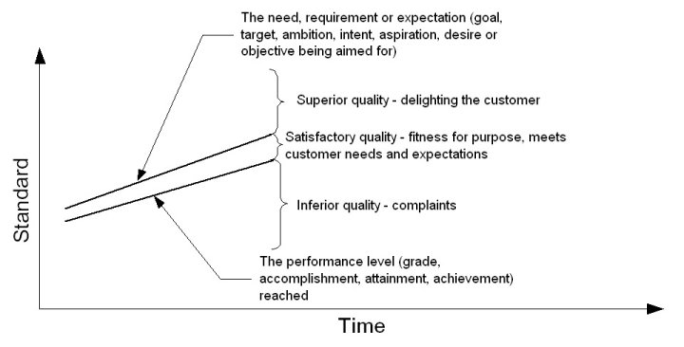

Quality data
Of note, many teams have difficulty tracking competitive employment data and other useful IPS data accurately and even more fail to review and plan to improve on outcome data on a regular basis.

The Basics to remember:

- Real time tracking of quality data is critical.
- Real time checking of quality data accuracy is critical.
- Real time analysis and improvement planning of quality data is critical.

- Collect data that is linked to IPS impact around job starts and job sustainment
- Collect data that is linked to IPS best practice delivery and promotes quality improvement – e.g., job terminations and dropouts.
- Collect data that is linked to IPS experience – e.g., service user, clinical staff, employer feedback
- Collect data that is consistent with your contract/ reporting requirements

Small group exercise:
In groups discuss how to manage day to day service delivery quality in IPS?

Hints:
What do we collect and track? – review fidelity template
Who does the data entry?
Who reviews the quality evidence?
How check accuracy of quality evidence/data?
How often report on quality evidence/data?
Why and how celebrate success?

When to collect quality data?

Job start and job end data must occur in real time.

It is critical for the Supervisor to review job outcome data weekly and analyse and report back to the team on findings. The aim is to identify the positives and strengths of the service first and then focus on the key issue for focus in the following weeks of the month.

It is then advised for the supervisor to analyse and report on outcome data monthly as data reporting for a short interval allows a more accurate review of the time period and attributing key issues to make sense of the data.

The end of month analysis would look at other IPS quality data aside from job outcomes and linked to key IPS best practice as flagged in the 25 fidelity items. This could include ES caseload size, ES referral sources, time between VP and first employer engagement, number of employer contacts per ES over the month etc.

Ensure you create a regular schedule for when the end of month analysis occurs, so staff are aware when the cut off is for their data input. Ensure you diarise time for you to undertake the end of month review of quality data and create a quality/performance report for your service.

Who collects it?

Employment specialists are responsible for maintaining the database for their own caseloads. No one else is more familiar with the outcomes for a group of clients than the employment specialist working with them. There may be occasions when clients get jobs unbeknownst to their employment specialist, and when this is discovered, the database should be changed accordingly.

Have a single point of responsibility for data quality.
If you are to have a successful data collection system, you need one go-to person to pay attention to the entire team's outcomes. In some places, this may be the team leader; in others it may be an administrative assistant. The team size will affect the decision for how best to manage the data collection. Someone needs to be responsible for ensuring timeliness of reporting and checking for obvious errors. Employment specialists should have deadlines for entering all outcome data, e.g., the 1st day of the month.

How is it collected?
- Ideally you have a data base/case records system, and each ES enters their own client data.
- Ensure staff are clear how to record all quality information in a standard way
- Use electronic spreadsheets as an alternative to your data base – a good example of use would be for tracking employer engagement
- Remember to have a system to periodically check the accuracy of the data

What do you do with it?
Quality data needs to be reviewed regularly and that gives you the chance to either CELEBRATE great service impact or to take remedial action working with the team to find ways to improve the service.

Set job outcome targets and review.
Set clear monthly and yearly targets/standards (such as expected starts per month, expected jobs per months) and measure and review. remember after public holidays and approved leave your staff are working over 10 months so targets need to be divided by 10 months versus 12 months.

A review of job outcomes needs to occur regularly to allow a focus and action. This could occur via email each week and verbally at a team meeting as the month progresses and an overall wrap up of the months results could be shared via email in the first week of the new month.

Do not be afraid to create a table which highlights each ES job outcome targets for the year and progression against that target each month. The idea is to then draw on those that are meeting or exceeding their targets for ideas and inspiration for others that are not.

Remember to keep an eye on the number of times the same client starts a new job per ES. Part of IPS is certainly helping people try to find the right job and this may take a few attempts. However not every client should need a few attempts on an ES caseload and may be an indication of a practice issue to explore.

Meet with your ES in their monthly supervision to discuss their own performance against all targets.

Create ways to capture and review other key IPS quality indicators.
Set standards for other IPS quality indicators and compare performance to standards monthly to identify issues that may need to be improved.

Some ideas (inspired by reviewing the fidelity template and guide):
- Active caseload size per ES
- Referral source per ES
- Time between VP and first contact with employer
- Number of employer engagements by individual ES each week
- Quality of the employer engagement done
- Number of clients that leave the program

Create ways to analyse and create quality reports.
Create a service wide quality report at the end of each month that captures the aggregated whole team or different teams’ performance. Remember the aim of the report is to then provide you with insight into your key action for the coming month. Easy to read graphs may be a better representation than dense script.

We suggest you create a table with a rolling comparison of the same month from previous year and the month in the current year and this way you can see if performance is increasing, staying the same or falling back. Also identify potential trends and comment on those to understand your service delivery area.

We suggest you leave a few days at the beginning of each month to focus on gathering, analysing, and creating your quality report. The aim is to complete a review and report on the previous month within 5 days of the new month. This report can be shared with the clinical service manager, Trust senior Exec contacts, steering committee members etc. By creating a monthly quality report, you ensure you capture key events in that month and have that on record for review.

Create ways to check accuracy of data.
A review of key performance data weekly or monthly with the team allows a sense check of the data entered.
A file review on a sample of open and closed cases each month also help you build up a picture of delivery and data accuracy.
Qualitative versus quantitative feedback
The experience of people coming into contact with the service is another important form of quality data
This could include client feedback, clinical staff feedback, employer feedback to name a few.

Client feedback at the mid-way and end of service point can build a picture of some of the strengths of the service and highlight areas for improvement. Areas that often fall a bit as reported by clients:

- Slow response time from my ES
- Hard to contact my ES

If this is a service-wide issue, then there may be some dramatic cultural issues to tackle. If it is linked to one ES, then a need to see what is happening for that person and support them to manage their client engagement more responsively.

CELEBRATE SUCCESS
Find ways to recognise good performance and celebrate, ideally daily, weekly, and monthly. Research would suggest that your best to focus on finding team performance and team success versus singling out individuals.

PRIORITY MATRIX TOOL:

The priority matrix to help you start planning for success and move from constant fire-fighting

A useful best practice matrix you can use to reflect on how to best to allocate your time is offered below:

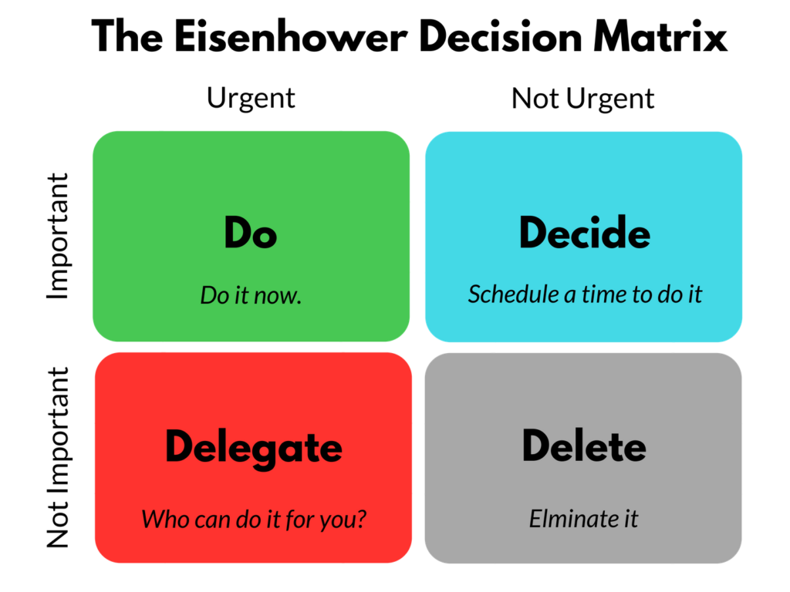
You need to rate your daily and weekly tasks based on urgency versus importance and in doing so be able to carve time to do the things that matter.

The aim is to identify those tasks that you must complete asap (high importance and urgency e.g., managing a staff absence, handling a request from the Commissioner)

However, ensure you make time and plan to complete those tasks that help with service improvement. These tasks need time scheduled in your diary to complete as they help the service function (e.g., analysis and writing of monthly report – high importance and low urgency).

Ideally you create time by identifying those time wasters.

Priority matrix review

Exercise: 5 mins

Consider your day yesterday and identify one thing for each of the quadrants of the priority matrix.
Could you have done anything differently?

Important & Urgent: | Important, but not urgent:
Urgent but Not Important | Not Important & Not Urgent:

Key links for resources and tools:

https://ipsgrow.org.uk/

https://www.centreformentalhealth.org.uk/topics/ips-employment

IPS Steering committees

Aims and purpose
An IPS steering committee is defined as a diverse group of stakeholders charged with reviewing fidelity, program implementation, and the service delivery system. The purpose of the meeting is to ensure that fidelity and performance of the IPS service is continuously monitored and improved. Implementation and sustainability should not be delegated solely to the IPS team and other stakeholders should have a role within this. The committee develops written action plans aimed at developing or sustaining high fidelity services.

The main functions of the group are to:
- Provide leadership, governance and decision making to the successful development and implementation of the IPS Service
- Ensure the project aligns to the strategic direction of the Trust, the Five Year Forward View for Mental Health, the NHS Long Term Plan and all statutory requirements
- Ensure the project delivers within its agreed boundaries (e.g. cost, organisational impact, expected benefits etc.)
- Resolve any strategic and operational issues and challenges associated with the implementation of the project, that require the input and agreement of senior stakeholders to ensure progress
- Manage the identification and mitigation of any risks or issues that arise and escalate as necessary to appropriate boards
- Discuss and agree service evaluations and new developments
- Ensure all board members work collaboratively to ensure the successful delivery both practically and strategically

For Wave 2 transformation-funded services, IPS Grow recommends an STP level and an IPS provider level meeting to make joint decisions across the wider system.

Who should attend?
- One member of executive team (someone who sits at board level)
- NHS trust representative – e.g. senior clinician/pathway manager (band 8 or equivalent)
- Employment Specialists/TL’s
- Service users/carers
- DWP representative – e.g. partnership managers
- NHS England - STP or locality lead
- IPS Grow regional lead
- Commissioners
- Implementation manager
- CEO (if third party IPS provider or no service manager)
- Comms/Finance/HR/IG as and when required

Who should chair the meeting?
Any of the following individuals would be a suitable chair for the steering committee meetings:
- IPS operational lead
- Commissioners
- Public Health England
- STP lead
- AHP lead
How do we encourage attendance?
- Using the fidelity scale/manual
- The importance of joint decision making for IPS service
- Shared ownership & accountability
- Improvement of quality of IPS service through partnership working
- Recovery strategies and sustainability of services
- Support with organisational change on a wider scale
- Use of relationship with NHS England leads to drive attendance of key individuals where needed
How often should the group meet?
- At least every 6 months for high fidelity services and at least quarterly for those who have not yet achieved high fidelity
- Monthly/6-weekly meetings for new services or those implementing change
Example agenda items & template
- Fidelity action plan (item 11 on fidelity scale, executive team support for SE)
- Budgets
- Organisation/Trust focus on competitive employment (item 10 on fidelity scale)
- Share information about service barriers & facilitators
- Policy/procedures
- Marketing & communications
- Co-production
- Information governance
- KPI’s/performance/trajectories/predicted positions
- NHS Long term plan planning
- Case study/good news story from client or ES
- Updates from stakeholders in attendance

*EXAMPLE*
IPS Steering committee agenda
DATE & TIME
VENUE & POSTCODE
Agenda item | Notes
1. Welcome, introductions, and apologies
2. Update on actions from last meeting – action log
3. Implementation update since last meeting
4. Data
5. Fidelity Action Plan and review
6. NHS Long Term Plan and planning for upcoming years
7. Case Study
8. Co-production
9. Future of the steering group
10. Partner updates- IPS Grow/ DWP/ Public Health
11. AOB
12. Agenda items for next meeting
13. Date of next meeting

Individual Placement and Support Project Steering Group
Terms of Reference

Vision – Enable service aims to:
Our partnership brings together x with the x NHS Mental Health Trusts in region x
In conjunction with ? we’ll deliver a single IPS service that aligns and improves employment support for people with severe mental illness (SMI) in our region.
Expand
How will we do this?
Outline Funding streams
Define Teams – 2 teams made of FTE, focus on where? how ensure seamless delivery

The new service will transform access to employment support for people with SMI. Employment specialists will fully integrate within secondary mental health services. They will attend team meetings, including CPA reviews, and work collaboratively with mental health professionals to identify suitable referrals.

People in contact with secondary mental health services will be able to self-refer online and book an initial appointment.

Services users will be given the support of trained employment advisors working on the IPS principles. These case workers will be responsible for supporting both in and out of work participants and individuals on the programme will require a range of employment, health, and wider support. Employment advisors will draw on a range of activities, approaches, and wider support to assist their clients on their employment journey as required.

Purpose of the Steering Group
The IPS Project Steering Group will support the implementation and delivery of the XXX Individual Placement and Support service and ensure we constantly improve access to the service and employment outcomes for service users.
The main functions of this group to drive access and improved employment outcomes are to:
- Provide leadership, governance and decision making to the successful development and implementation of the IPS Service
- Ensure the IPS project and employment aligns to the strategic direction of the Trust, the Five Year Forward View for Mental Health, the NHS Long Term Plan and all statutory requirements
- Ensure the IPS service and employment outcomes are shared widely as part of the Trust and STP culture
- Ensure the project delivers within its agreed boundaries (e.g. job outcomes, cost, organisational impact, expected benefits etc.)
- Resolve any strategic and operational issues and challenges associated with the implementation of the project, that require the input and agreement of senior stakeholders to ensure progress
- Manage the identification and mitigation of any risks or issues that arise and escalate as necessary to appropriate boards
- Discuss and agree service evaluations and new development
- All board members to work collaboratively to ensure the successful delivery both practically and strategically.
The group will also monitor to ensure effective liaison and joint working with the IPS Service and key stake holders (insert CCG, NHS, JCP etc.) is maintained, through 6-monthly meetings between the Service and Team Leads for each party.
The group will also maintain constructive working relationships with IPS Grow and the Centre for Mental Health.

The steering group is important to drive quality IPS Fidelity.
See IPS Fidelity Scale Item 11: UK IPS Fidelity Scale
https://www.centreformentalhealth.o?/.///////////+rg.uk/sites/default/files/uk_ips_fidelity_scale_2019_1.docx

Nb scale is also provided in pre-course information.

Membership, Roles and Responsibilities
Membership of this group must include as a minimum a commissioner from the CCG/STP, a clinical director of operations from the Mental Health Trust, a representative from the local JCP/DWP and the service manager from the IPS service. All the essential members must have the time and authority to help make decisions and act on recommendations within their respective organisation in order to best remove barriers for delivery.
Other membership should reflect the diverse range of stakeholders of the IPS service as follows:
- Service users
- Family and/or carers of service users
- Peer support
- Clinical team leads
- Employment specialists on a rotating basis
- Disability Employment Advisors (DWP)
- Council CCG and Trust leadership such as CFO
- IPS team management
- Employers
- Lead Occupational Therapists
- People Participation

Group includes:

Organisation | Name | Role
CCG/STP
Mental Health Trust
IPS service
JCP/DWP

Ways of working: Topics for the agenda will be generated by group members and the chair and meeting papers will be circulated by email at least two working days before the meeting.
Some agenda items may involve smaller group discussions. Non-members may be invited to meetings if this is agreed by the group.
Minutes for the meetings will be taken by an Enable staff member and shared to the group with clear actions within 5 working days of the meeting.

A shared learning approach will be taken, and sub-groups will be convened to work on individual pieces of work if necessary.

Sharing of information and resources: Group members will share information and resources via email between meetings if necessary.

Accountability: Group members are responsible for reporting back to the group on any agreed actions.

Attendance at meetings
There may be occasions when members are unable to attend. Members of the Group agree to nominate substitutes in their absence and will notify the secretariat of their intention to do so as soon as possible. Substitutes must have enough expertise and experience to be able to be an active participant in the meeting, with authorization to act on behalf of the member. They should give a clear steer as to the extent of their decision-making powers at the start of each meeting.
Chair
The meetings will be chaired by …………. in the first instance, with …………. as stand in/shared chair, this will be subject to review as the service moves into business as usual.
Frequency of meetings

It is expected that the initial first year’s meetings will need to occur monthly at office x or via teleconference/video conference. It is expected that after 12 months and quality improvements the meetings can move to bi-monthly or quarterly.
More frequent meetings may be required at the request of members or the if any urgent matter arises between meetings that cannot wait for resolution until the next scheduled meeting.
Actions
Short minutes with clearly defined Actions will be taken at every meeting to represent subjects discussed and ensure the delivery of the detailed project plan. These will be taken by the secretariat and circulated within 5 working days.
Review:
The effectiveness of the steering group and the ToR will be reviewed annually.

Another way to support the Steering committee could be to also have the Trusts/ CCG/STP/Team to sign a collaboration agreement such as:

The Collaboration Agreement signed by all Trusts references the steering group as below to define the trust responsibilities as part of the partnership.

IPS Steering Group

- Each Party shall appoint one senior management team executive (and one or more further individuals as may be agreed) as its appropriate representative(s) within 10 days after the date of this Agreement who, together with the representative(s) of the other Parties and individuals appointed shall comprise the steering committee of the IPS Programme.
- The Lead Provider, in consultation with the other Parties, shall ensure that individuals with lived experience of severe mental illness shall participate on the IPS Steering Group, as appropriate and in accordance with IPS Services Contract.
- The operating principle of the IPS Steering Group shall be reaching consensual agreement.
- The Lead Provider’s principal representative shall chair the IPS Steering Group.
- The Parties may agree that the representative of another Party may be vice-chair.
- To the extent consensual agreement of the IPS Agreement is not achieved and a decision of the IPS Steering Group is needed, the principal representative of each Party shall each have one vote and in the event that there are equal votes for and against any matter, the Lead Provider principal representative shall have the determining vote.
- The Parties shall promptly agree the initial procedures of the IPS Steering Group, on the basis of recommendations from the Lead Provider;
- The Lead Provider shall reasonably manage the procedures of and provide the administration for the IPS Steering Group;
- The principal representative of the Lead Provider shall chair the IPS Steering Group.
IPS Steering Group shall (subject to the Commissioning Contract and the role of the Lead Provider):
  - Further develop the IPS Programme to optimise its delivery in accordance with the Commissioning Contract;
  - Formulate Standard Operating Procedures that will govern the implementation of the Project;
  - Agree the division of operational responsibilities between Parties and any powers of delegation;
  - Develop the IPS Steering Group procedures and establish any sub-committees, with appropriate remits;
  - Conduct all required performance monitoring, reviews and assessments;
  - Formulate communications strategies related to the IPS Programme, including any communications to external media, government and/or stakeholders (subject to the Lead Provider’s direct obligations under the Commissioning Contract;
  - Use reasonable endeavours to facilitate collaboration in the agreement and implementation of any necessary adjustments to the Project arising from any performance failure of any Party; and
  - Use reasonable endeavours to resolve any problematic issue, disagreement, or dispute.
  - The IPS Steering Group shall (subject to contrary resolution of the IPS Steering Group) meet on a quarterly basis with appropriate provision for virtual attendance.
  - Minutes and agreed actions will be recorded for each IPS Steering Group meeting and promptly circulated by the Lead Provider;
  - Each Party shall report to the Lead Provider promptly in preparation for each IPS Steering Group meeting, highlighting:
- The progress of its activity under the IPS Programme during the previous month;
- Material issues being managed;
- Material issues requiring the help, guidance, or decision of the IPS Steering Group; and
- Planned developments and progress for the next month and into succeeding months.

Exercise:

Group activity approx. 15 minutes.

Review these resources:
- Setting up a steering committee guide
- Terms of Reference
- Collaboration agreement for members
Explore the challenges of establishing an effective steering committee and discuss and identify solutions that could overcome these challenges.

Notes:

Creating a strong team climate:

With a strong team climate and a supportive leadership style, the team can withstand operational challenges/stressors and still perform. This combination yields high levels of discretionary behaviour (teamwork, loyalty, effort).
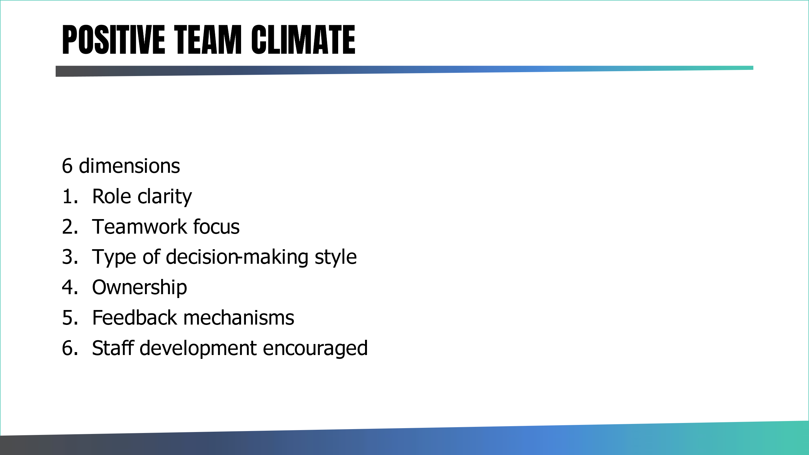

Tools to achieve a strong team climate include:
- Supportive leadership style
- Performance achievement system and development
- Quality system which is straightforward, supports and improves practice, ensures customer needs are met and consistency of service – incl. field mentoring!
- Performance management system
- Staff engagement strategy
- Yearly business planning
- Quarterly reviews
- Team meetings
- Individual supervision and coaching
- Weekly email

Managing change

Change is a part of working life. As managers you will be introducing changes when you seek to improve your services. ​Some changes may seem small to you, but they can become huge difficulties for others.​
​
Many theroies of change talk about people experincing a process as they work through the change from the old to the new. See table below:

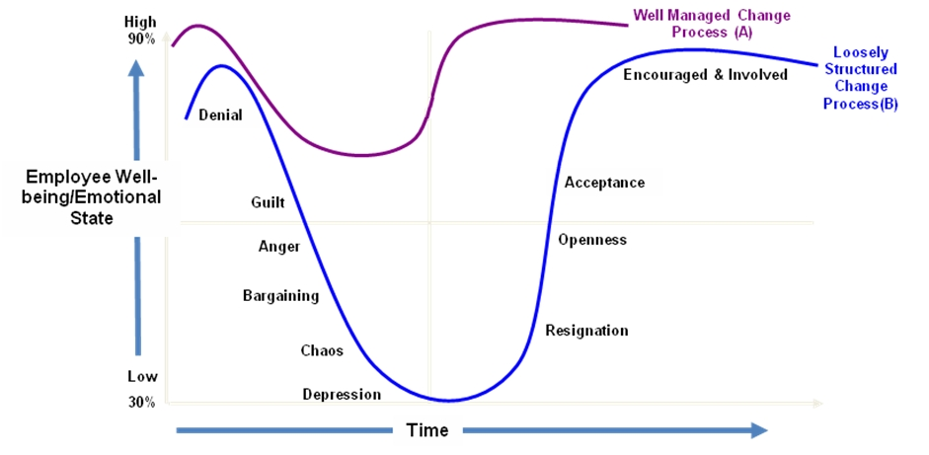

Helping staff manage change is an essential part of your role.
People sometimes move forward in adapting to the change and then take a step back. This is expected and known in the change management literature as “change resistance”.

Resistance to change is not only a psychological reaction to change but actually a physiological reaction (see: Neuroscience of Leadership by David Rock and Jeffrey Schwartz). To act in a new way requires MORE power from the brain. The physiological way of reaction when presented with a new way of doing something is to revert back to what the brain already knows – people can adapt and change and its just a difficult and painful process even for the brain itself.

Likely sources of resistance include:
- Employees who are invested in the previous way of working
- Employees who fear more work with the new way of working
- People who in the past have been rewarded for their efforts doing the former way
- The above groups are likely to be resistant and need specific 1:1 coaching/support to understand their root cause for resistance.

At some point though change occurs. Change then needs to be re-enforced.

The supervisor needs to play 5 roles in the change process:

- Communicator: communicate with direct reports about the change
- Advocate – Demonstrates support for the change
- Coach – Coach employees through the change process (CBAM model great for this!)
- Liaison: Engage with and provide support to the change team
- Resistance Manager: Identify and manage resistance (CBAM model and requires dealing with confrontation)

Effective change communication approach

- Preparation – set the scene
- Sell the idea of the change and the benefits it will bring
- Collaboration
- Involve people who will be affected
- Develop a common vision
- Listen to the challenges
- Address any fears
- Produce evidence
- Build resilience

NOTE: Great book to read on change: Who moved my cheese by Dr Spencer Johnson
See overview summary: https://www.rethink.co.tt/5-lessons-i-learned-from-who-moved-my-cheese/

DAY 4

Day 1 & 2 Reflections
Using the Gibbs model of reflection consider what you have learnt so far.

Description | Feelings | Evaluation | Conclusion | Action

Data for IPS Services

Aims
Supporting services to capture and more effectively use data for the ongoing service improvements & development including increasing in performance management, fidelity and equality and diversity of staff and clients.
Objectives
- Understand what we mean by Data for IPS services
- Provide an overview of key data requirements and the responsibility of the team leader.
- Share best practice and examples of how to collate and present data.
- Demonstrate resources and tools.

What would you like to get out of this session?

What do you currently capture? | Where is this captured? | Who is this information for? | How is it used? | Is it IPS Specific? | Is it needed? | Fidelity Item | Notes

Data Maturity

Where would you rate yourself and why?

IPS Grow IPS key performance and outcomes framework.
Thoughts/comments?
Have you seen this document? Does it inform your practice? Any unknowns?

Individual Vs team KPIs
Complete this exercise for having both individual and team targets.
Pros | Cons
Intended Consequences | unintended Consequences
Complete Page 7 Checklist on Independent Organisation: MHSDS Guide - IPS Services - Individual Placement and Support (IPS) - FutureNHS Collaboration Platform
Fidelity
Date of last review | Fidelity Rating | Date of next planned review? | Actions required

Client feedback / Co-Production
What examples do you have of co-production?
How do you currently gather client feedback?
What feedback do you ask for from clients?

Using Data Effectively
Assignments - Technical
- Review your data, draw up conclusions.
- Review what you collect, how you collect it, who this is for and how it is helpful, present back actions to improve your data.
- Provide an appropriate summary for either ES, SLT, clinicians,
- Review MHSDS data against for local outcomes
- Complete Measuring up exercise for your team and or clients

Technical Competence
Role modelling & Coaching for better outcomes
Aims and objectives:
- To improve team leader confidence and competence in being able to both role model and coach best practice.
- Increase client experience
- Reinforce Employment Specialist competence
- Improve client outcomes.
- Highlight best practice on a range of fidelity items.
- Provide tools and resources to support ES/front line delivery and the client journey.
- Demonstrate what good practice look like?
- Self-assessment against fidelity items
- Complete individual SWOT analysis

- Create individual Team action plans Gain an increased understanding of Principles of IPS

Consider what good looks like for your team/service?
If you were to honestly review your service, what fidelity rating would you give and why?
What are the non-negotiables for your service’s minimum standards?

Employment specialist competence
What do we mean competence? What do you look for/expect from staff?

How can you maintain and or increase people’s competence?

Exercise:
Consider the current skill set or a team member and complete and the below SWOT analysis. 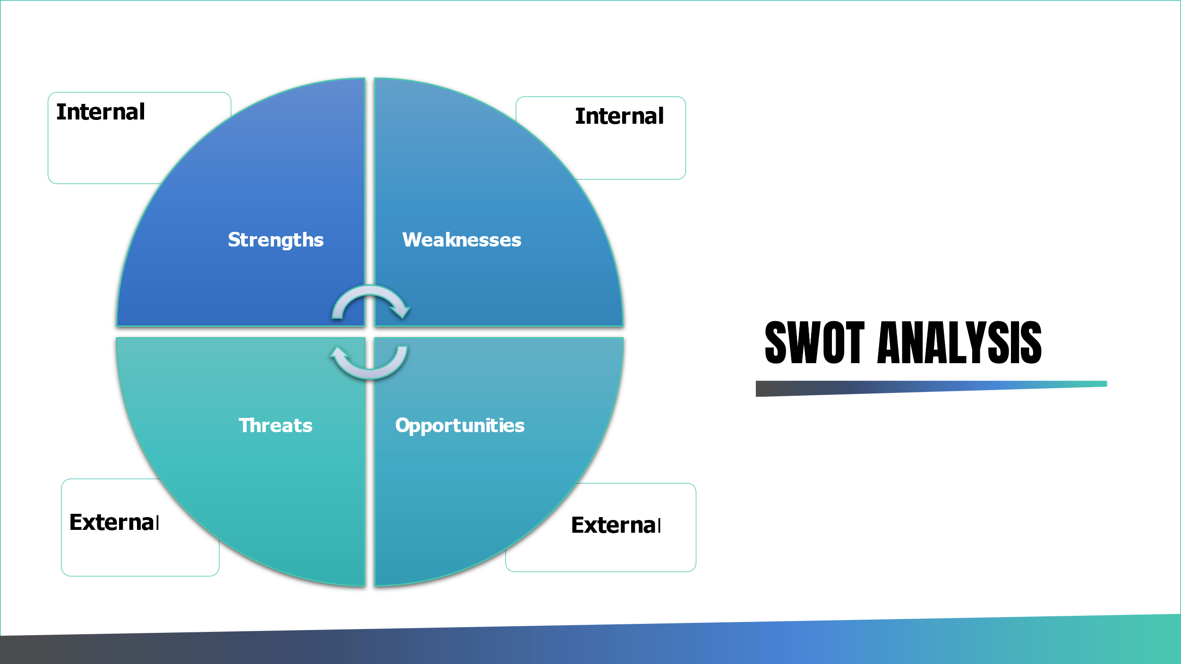

Strengths | Weaknesses
Threats | Opportunities

Supporting the client journey
What does a successful client journey look like?

How would you know when to review the support being offered?

At what point can and do clients give feedback?

Do you know the clients?

Case Conferencing scenarios activity

Break into groups and discuss your allocated scenario and work through as a small group. Return to plenary and present back an action plan.

For each scenario consider:

- What is the problem you are trying to address?
- What is the outcome you are looking for?
- What actions will you take to achieve this?
- How will you evidence this outcome?
- What fidelity items does this impact on?

Group 1: Service Promotion
Some workers in your team do not have full caseloads and seem to struggle to gain new referrals and report that there is limited demand for employment support. As a service you are below your trajectory for both your access and your outcome targets. Clinicians feedback that clients are too unwell to work.

Group 2: Initial assessments
Employment specialists report that clients often disengage during the initial assessment process, and that most clients quickly become disheartened when they find out employment specialists can't give them a job. On average data shows that rapid job search occurs within 60 days of an initial assessment. A recent review also highlighted that few clients seem to receive benefits counselling and most clients don't want to disclose any personal information to employers.
Group 3: Active Support
As a team your outcomes are generally good, but on closer review of the data you see that you have team members who consistently exceed their targets and others who regularly full below expectations. Employment specialists often say clients don't turn up for appointments and don't follow through with actions. There is little evidence of employer engagement taking place. Vocational profiles often have limited information and very generic job goals such as “looking for part time retail work”. Action plans read as if they are a record of what has been done and not a proactive plan for what needs to happen.

Group 4: Step down support
There seems to be a reluctance from employment specialists to support clients to move beyond the IPS service with many workers taking the time unlimited support principle literally. The service has clients on the caseload who have not been seen for several weeks and several clients who are in work and only contact the employment specialist infrequently to update them on their progress. Once employed clients are often told to contact the employment specialist if there is a problem and are typically left open on the caseload for undefined amounts of time.

Group 5: Fidelity
You are confident in your teams ability to deliver an effective service, but there is a lack of hard evidence to support this for fidelity purposes. Some workers openly say they cant do both deliver and record evidence and suggest the choice is either help people get jobs or do admin. There is a culture of focussing solely on jobs for clients but a reduction in the amount of quality evidence to show the client journey and evidence for fidelity.

Principles of Support | Ethos, values & Spirit of IPS
Competitive Employment is primary goal
Zero Exclusion
Honouring Client preferences
Rapid Job Search
Integration with Mental Health Treatment Teams
Employer Engagement
Availability of time unlimited support
Benefits Counselling

Integration with Mental Health Treatment Teams
How do you support and develop this as a team leader?

Employer Engagement
How do you support and develop this as a team leader?

DAAM Model:
When managing poor performance think the following four areas:
  - DIRECTION – Does the ES understand the journey/purpose?
  - AUTHORITY – Does s/he realise they have the relevant authorities to act?
  - ABILITY – Is the issue about their ability?
  - MOTIVATION – How motivated is the ES?

Problem Tree
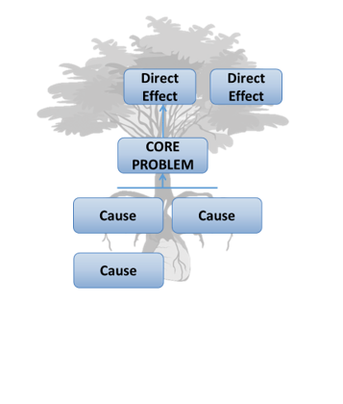
The problem tree helps you think of a problem in a manner and provides a structured way to analyze it.
It pushes you to deconstruct all possible causes for the problem rather than the obvious ones.
Brainstorm problems related to issues in one of your projects.

Consider the principles of IPS and label the core problems and arrange the remainder into causes (contributors) and effects (negative results because of the problem).

Caseload management
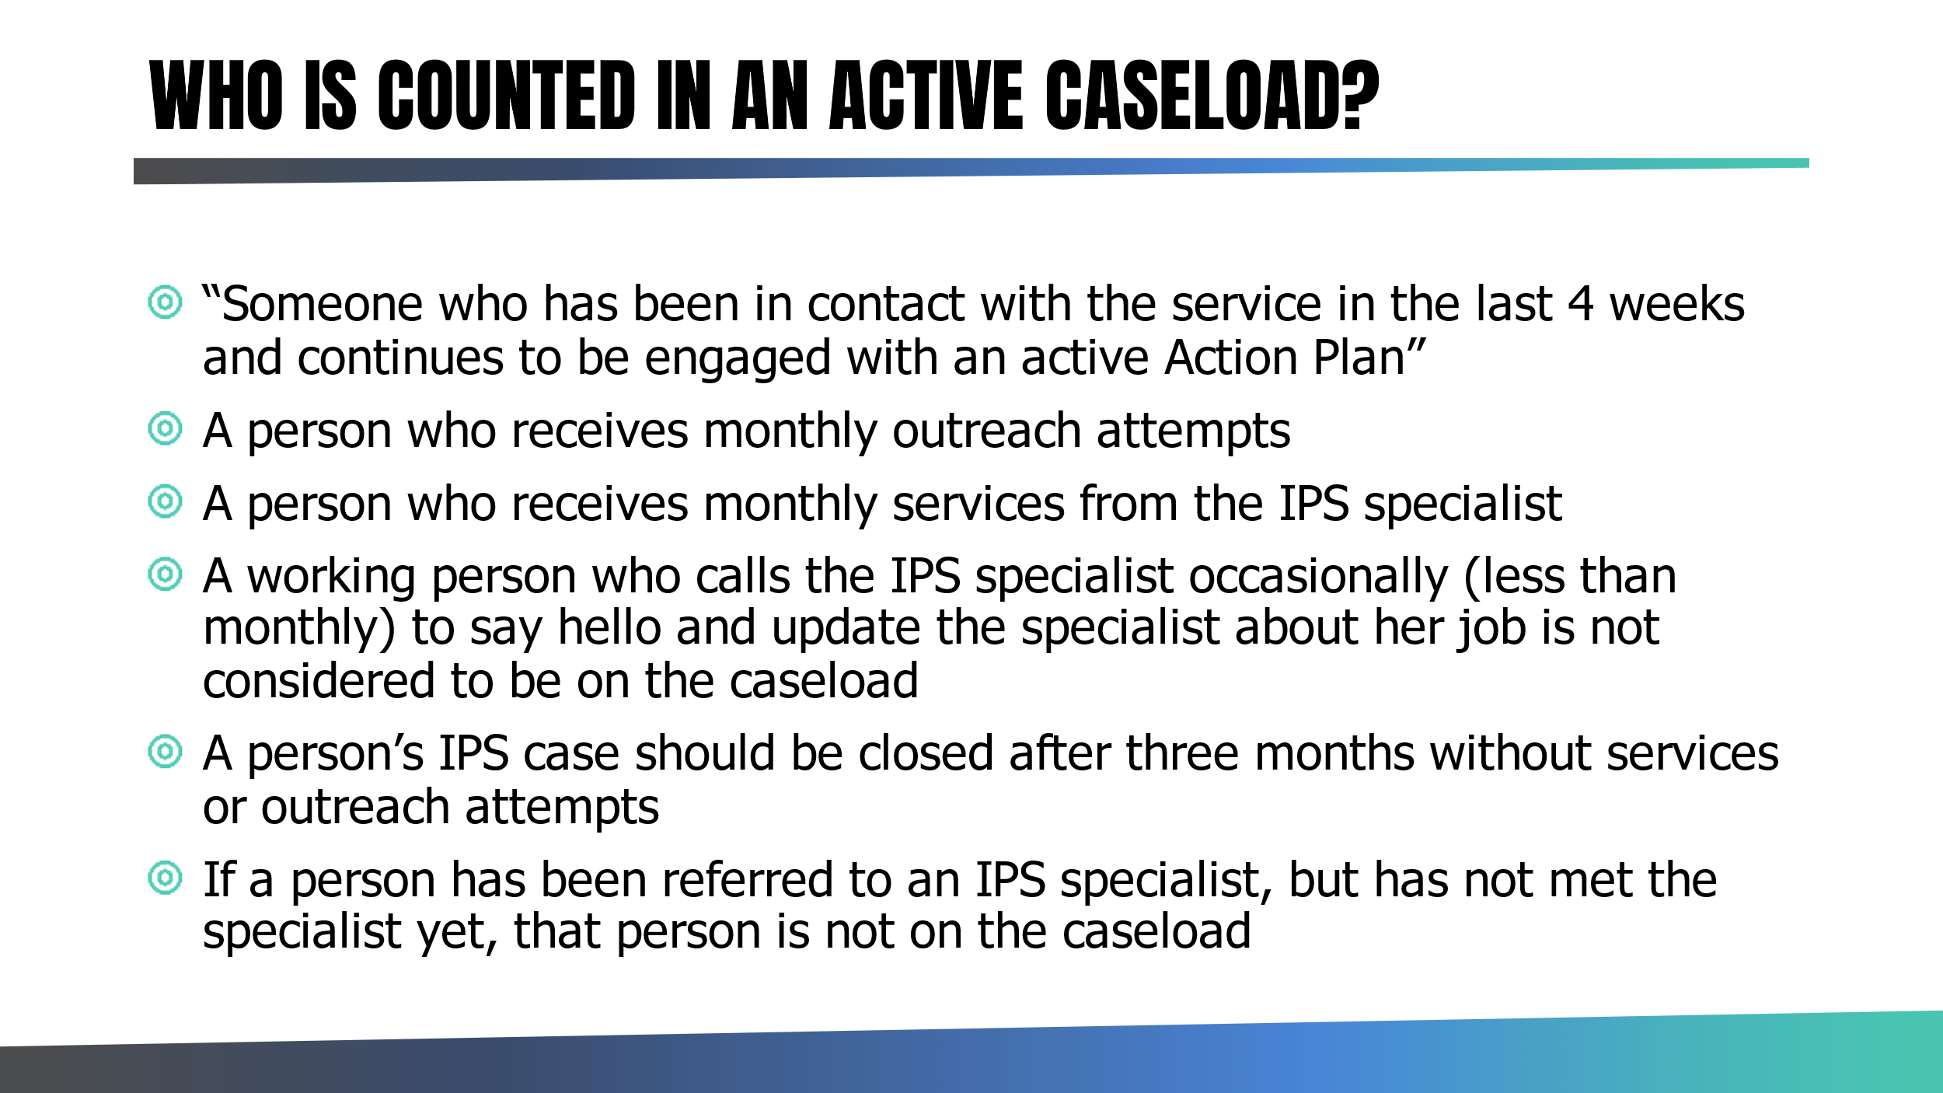

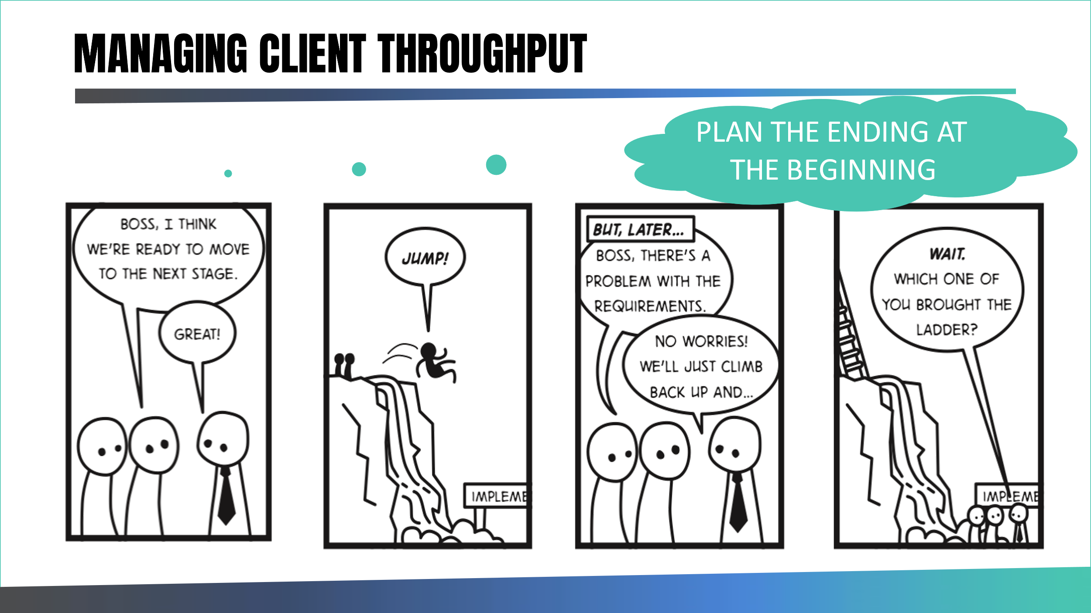

Plan the ending at the beginning.
How do you support and develop this as a team leader?

Individual case management Vs Case load management
List all the associated duties of your employment specialists.
Identify the roles they find more difficult and how you may be able to support them.
Individual case Management | Case Load Management

Technical Competence/Data Assignment(s)
- Travel agent exercise
  - Complete this exercise with your team and a clinical team member.
- Problem Tree
  - Use this approach to reflect on your team’s challenges and devise solutions to common problems.
- Case load review
  - Identify the longest client on all ES caseloads and review these as a team.
  - Identify what support has been offered/received and create new action plans.
- Field mentoring
Conduct field mentoring with all employment advisers and demonstrate good employer engagement.

Reflective Log Template
A reflective journal is a place to document your reflection entries. It can be something good or bad that has happened to you that you can self-reflect on and learn from past experiences. A reflective journal can help you to identify important learning events that had happened in your life:
What happened? | Describe what happened:
What were your feelings? | Consider how this made you feel/react?
Evaluate what was good or bad about the experience? | Link this to task, relationship, or process.
Analysis | What can you make of this situation?
Conclusion | General thoughts/feeling and what else could you have done?
ACTION PLAN | If this situation arose again – what would you do differently?

Comments | General thoughts/feeling

Assignment Options:
Choose at least one assignment from the list below. Please note that there is one assignment required per course. Please note that in addition to the assignment, you are asked to complete a reflective log on the assignment and submit with the assignment.

Assignment 1
- Review your fidelity for Item 8.
- Identify other areas that you directly impact in the model.
- Create an individual improvement plan for yourself on these items.
Comments
Evidence
Fidelity Rating
Actions required
Assignment 2: Stakeholder mapping
Undertake a stakeholder mapping exercise for your service. (c.f. pages 9-14). Categorise stakeholders and identify how to best communicate and engage with them. Build a plan to make that happen and complete a reflective log.

Assignment 3: Difficult conversations
Using the preparation guide, plan and undertake a difficult conversation with a key stakeholder that perhaps you have avoided or could revisit. Page 20. Please reflect on the experience in your reflective journal and complete a reflective log.

Assignment 4: Data and diversity
Compare the ethnic diversity of your IPS staff team with a) your IPS client group and b) the local population. Does your staff team reflect the ethnic mix of your client group? Does your client group reflect the ethnic mix of the local population?

Review the results and use the IPS Grow template to review your practice using the race equity anchors (appendix 4) and develop a plan to ensure IPS services are meeting local needs.

For template please see: Fidelity, GSA & Race Equity Action Plan Template available on FutureNHS platform
https://future.nhs.uk/gf2.ti/f/1000098/202042341.2/XLSX/-/Fidelity_%20GSA%20_%20Race%20Equity%20Action%20Plan%20Template.xlsx

Please complete a reflective log.

Assignment 5: Supervision
Design a supervision contract/template for use with supervisees. Reflect on its use or how you plan to introduce this with team members.

Assignment 6: Field Mentoring
Conduct field mentoring with all employment advisers and demonstrate good employer engagement. Provide a reflective log and identify any team training needs.

You may wish to complete an assignment of your own choosing based on the content of the course. If this is the case, please discuss with the trainers or email courses@centreformentalhealth.org.uk

Appendix 1: Employer Engagement
Date:
Name of Employment Specialist:
Name of Employer:
Items covered | Observed | Notes
IPS info given.

Was an appointment made in advance of this meeting?

Was an appointment made as a follow up to find out more about the employer?

Did ES find out about the business? (history, locations, type of products/service provided)

Did ES find out about hiring preferences?

Did ES find out about different type of roles at employer?

Did ES find out about type of candidate employer feels is a good match? (Skills, strengths, qualifications)

Was ES following up on a client’s application?

Did ES describe a client who is a good match to employers hiring preferences?

Did ES explain service to employer?

Were there actions agreed at end of meeting?

Appendix 2: Client Meeting Checklist
Date:
Name of Employment Specialist:
Client Initials:
Induction | Observed | Notes
Client given IPS info
Support explained
Motivation/confidence explored
Vocational profiling discussed
Personal preferences discussed
Skills discussed
Strengths discussed
Interests explored
Dislikes explored
Barriers explored
Past work history discussed
Training/education explored
Financials/benefits discussed
Disclosure discussed

Induction | Observed | Notes
Potential employers discussed
Job search conducted
Signposting support given
Zero exclusion practised
Updated job experience discussed
In work support plan discussed
Adjustments discussed
Application support
Interview techniques
Actions discussed and agreed

Appendix 2:

IPS Providers SWOT Template

Please complete this with your team by considering how your IPS service is placed to deliver over the next 6 months:

Strengths | Weaknesses
Opportunities | Threats
Solutions
NOTE: Ideally you want to identify what strengths you can build on and also what tactics you need to put in place to work on your weaknesses.
Then identify what opportunities you have and how you can try and make them a reality and what tactics are needed by your all to overcome any relevant external threats.
Appendix 4:
For IPS Grow template please see:
Fidelity, GSA & Race Equity Action Plan Template available on FutureNHS platform
https://future.nhs.uk/gf2.ti/f/1000098/202042341.2/XLSX/-/Fidelity_%20GSA%20_%20Race%20Equity%20Action%20Plan%20Template.xlsx
Thematic Area 1: Data  Race equity anchors:  1.1 The team analyses access and outcomes data and compares it to both local treatment caseload data and local population data to ensure proportionate representation of all ethnic backgrounds within caseloads.  1.2 The team undertakes IPS staff demographic analysis to ensure that teams are representative of the local population in which they work.  1.3 The team has a plan of how race equity data is shared and acted upon following analysis. | Thematic Area 2: Learning  Race equity anchors:  2.1 All staff are actively participating in, and making the most of equality and diversity learning opportunities provided by the treatment team organisation.  2.2 Teams are applying training and learning opportunities, to make an impact in day-to-day practice.  2.3 Team leaders actively seek opportunities to upskill and consolidate their team’s learning.
Thematic Area 3: Processes  Race equity anchors:  3.1 Race equity is a high priority, standing item on team meeting and steering group agendas  3.2 Mechanisms are in place to support Black, Asian and Minority Ethnic staff in raising concerns around facing racial abuse or discrimination  3.3 Team leaders review the demographic makeup of caseloads with their Employment Specialists and work to rectify discrepancies  3.4 The service is accessible to all  3.5 Mechanisms are in place to consolidate whole team learning and share best practice around race equity | Thematic Area 4: Partnerships  Race equity anchors:  4.1 The team makes the most of wider resources available within the provider and treatment team organisation, to organisation to ensure a cohesive and collaborative approach.  4.2 There is a whole organisational focus on race equity including at senior and executive levels.  4.3 Co-production with clients and wider stakeholders is a core part of the team’s strategy.  4.4 Employment Specialists actively seek opportunities to promote IPS across community groups  4.5 The team’s Employer Engagement strategy considers the needs of ethnically diverse clients.  4.6 The team’s Employer Engagement strategy considers how to work with racially diverse employers.

