
COURSE MANUAL
INDIVIDUAL PLACEMENT & SUPPORT

CONDUCTING IPS
SUPERVISIONS
CONTENTS
Personal action plan | 3
Making it work action plan: Actions involving others | 4
Personal experience of supervision | 5
Reflective supervision exercise | 6
Advantages/concerns about field mentoring | 7
Past experiences of receiving / giving feedback | 8
CORBS model and past experiences of giving / receiving feedback | 9
Applying ‘CORBS’ to feedback examples | 10
Making it work for everyone | 11
Post-course resources | 12

PERSONAL ACTION PLAN

Action | Who | When

MAKING IT WORK ACTION PLAN: ACTIONS INVOLVING OTHERS

Action | Who | When

PERSONAL EXPERIENCE OF SUPERVISION

Pre-course exercise: You will be asked to share your ideas during the training so please spend some time considering this topic and noting your thoughts below.

Think about supervisions you have had in your career…

What has been most useful to you?

What approaches /qualities in your supervisor have you found most / less helpful?
a) Most helpful for learning, problem-solving and improving practice?
b) Most helpful for support?
Reflect on the differences, if any, between a) and b) in your answers above.

REFLECTIVE SUPERVISION EXERCISE

Pre-course exercise: You will have an opportunity to practice ‘reflective supervision’ during the training.
Within the exercise you will also take a turn in the supervisee role and, for this, we ask you to bring a situation for supervision discussion.

Please think of a situation from your own client work that might be good for discussion in supervision. Be kind to the person who will be in the supervisor role and don’t choose the most complicated or challenging case of your career! It could be a situation where you are unsure about the best way forward, or a session with a client or employer which has not gone so well and where some reflection might be useful.

Role play guidelines for activity during training:

- Supervisee: The aim is to help the person in the supervisor role practice and learn. They need enough material to work with, but don’t make it too difficult.

- Supervisor: Start with a question such as “So, who would be helpful to talk through today?”. Please stay in role throughout rather than breaking off to discuss at any point.

- This role play focuses on the initial stage of identifying and exploring the issues so, unless this has been fully completed, don’t force the discussion on to the next stage of looking at action or 'solutions'.

- Feedback: The supervisor should conclude within role, attempting to summarise what they have heard and where the discussion has got to. Coming out of role, the supervisee can give brief feedback on how well the supervisor appeared to have understood the situation and any questions that may have helped with reflection. Aim for brief feedback of around a minute before roles are reversed.

ADVANTAGES/CONCERNS ABOUT FIELD MENTORING

What are the advantages or possible concerns about field mentoring from the employment specialist's point of view?

Advantages of field mentoring, from the employment specialist's perspective

Possible employment specialist concerns about field mentoring:

PAST EXPERIENCES OF RECEIVING / GIVING FEEDBACK

Pre-course exercise: Think about feedback that you have either received in the past (in any job role), or given to someone else in your role as IPS supervisor. Choose one or more examples of either giving or receiving feedback (you don’t need to do both) and answer the questions below.

If you can, please include in each answer your thoughts on:

- How did receiving/giving the feedback make you feel?
- Why did it make you feel that way?

What did the person giving the feedback do well?
What did the person giving the feedback do poorly?

CORBS MODEL AND PAST EXPERIENCES OF RECEIVING/GIVING FEEDBACK

- Clear - about ‘what’ feedback and ‘why’ give it
- Owned - use ‘I’ statements (it’s your perception)
Corrective
Confirmatory
Reflective (wondering)
- Regular - forms part of supervisions
- Balanced - range of feedback types
- Specific – related to specific behaviour/events

Using your pre-course work on ‘past experience of receiving/giving feedback’ from page 8, complete the activity below:

Looking at your example/s of what the person giving the feedback did well, identify which parts of the CORBS model the person was following when delivering that feedback.

Share your conclusions with the people in your group.

APPLYING ‘CORBS’ TO FEEDBACK EXAMPLES

- Feedback delivered well (5 mins)
  - Identify: Which parts of CORBS were applied?
  - Share conclusions with partner
- Feedback delivered poorly
  - Solo work: how to deliver it well, using CORBS (5 mins)
  - Share ‘CORBS-improved’ delivery with partner (10 mins)
  - Exchange feedback on the improved version (5 mins)

Using your pre-course work on ‘past experience of receiving/giving feedback’ from page 8, complete the activity below:

Looking at your example/s of what the person giving the feedback did poorly, use the CORBS model from page 9 to create an alternative way to deliver that same feedback well.

Share your ‘CORBS-improved’ way of delivering the same feedback with the people in your group. Ask them for their reactions on how this sounded to them.

MAKING IT WORK FOR EVERYONE

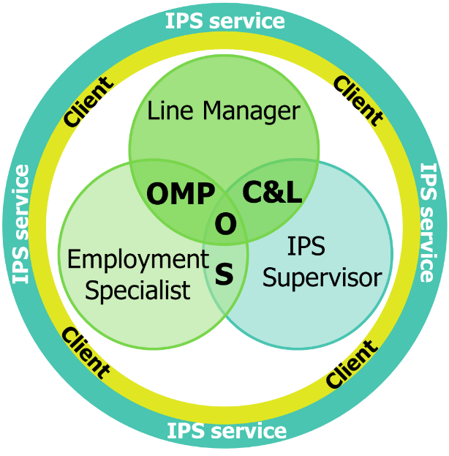

S: IPS supervision/field mentoring
O: Overlap
OMP: Other management processes
C&L: Communication and liaison

Make a note below of things that you need to clarify with other people, connected with the supervisions that you will be conducting with employment specialists. Think about who is the ‘everyone’ that this must work for, within the context of your service and your situation.

What is their interest in, and relevance to, your role in conducting IPS supervisions?

The ‘everyone’ could include:
Clinical supervisor, occupational therapist, CMHT/clinical unit’s team leader, IPS service team leader and/or service manager, NHS line manager (if this is not you) either:
- Actual line manager (if ES is an NHS employee) or
- ‘Dotted line’ manager (if ES employed outside the NHS and has an ‘acting’ NHS line manager).

POST-COURSE RESOURCES

DESC model for requesting change:

- Describe the behaviour you want changed
- Express your concern (feelings)
- Specify the change in behaviour you want
- Consequences - explain the reason you want the change

The DESC model can be useful if the employment specialist has not realised or accepted that a change in their behaviour is required.

Note that the DESC model is not always needed, For example:

    - If the feedback conversation you have had using the CORBS model concludes with the ES being clear about the actions they need to take.
    - And/or… If you have used the reflective learning model of supervision, which has led the ES to clarity over what to do next.

However, if these other methods have not worked, then the DESC model for requesting change provides a clear and directive way to make the change request to the ES.

Reflective learning model of supervision:

Examples of questions that may aid discussion

Based on “One hundred and more questions” p169-172 in Davys, A and Beddoe, L (2021)
Best Practice in Professional Supervision. 2nd edn. London. Jessica Kingsley.
Additional questions (and variations) added in italics.

Event:
- What have you brought to supervision today?
- What is it about this situation that concerns you?
- What are you hoping to get from today’s discussion?
- Where do you want to start?
- What would be helpful?
- What do you want from me?
- How much do I need to know to understand the situation?

Exploration
- What have you done so far?
- How did you approach this when you talked about it with the client?
- How are you feeling right now about the situation?
- How were you feeling at the time?
- Have you been in a situation like this before?
- What has helped you on previous occasions?
- Have you discussed this with the client?
- How do you think the client/employer sees you?
- What do you like about this client/employer? What do you not like about this client/employer?
- What do you think the client/employer likes about you?
- What is your greatest concern?
- What do you think might be going on for this client?
- How might the client be feeling?
- Why might the client be behaving as they are?
- What aspects of the client’s mental health do you think might be affecting this situation?
- What have you thought of so far?
- How did you come to that conclusion/decision?
- What is your goal?
- What other approaches could you take?
- What do you think you have done well?
- What strengths does this client have?
- What are this client’s goals?
- Are the client’s goals realistic?
- What do you wish you had done differently?
- What would IPS fidelity suggest should be happening here?
- What would the IPS approach suggest we should be doing here?

Experimentation:
- So, what are you going to do now?
- Where are you going to start?
- How are you going to say that?
- What is the most likely response from the client/employer?
- How will you respond to the client’s/employer’s response?
- What responses are you most concerned about?
- What are the possible consequences of your plan?
- What contingency plan do you have in mind?
- Who else needs to know?
- Who else might it be useful to involve?
- What do you need to record about this case?
- Are there issues of safety involved?

Evaluation
- Given where you started, where are you now?
- How will we follow up, review, evaluate, debrief?
- How has this process been?
- How could it have been different?
- What have you discovered/learned?
- Any issues remaining about the case or with me?

Supervisor reflector log:

Date of supervision |  | Initials of supervisee
What specific issue was identified for discussion?
What did the supervisee wish to gain from the discussion?
What insights were gained from the discussion? How did the supervisee’s understanding of the situation change in the course of the supervision session? *
What learning was gained by the supervisee through the session? *
What actions were taken forward from the session? Who decided these actions? *
Did you reflect together at the end of the supervision on whether the supervision had been helpful and on any ways it could have been improved?
Any additional reflections on ways this session might have worked better?
Note: You may well not have anything to write against all of the sections marked *. However, if you find they are all blank, you may want to reflect further on what help the session was to the supervisee!

NOTES

Make notes here

REFERENCES

Davys, A and Beddoe, L (2021) Best Practice in Professional Supervision. 2nd edn. London. Jessica Kingsley. p169-172

Hawkins,P and Shohet,R (2012) Supervision in the Helping Professions 4th edn. London. McGraw-Hill Open University Press. (page 160)

Lockett, H (2020) You Tube, Work Counts interview ”What makes an effective employment consultant”
Available from: You Tube: https://www.youtube.com/watch?v=rLJ45m95Sjg

Luft, J and Ingham, H (1955) The Johari Window Model Diagram Available from: https://www.businessballs.com/self-awareness/johari-window-model-and-free-diagrams/ (updated February 21, 2022)

Reflective learning model of supervision:

Based on “One hundred and more questions” p169-172 in Davys, A and Beddoe, L (2021)
Best Practice in Professional Supervision. 2nd edn. London. Jessica Kingsley.

DESC model for requesting change:

Davys, A., & Beddoe, L. (2021).
Best practice in professional supervision: A guide for the helping professions (2nd ed.). London: Jessica Kingsley.
Based on: Bower, S. A., & Bower, G. H. (1991).
Asserting yourself: A Practical guide for positive change (2nd ed). Reading MA: Addison-Wesley

CORBS model based on Hawkins and Shohet, 2012 (p160)


CONDUCTING IPS SUPERVISIONS
COURSE MANUAL

Visit our website for more IPS information and resources.

www.centreformentalhealth.org.uk

© Centre for Mental Health, 2023
Some items adapted from Dartmouth Psychiatric Research Center, New Hampshire, USA.

